EPS 200 (Stapleton) Name: _________________________________
Heat Pump

Assume that the diagram below shows a heat pump that is being used to cool a house to 70$℉$ on a 90$℉$ summer day.

- Label the evaporator and the condenser.
- Label the compressor and the expansion valve.
- Label the refrigerant path and use arrows to show the direction of refrigerant movement.
- Label the pathways of the water/glycol and use arrows to show the direction of its movement.
- Insert reasonable temperatures onto each of the provided lines.
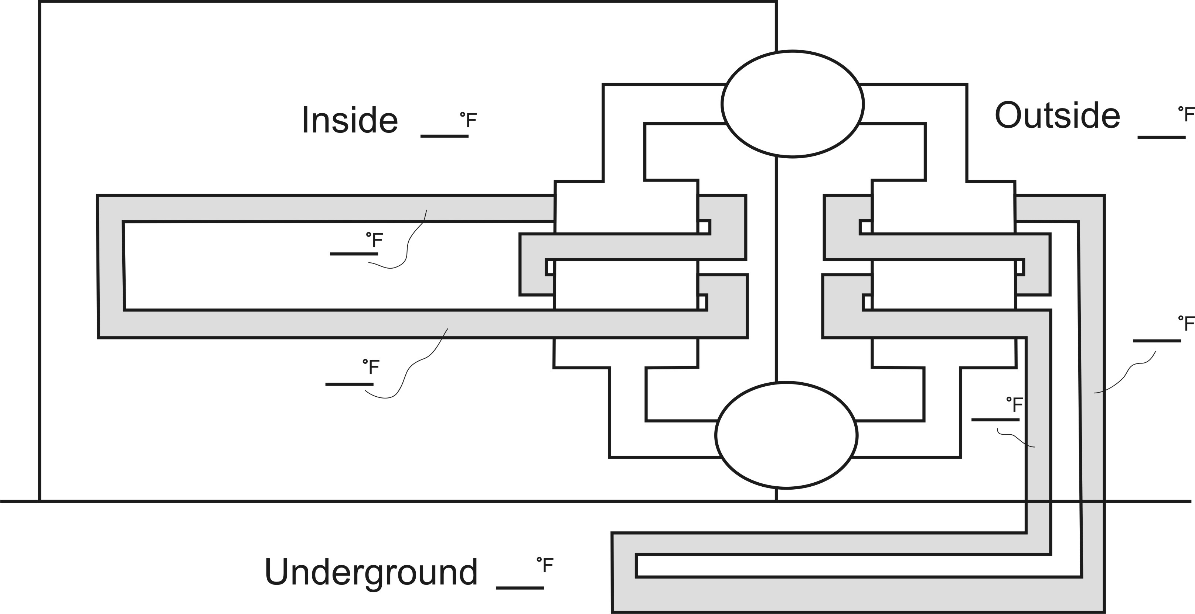
- Show and/or label areas where the refrigerant is liquid and areas where it is a gas.

