EPS 200 (Stapleton) Name: ____________________________
Buoyancy Questions

1. Do you weigh as much when you’re swimming as you do when you are on dry land? Justify your answer.

2. a. Explain how you can reduce your weight by changing your mass.

b. Explain how you can reduce your weight by changing gravity.

c. Are there any other ways to change your weight? If so, what are they?

d. Go back and check your answer to #1. Feel free to change it if you want.

3. In the diagram below, object A is rising and object E is sinking. The rest of the objects are not moving.

- Rank the objects according to the force of buoyancy that is acting on them.
- Fill in the table below. If you do not know the exact answer, approximate and/or use < or > symbols.
- For each object, use arrows to represent the forces of buoyancy and weight that are acting on the object. Label them B (for buoyancy) and w (for weight).

Object | Current Motion | Weight (pounds) | Buoyancy (Pounds) | Net force (pounds) | Direction of Net Force | Density (g/ml)
A | Rising | 1
B | Motionless
C | Motionless | 4
D | Motionless | * | 5
E | Sinking | 2

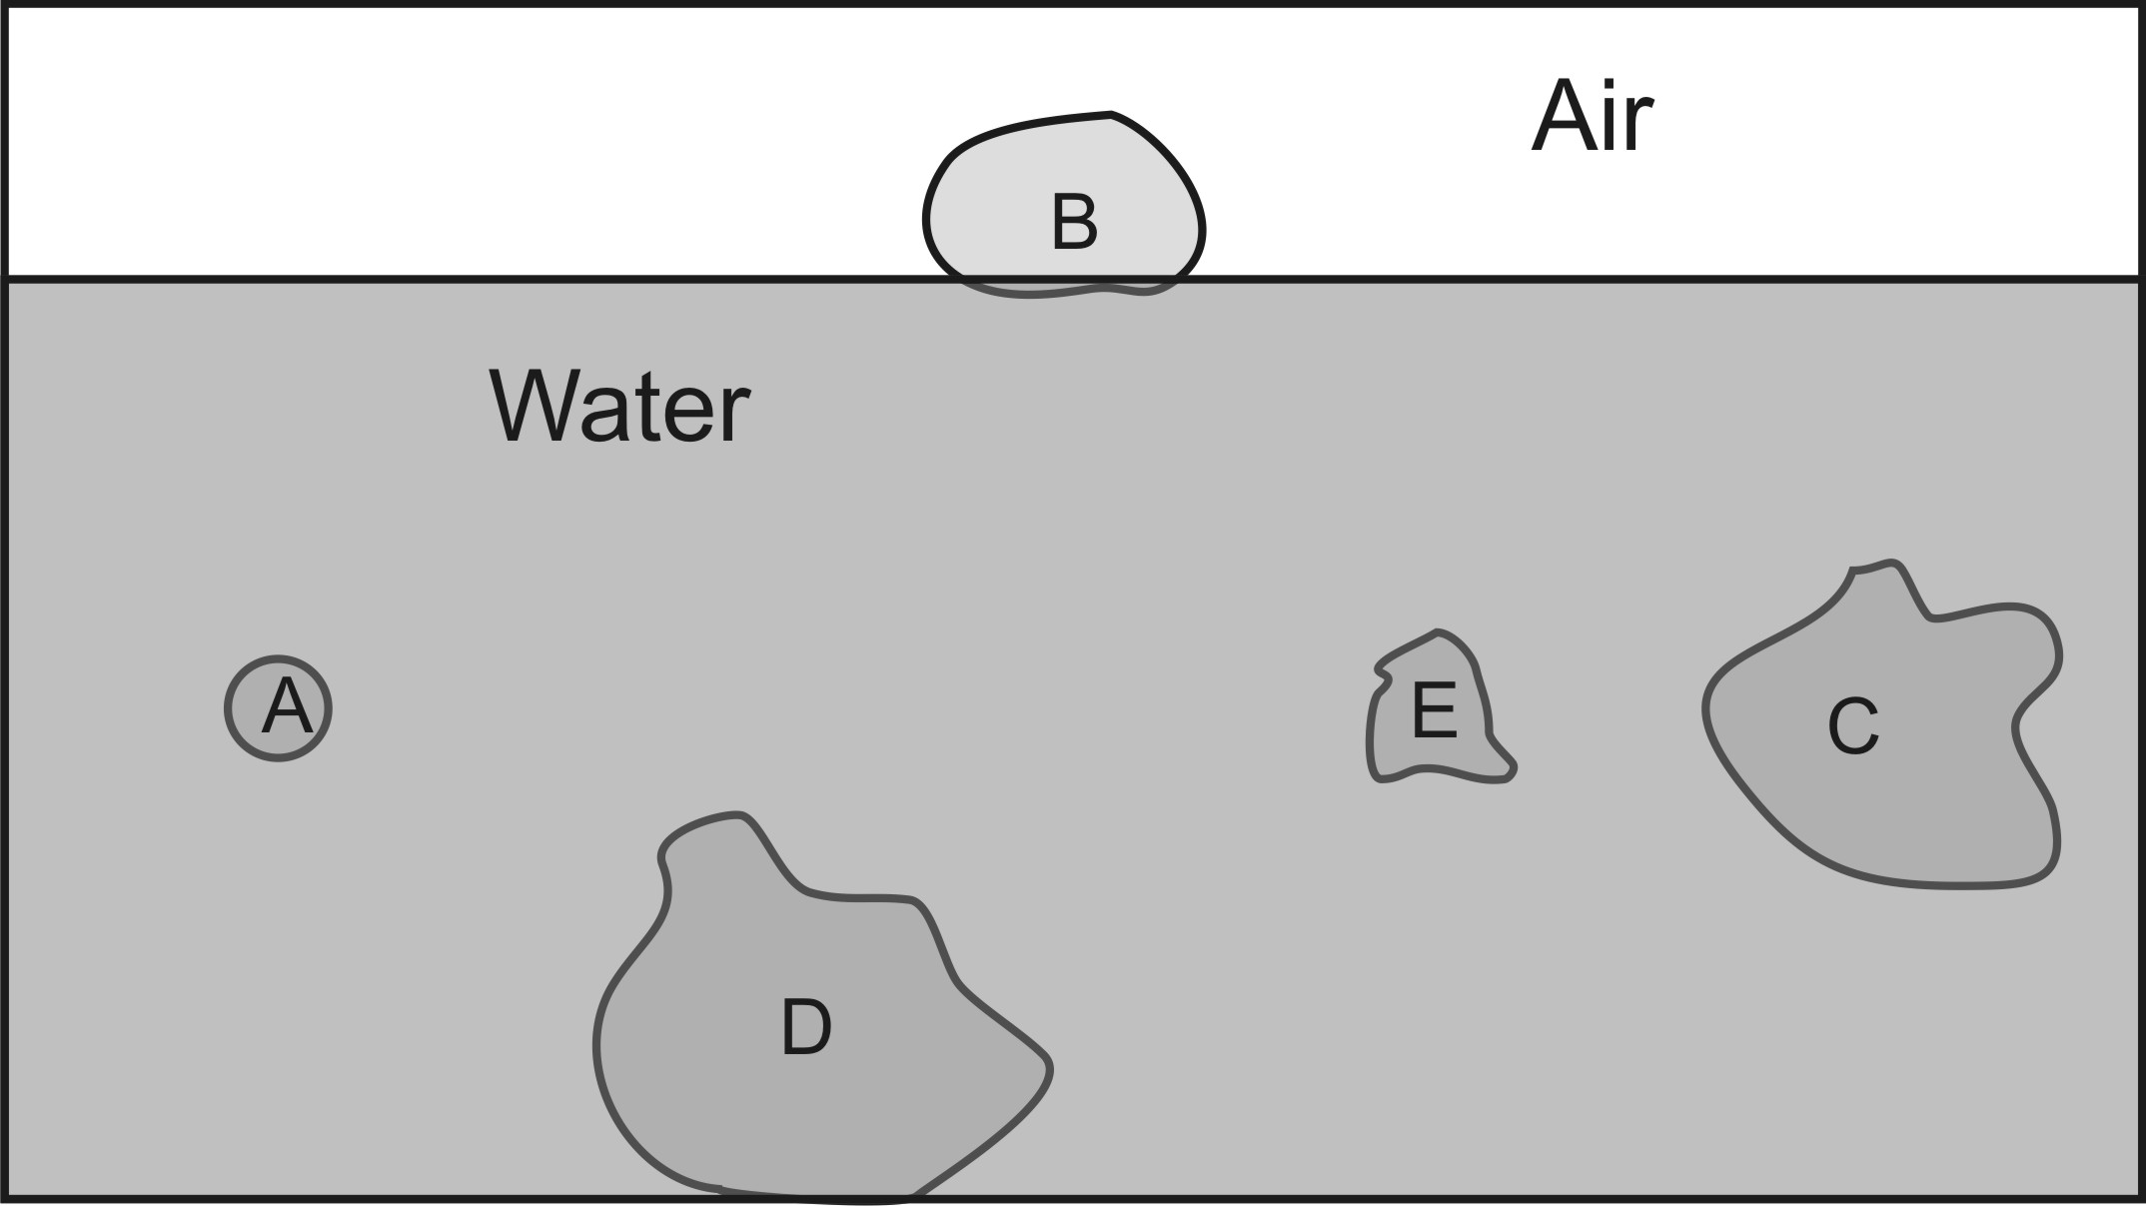

4. Only one thing determines the force of buoyancy acting on an object. What is that one thing?

