EPS 200 (Stapleton) Name: ______________________________
Inquiry/Experimental Design Notes

- Scientific studies control variables. A good experiment generally has only one variable (or, at least, one variable at a time).
  - A variable is a factor in your experiment that can vary. If there is only one variable in your experiment, then any effects that you observe can be attributed to that variable.
    - The concern with extra variables (a.k.a. confounding variables) is that their variation can have confusing effects on your experimental results, thus rendering your investigation inconclusive.
    - Potential confounding variables must therefore be controlled, which means that they are kept the same for the sake of a fair and valid comparison. Suppose, for example, that we are trying to compare the swimming speeds of British and American Swimmers. If, during our swimming tests, the British team wears Speedos and the Americans wear Carhartt overalls, the extra variable of type of swimming suit would be a confounding variable that would invalidate the experiment. Similarly, if the Americans were allowed to swim with a freestyle stroke, and the British were forced to swim the butterfly, the confounding variable of swimming stroke would invalidate the experiment.
  - The experimental variable is a term for the one variable that should not be controlled (kept the same) in an experiment. This is the variable being tested. In the swimmer example, the only difference between the two groups of swimmers should be that they are selected from two different populations of swimmers, British versus American.
    - Independent variable: another name for the experimental variable. By designing an investigation, you are trying to find out if the independent variable has an effect on the dependent variable. In the swimmer example, nationality is the independent (or experimental) variable.
    - Dependent variable: this is the variable that you measure in order to see if there is an effect. Measuring the dependent variable tells us the result of varying the experimental variable. In an investigation, you are trying to find out if the dependent variable actually depends on the independent variable. In the swimmer example, swimming speed is the dependent variable. The question could be stated as “does swimming speed depend on nationality?” Swimming speed is the dependent variable, whereas nationality is the independent variable.
  - Controlling Variables Means Eliminating Bias: Bias is prejudice or the favoring of a certain outcome. If, for example, an American investigator is collecting the data in the swimmer experiment, he or she might cheat in favor of one nationality or the other. Controls must be in place to prevent cheating.
  - Controlling Variables Requires Careful Protocols: Clear data collection protocols (steps to follow) minimize the chances that unwanted variables can sneak into an experiment. The clearer the protocol, the more confidence we can have in its implementation. When the details of data collection are left up to the measurer, it is easier for that person to introduce bias to the measurement process.

- Scientific studies have sufficiently large sample sizes.
  - Sample size tells you how much testing was done. In the swimmer example, testing one British swimmer and one American swimmer would not be a large enough sample size. Testing ten swimmers from each country would be better. Testing 1,000 swimmers would be even better.
  - Statistics tells us how large the sample size needs to be. Statistical analysis boils down to this question – what is the probability that our two groups are the same, and that the difference we are seeing is due to chance and natural variation?
    - Consider the swimmer example… Suppose that we randomly select ten swimmers from each country, and using a careful and consistent protocol we find that all ten American swimmers are faster than all ten British swimmers. Given these consistent results, is it possible that there is really no difference between American and British swimmers? Is it possible that, out of the thousands of swimmers from each country, we just happened to select ten faster swimmers from America and ten slower swimmers from Britain – even though the two populations are, in reality, identical? Is it possible? Is it likely? What is the probability of seeing this striking difference if the populations are essentially identical? If this probability is very low, we generally reject the idea that there is no difference between the populations, and we say that it is very likely that there is an actual difference between the populations.
    - In many scientific studies, statistics must show 95% certainty in order for findings to be considered “significant.” 95% confidence is called the significance cutoff. What this realy means, in statistical testing, is that the probability of the observed effects having occurred by chance must be 5% or lower. Five percent is the P-value, or the probability of our observation of an apparent effect being an accident.
    - If a study shows with 95% certainty that British swimmers are faster than American swimmers, is there a chance that the study could be wrong? Yes, a 5% chance!
    - How big should your sample size be? If you do not know how to use statistical tools to answer this question, your sample size should be as big as you can reasonably manage. Consider this… how many times would you want someone to flip a coin so that you could decide whether or not it is really a “fair coin?”
  - “n” is often used to represent the number of samples in an experiment. If you conduct a test with 50 human subjects, you have an “n of 50.”

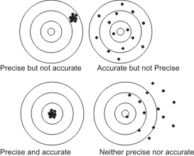
- Solid scientific studies rely on precise and accurate numerical measurements.
  - Precision: consistency; when something is measured precisely multiple times, the measurement will always be the same. This is not the same as accuracy; you can be consistent without hitting the target. When you are looking for a potential difference between two groups, precision is arguably more important than accuracy.
  - Accuracy: how close measurements are to the right answer, on average.
    - The virtue of having accurate measurements relates to logical validity, below. If our measurements are not accurate, then we may not be testing what we think we are testing.
  - Data need to be quantitative (numerical). If the results of an experiment cannot be converted to numbers in a meaningful way, then we cannot apply statistics to see if they are significant (95% certainty). We must be able to apply statistics in order to assess the strength of our conclusions.

- Investigations and their conclusions must be based on valid logic. We should always ask “are we really testing what we think we are testing?” You can do everything right, but if your study is based on an illogical premise, it may be worthless.
  - Examples:
    - An example of a logical experiment: You want to know if sheep are heavier than pigs, so you weigh both groups. The pigs weigh more, on average, so you conclude that pigs are heavier.
    - An example of an illogical experiment: You want to know if bowling balls are heavier than snakes. Using a meter stick, you measure their lengths and conclude that snakes are longer, so they must be heavier.
    - There are many other ways to be illogical. We will deal with them as they arise.
  - Do not confuse correlation with cause. A correlation between two things means that a change in one variable is accompanied by a change in the other. This does not necessarily mean that one phenomenon is causing the other. For example, there is a correlation between wearing skirts and having long hair, but we know that neither phenomenon causes the other.

The passages below summarize a couple of really bad investigations. Read the passages, identify mistakes, and then categorize the types of mistakes. Some categories are:
- Sample size
- Variables
- Logic
- Bias
- Quality of Measurements
  - Precision
  - Careful Protocol

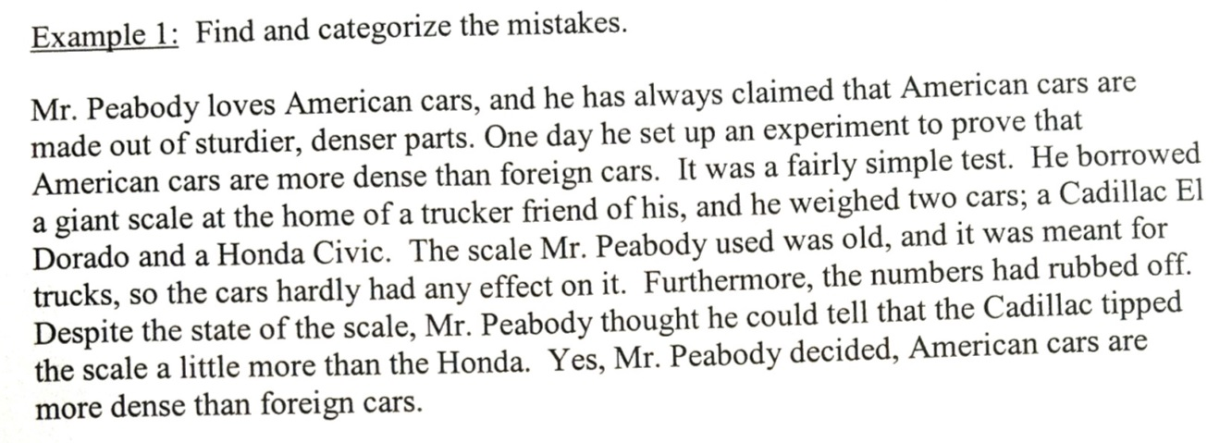

The passages below summarize a couple of really bad investigations. Read the passages, identify mistakes, and then categorize the types of mistakes. Some categories are:
- Sample size
- Variables
- Logic
- Bias
- Quality of Measurements
  - Precision
  - Careful Protocol

