EPS 200 (Stapleton) Name: ___________________________
Calculating Weight and Density
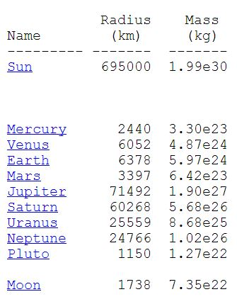
Helpful Information:
On Earth, 1kg of mass has a weight of about 2.2 pounds.
1kg = mass of 1 liter of fresh water
1L = half the volume of a 2 liter bottle; about 1 quart
1Newton = 1N = The force required to accelerate 1kg at a rate of 1m/s/s
1N ≈ 0.224 pounds
Volume of a sphere = $\frac{4}{3}πr^{3}$
1km = 1,000m
1,000 kg/m³ = Density of Fresh Water
Density = ρ =$\frac{m}{v}$
Law of Universal Gravitation: $F=\frac{Gm_{2}m_{1}}{d^{2}}$
Gravitational Constant = $\frac{6.67 x {10}^{-11} {Nm}^{2}}{{kg}^{2}}$

Density:

1. Describe density from a mathematical standpoint.

2. The density of fresh water is 1kg/L. What does “one kilogram per liter” mean?

3. If fresh water has a density of 1kg/L, this means it also has a density of 1,000kg/m³. Explain why.

One Way to Convert Between Units:

Step 1: Find equivalent quantities in two different units [You can Google “convert pounds to kilograms”]
Step 2: Arrange those two quantities as a fraction (which will be equal to 1, because they are equal quantities)
Step 3: Multiply the quantity you want to convert by one of those fractions. Choose fraction that causes the unwanted units to cancel when you multiply. [You may have to flip your fraction, but that’s okay, because it will still be equal to 1.]
Step 4: Do the math

Example: A slug is 8cm long. How many inches is that?

Step 1: 1 inch = 2.54 cm

Step 2: $\frac{1 in}{2.54cm}$ or $\frac{2.54cm}{1 in}$

Step 3: The quantity I want to convert is 8cm. I want inches, so I want cm to cancel. (8cm) $\left(\frac{1 in}{2.54cm}\right)$
Step 4: $\frac{8 in}{2.54} =3.15 in$
Scientific Notation:

- Exponent:
- Converting to decimal notation: If the exponent is negative, you’re dealing with a small number; move the decimal point to the left. The exponent tells you how many places to move the decimal point. If it is positive, the number is big; move the decimal point to the right.
- Converting to scientific notation: Find the decimal point or write it in. Then move it so that there is one digit in the ones place and no digits in the tens place. The number of places that you moved the decimal becomes your exponent. If you moved the decimal to the left, the exponent is positive. If you moved it right, the exponent is negative.

4. 6.67 x 10⁻¹¹ may also be written as 6.67e⁻¹¹. How do you write this as a decimal?

5. Write 4.46 x 10⁻⁵ in decimal form.

6. Write 7.2 x10⁸ in decimal form.

7. Write 2.8 x10⁴ in decimal form.

8. Write 5,200,000 in scientific notation.

9. Write 49,600,000,000 in scientific notation

10. Write 0.00023 in scientific notation.

11. Write 0.000087 in scientific notation.

Planet Problems:

12-18. The sun…

12. What is its radius, in meters?

13. What is its volume, in m³?

14. What is the sun’s density, in kg/m³?

15. Based on that density, would it sink or float in fresh water? Explain.

16. If a human weighs 100 pounds on the surface of the Earth, what is his/her mass, in kilograms?

17. What would be the weight of this human if he or she were standing (somehow) on surface of the sun? Answer in Newtons.

18. What would be the weight of this human standing on the sun, in pounds?

19-25. Saturn…

19. What is its radius, in meters?

20. What is its volume, in m³?

21. What is its density, in kg/m³?

22. Based on that density, would it sink or float in fresh water? Explain.

23. If a human weighs 150 pounds on the surface of the Earth, what is his/her mass, in kilograms?

24. What would be the weight of this human if he or she were standing on the surface of this planet? Answer in Newtons.

25. How much would this human weigh on this planet, in pounds?

26-32. Pluto…

26. What is its radius, in meters?

27. What is its volume, in m³?

28. What is its density, in kg/m³?

29. Based on that density, would it sink or float in fresh water? Explain.

30. If a human weighs 200 pounds on the surface of the Earth, what is his/her mass, in kilograms?

31. What would be the weight of this human if he or she were standing on the surface of this planet? Answer in Newtons.

32. How much would this human weigh on this planet, in pounds?

