EPS 200 Name: ________________________________
Astronomy: Formation of the Solar System

Purpose: To understand how and why a cloud of “dust and frozen gasses” would turn into a solar system like ours.
Gravity is a force of attraction. Any two objects are attracted to one another by gravity as long as they have mass. Does dust have mass?

Does ice have mass?
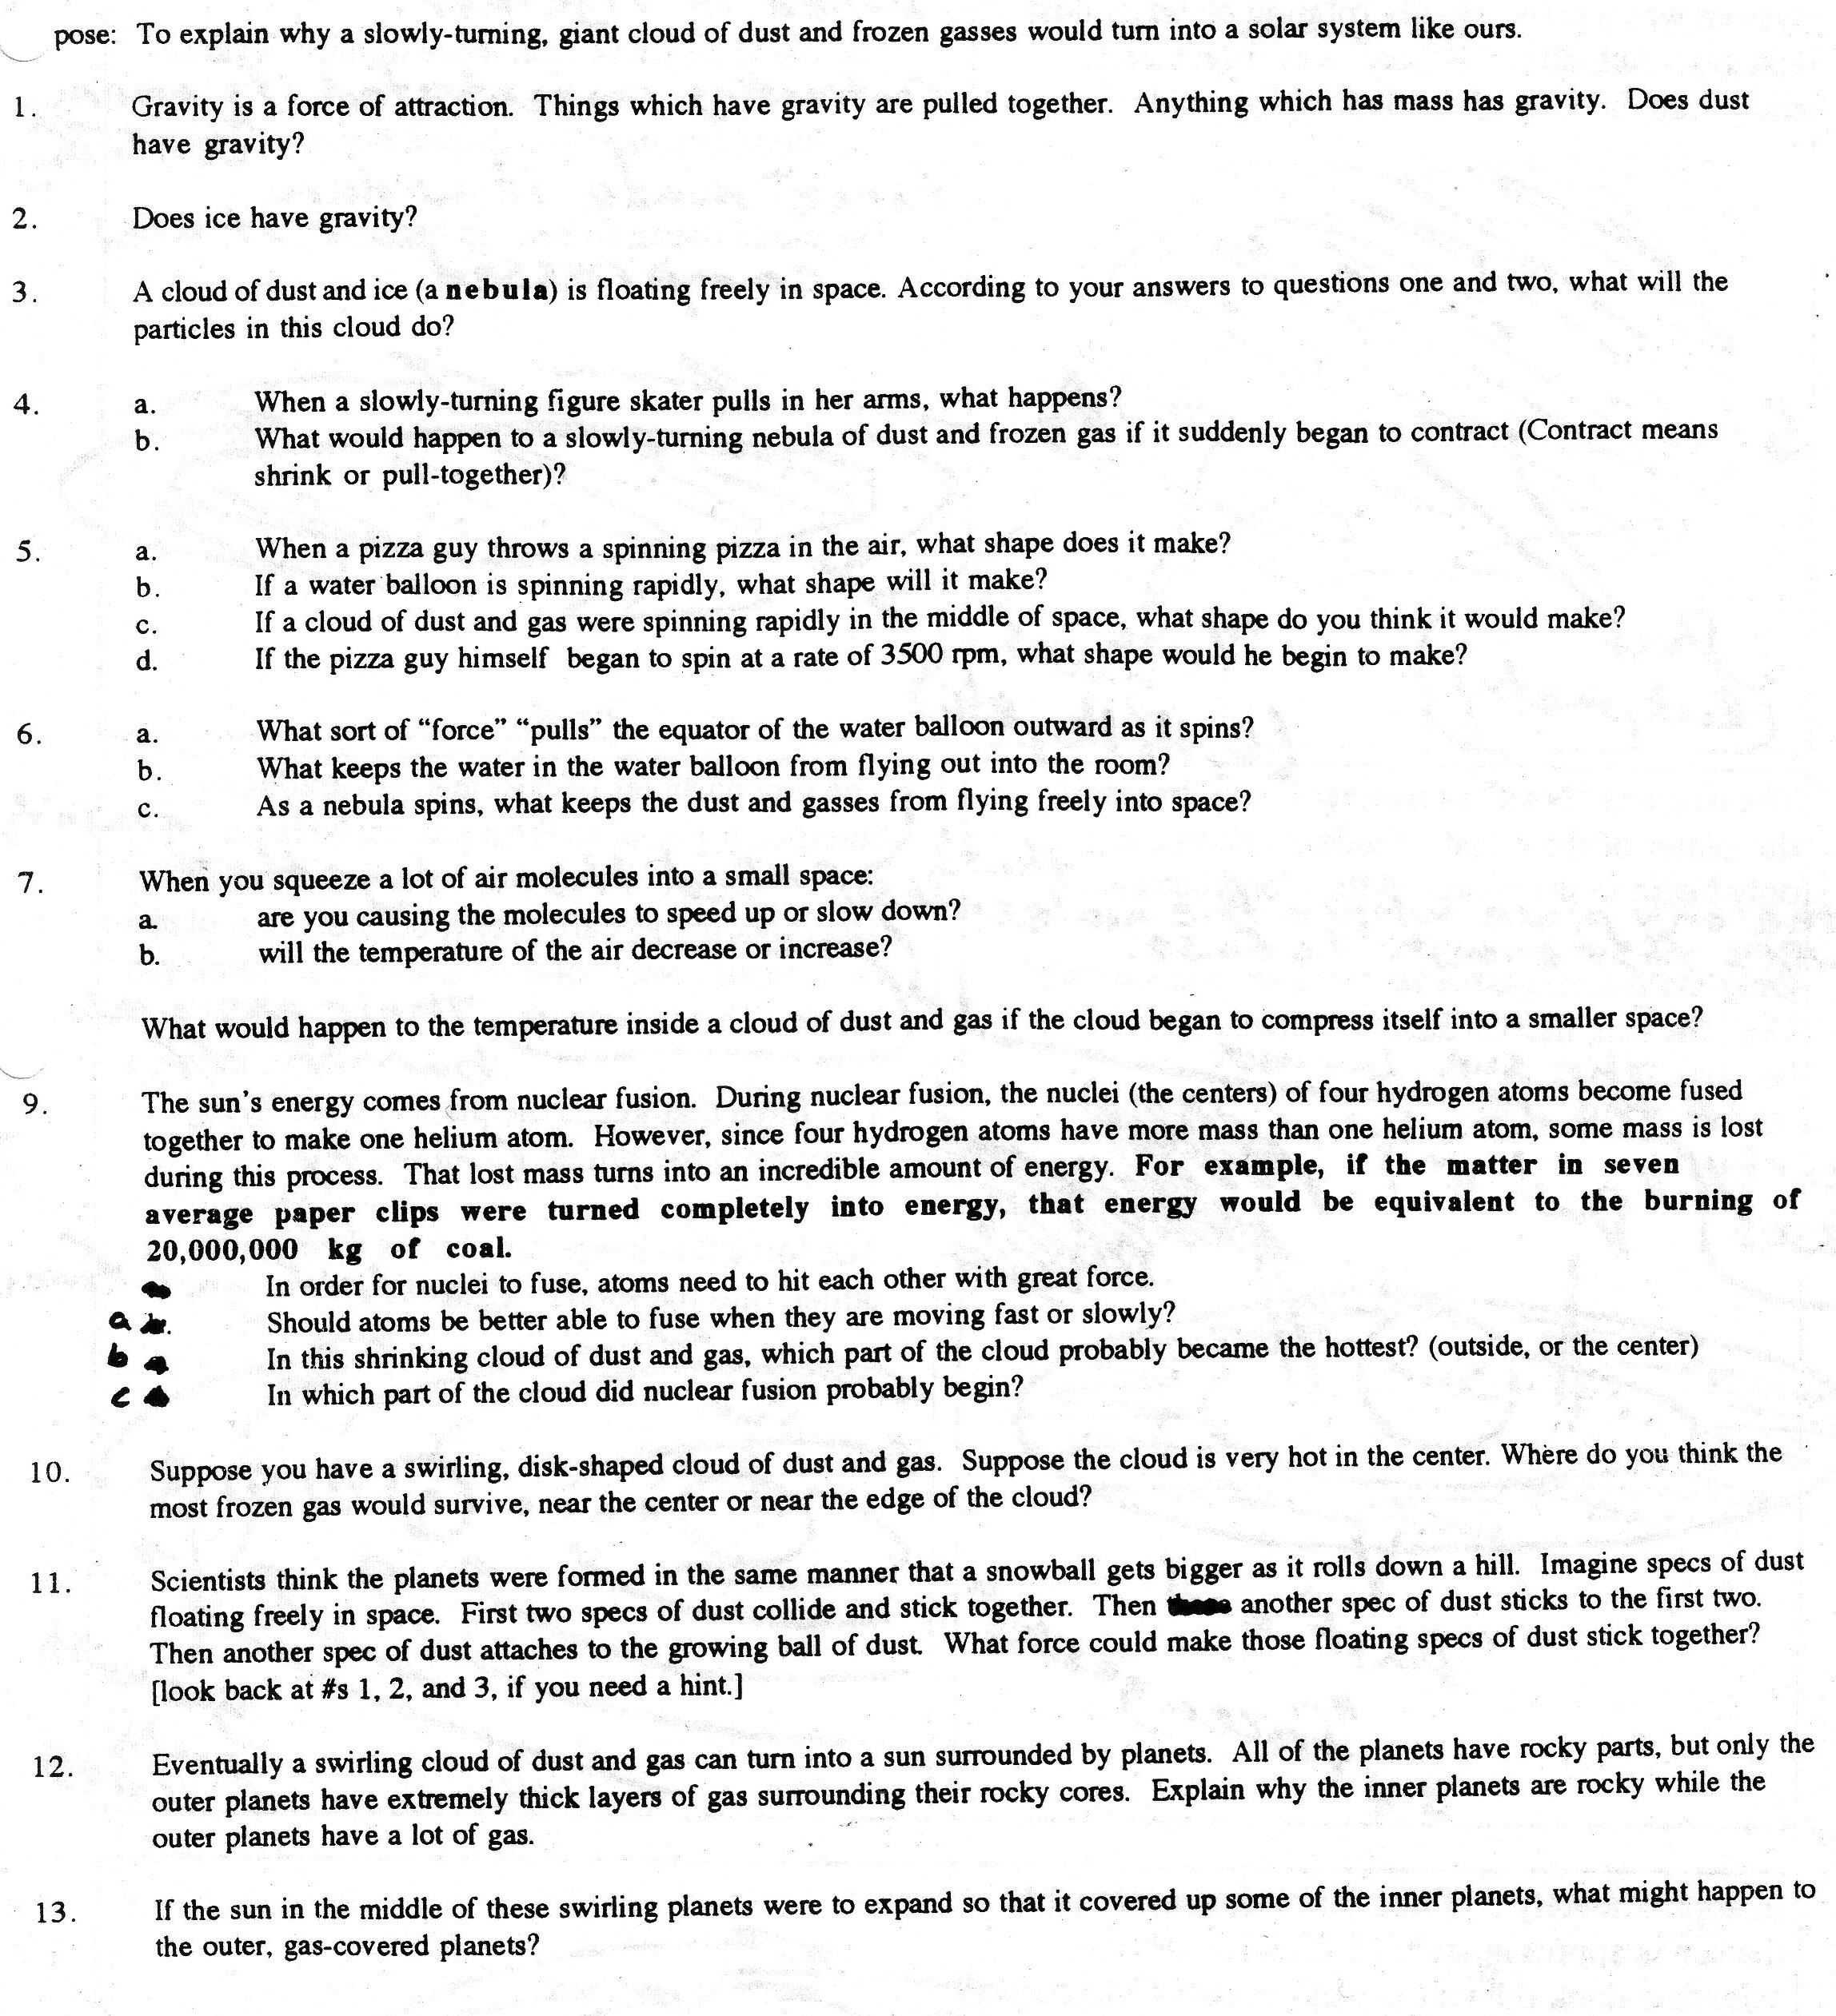
8.
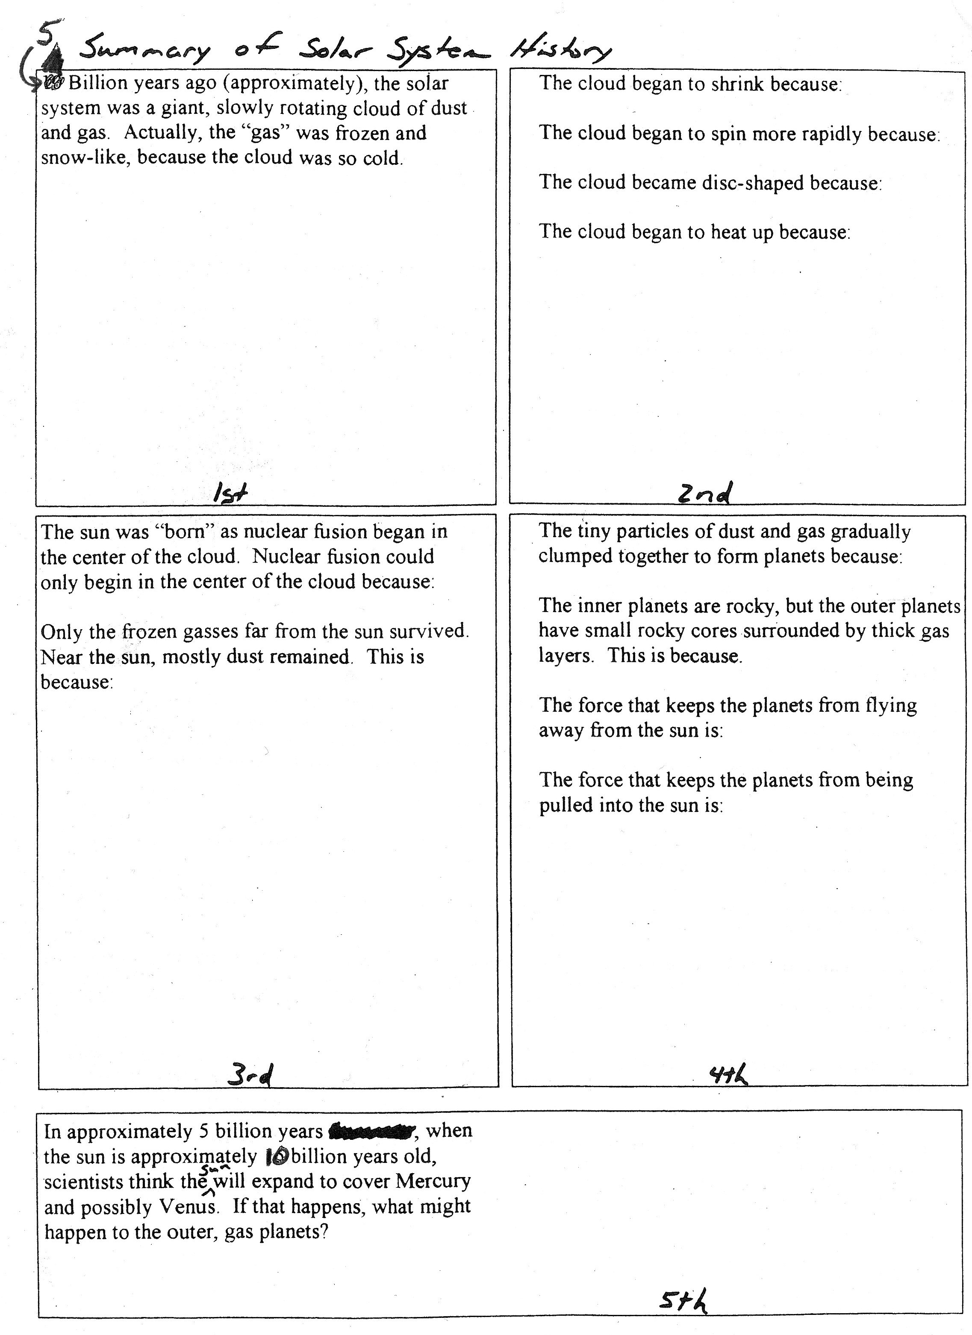

4.6

