EPS 100 Name: _____________________________________
Quiz 2 – More Practice: Plate Tectonics

Match each description to the appropriate type of crust, continental crust or ocean crust.

7. Continent Ocean The most explosive volcanoes have some of this type of lava.
8. Continent Ocean This is the least dense type of crust.
9. Continent Ocean Seafloor sediment contains a lot of this type of material.
10 Continent Ocean Lava of this type piles up easily. It forms steep volcanoes.
11. Continent Ocean An example of this rock type is called basalt.
12. Continent Ocean Melts to become low viscosity (runny) lava.
13. Continent Ocean This type of lava forms low, rounded volcanoes.
14. Continent Ocean Darker in color/shade

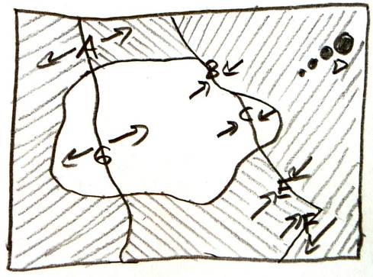
Match each feature name to the corresponding feature on the plate map on the right.

15. A B C D E F G Transform Boundary
16. A B C D E F G Hotspot
17. A B C D E F G Continent/Continent Convergent
18. A B C D E F G Continent/Continent Divergent
19. A B C D E F G Ocean/Continent Convergent
20. A B C D E F G Ocean/Ocean Convergent
21. A B C D E F G Ocean/Ocean Divergent

Match each of these real-world locations to the similar tectonic feature on the map.

22. A B C D E F G San Andreas Fault, California
23. A B C D E F G Mid-Atlantic Ridge
24. A B C D E F G Japan
25. A B C D E F G Andes Mountains (South America)
26. A B C D E F G Himalayas (Mt. Everest)
27. A B C D E F G Hawaii
28. A B C D E F G East Africa

