ESS 100 Name: _________________________
Practice Test: Meteorology

Part 1: Structure of Matter
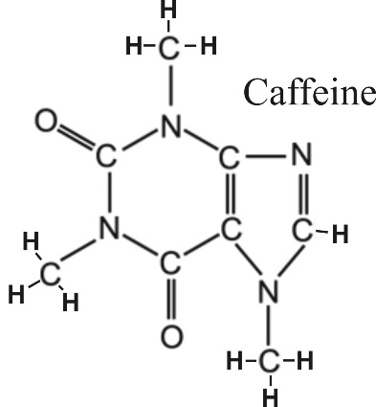
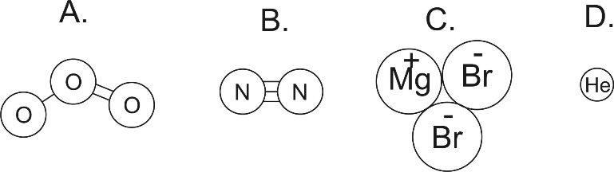
1. How many atoms are shown in the diagrams above?
2. How many elements are shown in the diagrams above?
3. How many ions are shown in the diagrams above?
4. Which item above is a compound?
5. Which items above are molecules?
6. Which item is neither a compound nor a molecule?
7. Write the chemical formula for caffeine (see diagram on the right).

Part 2: Cloud Formation – why and how rising air “is wet.”
The warmth at the ocean’s surface transfers heat to the ocean water, causing the speed of water and air molecules to _____________________ (increase or decrease). Eventually, the water molecules have gained enough energy to _________________________(evaporate or condense). Their state of matter turns from __________________ to _______________, and they leave the ocean to become an invisible part of the warm air near the ocean’s surface.
Another effect of this increasing warmth near the ocean’s surface is that the volume of the air at the Earth’s surface begins to __________________(increase or decrease). This change in volume causes the air’s density to _________________(increase or decrease). This density change causes the air to ____________________ (rise or sink). As it moves upward, this rising mass of air carries heat with it, so it is called a __________________ (conduction, convection, or radiation) current.
As the rising air gets higher, it encounters _________________ (higher or lower) air pressure. This change in air pressure causes the volume of the air to _________________ (expand or shrink). This ____________________ (expansion or compression) of the air causes the temperature of the air to _________________ (increase or decrease). This new change in the temperature of the air causes the speed of the air molecules to _______________ (increase or decrease). The change in molecular motion causes the water molecules to change phase (state) again from _________________ to _______________. When this happens, tiny droplets of water form around specs of dust, creating clouds.

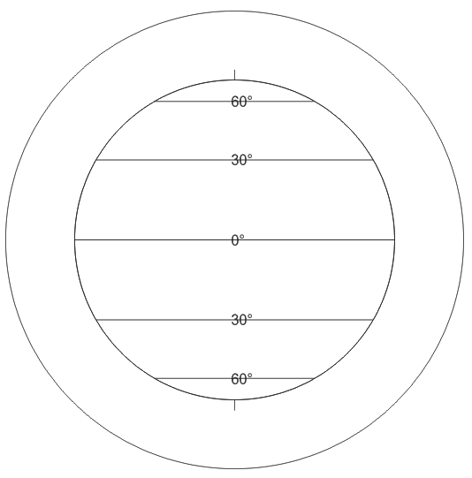
Part 3: Circulation of the Atmosphere

On the diagram to the right….
1. Use arrows to show the circulation of the Earth’s atmosphere. You only have to draw ¼ of the pattern, if you want.
2. Use Hs and Ls to label all of the areas of high and low pressure.
3. Use arrows to draw the prevailing winds.

Part 4: Meteorology Facts
- Sinking air = ________ (high or low) pressure.
- Rising air = ________ (high or low) pressure.
- High pressure air = _________ (dry or wet) conditions.
- Low pressure air = _________ (dry or wet) conditions.
- Rising air = _________ (dry or wet) conditions.
- Sinking air = _________ (dry or wet) conditions.
- Deserts are bigger near ________ (warm or cold) ocean currents.
- Rainforests are bigger near ________ (warm or cold) ocean currents.
- Coastlines are wetter when wind comes from _____ the (ocean or land).
- In the diagram below, wind crosses the mountains. Which side of the mountains is dry because of the rain shadow effect? (west east)

Part 5: Climate Mapping – This is covered on a separate practice test.

