ESS 100 (Stapleton) Name: _______________________________
Test Review: Physical Properties

Part 1: Mass, Volume, Density, and Weight

Match each term to the appropriate description: Volume, Mass, Weight, Density

1. _________________ The force of gravity pulling an object toward a planet.

2. _________________ How compressed or crowded the stuff inside an object is; a ratio of stuff to size.
3. _________________ The amount of space something takes up; how big something is; size

4. _________________ The amount of “stuff” in something.

The objects below are mostly empty space. The circle is the edge of each object. The dots inside represent all of each object’s mass. The empty space inside the objects has no air or mass of any kind. All of the objects are in similar locations on the same planet.
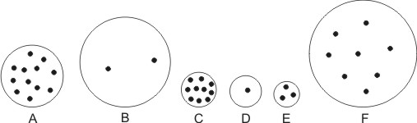
5. Which object has the most mass?

6. Which object has the least mass?

7. Which object has the most volume?

8. Which object has the least volume?

9. Which object is most dense?

10. Which object is least dense?

11. Which object has the most weight?

12. Which object has the least weight?

13-20 For the following questions, tell whether each property increases, decreases, or stays the same. Darken the correct symbol, either +,-, or =.

13-16. A film canister submarine sits on the bottom of a pool. Inside the canister there is Alkaseltzer, water, and pennies. As the Alkaseltzer fizzes, a bubble forms in the top of the canister, and water gets pushed out the bottom. During this process, what is happening to the canister’s overall…

13. mass + - = 14. volume + - =

15. density + - = 16. weight + - =

17-20. Something gets smaller, but the amount of stuff in it does not change. What is happening to its…

17. mass + - = 18. volume + - =

19. density + - = 20. weight + - =
Part 2: Atmospheric Pressure

1. A student is standing in front of the school. Air pressure is pushing against all of the student’s surfaces. What causes the air pressure that we feel when we are standing in front of the school (or anywhere else on the Earth’s surface)?

2. This room has a lot of air in it. Does that air have weight? Circle the answer: Yes No

3. One way to measure air pressure is in psi.

“PSI” stands for _________________ per _________________ ___________________.

4. On Earth, ordinary air pressure at sea level is about _________ psi

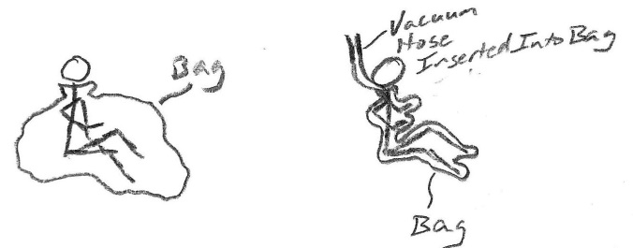
5. The pictures on the right show a student before and after being vacuum packed in a plastic bag. Use arrows to show why the student on the right is being squeezed by the bag, while the student on the left is not.

6. a. If you climb down a mountain, moving from a high altitude to a lower altitude, does the air pressure around you increase or decrease?

b. Explain why.

7. Elevation changes can cause your eardrums to stretch and hurt. When do your eardrums stretch inward, and when do they stretch outward?

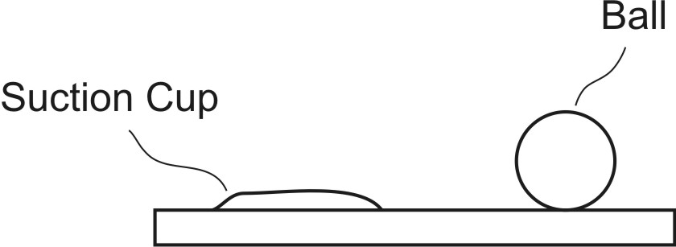

8. The diagram on the right shows a ball sitting on a table, and it also shows a suction cup that is stuck to the table. In the diagram on the right, draw arrows representing air pressure. Use those arrows to show why the suction cup sticks to the table and why the ball does not.

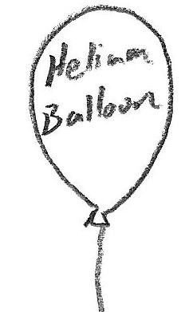
9. Use arrows to show why helium balloon rise. Your arrows should represent the air pressure pushing against the helium balloon in the picture. If you feel like your arrows don’t fully explain why the balloon rises, you can also use words to explain how pressure causes the balloon to rise.

Part 3: Temperature and Pressure
Suppose you have some air trapped in a sealed jar. Air cannot leave the jar, and air cannot enter the jar. The jar is made of glass, so its volume cannot change.

1. If you heat up the jar, what happens to the speed of the air molecules in the jar?
a. They speed up b. They slow down c. No change

2. If you cool down the jar, what happens to the air pressure inside the jar?
a. Air pressure increases b. Air pressure decreases

3. What causes the air pressure to change when the jar cools down?
a. The air molecules push against the jar with more force.
b. The air molecules push against the jar with less force.
c. The air molecules get heavier
d. The air molecules get lighter

Suppose you blow up a balloon and tie it off. No air can leave the balloon, and no air can enter it. What will happen the balloon if you put the balloon in a warm oven and heat up the balloon? Assume that the balloon does not pop. Because it is made of rubber, the balloon can expand and shrink.
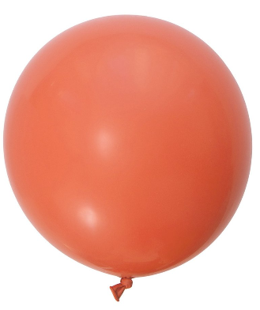
4. What will happen to the pressure inside the balloon when it is in the oven?
a. It will increase b. It will decrease c. It will stay the same

5. What will happen to the overall mass of the balloon while it is in the oven?
a. It will increase b. It will decrease c. It will stay the same

6. What will happen to the overall volume of the balloon?
a. It will increase b. It will decrease c. It will stay the same

7. What will happen to the overall density of the balloon?
a. It will increase b. It will decrease c. It will stay the same

8. Air:
a. moves from areas of higher pressure to areas of lower pressure
b. moves from areas of lower pressure to areas of higher pressure
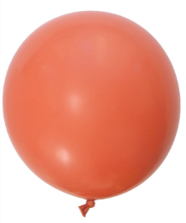
c. does not move because of pressure differences

9. a. Is there stronger air pressure inside the balloon on the right, or is there stronger air pressure outside the balloon?

b. If you were given that balloon, how could you prove that your answer to part A is correct?

Part 4: Measuring and Calculating Density

1. What is the formula for calculating density?

2. What is the formula for calculating the volume of a box?

3. Measure these line segments, to the nearest 0.1 centimeters:

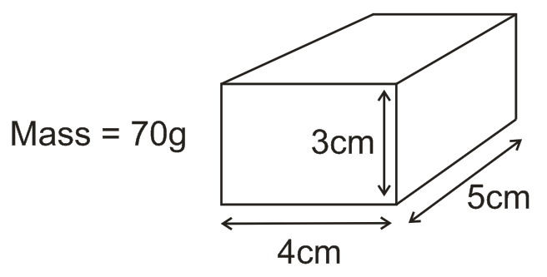
4. What is the volume of the box on the right?

5. What is the density of the box on the right?

6. Water has a density of 1g/cm³. Will that box float in water or sink in water? Explain how you know.

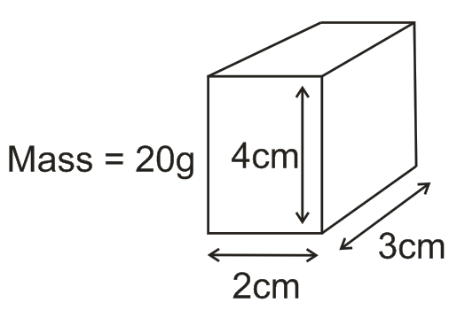

7. What is the density of the box on the right?

9. Water has a density of 1g/cm³. Will that box float in water or sink in water? Explain how you know.

Part 5: Understanding Hot Air Balloons – extended response question

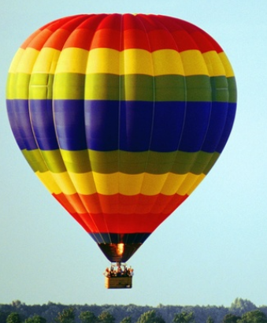
A fully inflated hot air balloon is flying over Essex High School. Suddenly the pilot of the hot air balloon turns on a flame, heating up the balloon. Since the balloon is already fully inflated, it cannot get any bigger.

Why does the hot air balloon rise? In your answer, make sure that you explain what is happening to the balloon’s mass, volume, density, and weight. For each property, explain why it is changing in that way (or why it is not changing). For full credit, you must explain the role of the motion of air particles inside the balloon.

