ESS 100 Name: _______________________________
Physical Properties Practice Quiz: Pressure

1. A student is standing in front of the school. Air pressure is pushing against all of the student’s surfaces. What causes the air pressure that we feel when we are standing in front of the school (or anywhere else on the Earth’s surface)?

2. This room has a lot of air in it. Does that air have weight? Circle the answer: Yes No

3. One way to measure air pressure is in psi.

“PSI” stands for _________________ per _________________ ___________________.

4. On Earth, ordinary air pressure at sea level is about. Circle the answer: 5psi 10psi 15psi 20psi

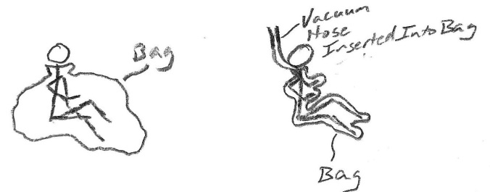
5. The pictures on the right show a student before and after being vacuum packed in a plastic bag. Use arrows to show why the student on the right is being squeezed by the bag, while the student on the left is not.

6. a. Is air pressure stronger at lower altitudes or at higher altitudes?

b. Why?

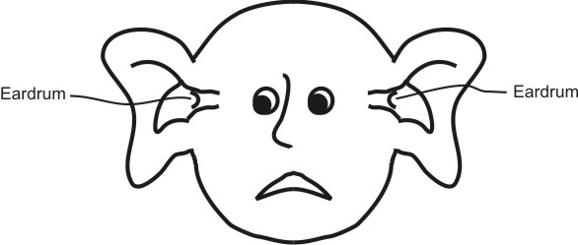

7. The person on the right is experiencing ear pain. According to the diagram, has the person just moved to a higher altitude or to a lower altitude?
Circle the answer: Higher Altitude Lower Altitude

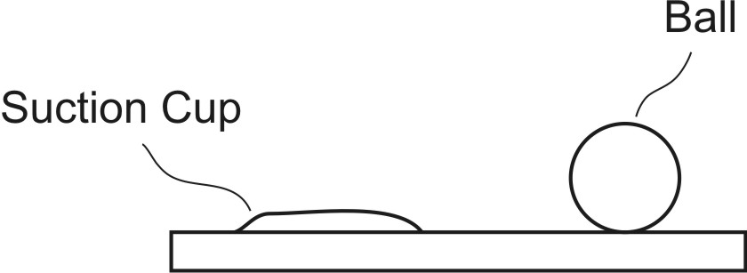

8. The diagram on the right shows a ball sitting on a table, and it also shows a suction cup that is stuck to the table. In the diagram on the right, draw arrows representing air pressure. Use those arrows to show why the suction cup sticks to the table and why the ball does not.

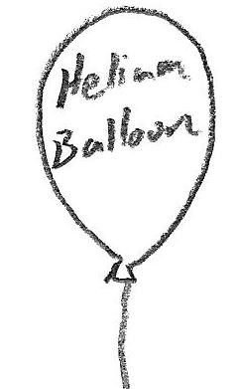
9. Use arrows to show the air pressure pushing against the helium balloon in the picture. Make sure that your arrows show why the balloon rises. If you need them, you can also use words to explain how pressure causes the balloon to rise.

