ESS 100 Name: ____________________________________________
Quiz 3 Practice: Plate Tectonics

Place a check (or an X) next to each of the true statements for each type of plate boundary (or hotspot)

1. Which statements are true about a Continent/Continent Convergent Plate Boundary?

a. ____ Relatively gentle eruptions may occur.
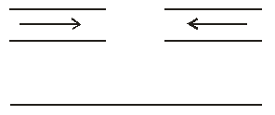
b. ____ Very violent eruptions may occur.
c. ____ Rounded, shield volcanoes exist here.
d. ____ Steep composite cone volcanoes exist here.
e. ____ Situated over a hotter part of the mantle
f. ____ Shallow-focus earthquakes may occur.
g. ____ New ocean crust is being created here.
h. ____ There is an ocean trench.
i. ____ There are tall mountains but no volcanoes.
j. ____ There is a subduction zone.

2. Which statements are true about an Ocean Hotspot?
a. ____ Relatively gentle eruptions may occur.
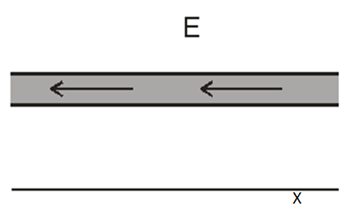
b. ____ Very violent eruptions may occur.
Hotspot
c. ____ Rounded, shield volcanoes exist here.
d. ____ Steep composite cone volcanoes exist here.
e. ____ Situated over a hotter part of the mantle
f. ____ Shallow-focus earthquakes may occur.
g. ____ Deep-focus earthquakes may occur.
h. ____ There is an ocean trench.
i. ____ There are tall mountains but no volcanoes.
j. ____ There is a subduction zone.

3. Which statements are true about an Ocean/Ocean Convergent Plate Boundary?
a. ____ Relatively gentle eruptions may occur.
b. ____ Very violent eruptions may occur.
c. ____ Rounded, shield volcanoes exist here.
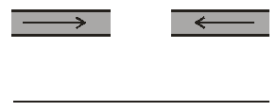
d. ____ Steep composite cone volcanoes exist here.
e. ____ Situated over a hotter part of the mantle
f. ____ Shallow-focus earthquakes may occur.
g. ____ Deep-focus earthquakes may occur.
h. ____ New ocean crust is being created here.
i. ____ There is an ocean trench.
j. ____ There are tall mountains but no volcanoes.
k. ____ There is a subduction zone.

4. Which statements are true about a Continent/Continent Divergent Plate Boundary?

a. ____ Relatively gentle eruptions may occur.
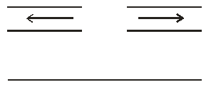
b. ____ Situated over a hotter part of the mantle
c. ____ Shallow-focus earthquakes may occur.
d. ____ Deep-focus earthquakes may occur.
e. ____ New ocean crust is being created here.
f. ____ There is an ocean trench.
g. ____ There are tall mountains but no volcanoes.
h. ____ There is a subduction zone.

5. Which statements are true about a Continent/Ocean Convergent Plate Boundary?

a. ____ Relatively gentle eruptions may occur.
b. ____ Very violent eruptions may occur.
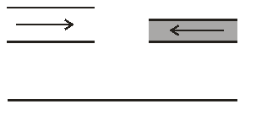
c. ____ Rounded, shield volcanoes exist here.
d. ____ Steep composite cone volcanoes exist here.
e. ____ Situated over a hotter part of the mantle
f. ____ Shallow-focus earthquakes may occur.
g. ____ Deep-focus earthquakes may occur.
h. ____ New ocean crust is being created here.
i. ____ There is an ocean trench.
j. ____ There are tall mountains but no volcanoes.
k. ____ There is a subduction zone.

6. Which statements are true about a Transform Plate Boundary?

a. ____ Rounded, shield volcanoes exist here.
b. ____ Steep composite cone volcanoes exist here.
c. ____ Situated over a hotter part of the mantle
d. ____ Shallow-focus earthquakes may occur.
e. ____ Deep-focus earthquakes may occur.
f. ____ New ocean crust is being created here.
g. ____ There is an ocean trench.
h. ____ There are tall mountains but no volcanoes.
i. ____ There is a subduction zone.

7. Which statements are true about an Ocean/Ocean Divergent Plate Boundary?

a. ____ Relatively gentle eruptions may occur.
b. ____ Very violent eruptions may occur.
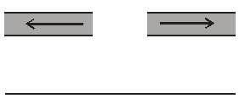
c. ____ Rounded, shield volcanoes exist here.
d. ____ Steep composite cone volcanoes exist here.
e. ____ Situated over a hotter part of the mantle
f. ____ Shallow-focus earthquakes may occur.
g. ____ Deep-focus earthquakes may occur.
h. ____ New ocean crust is being created here.
i. ____ There is an ocean trench.
j. ____ There are tall mountains but no volcanoes.
k. ____ There is a subduction zone.

