ESS 100 Name: _____________________________________

Plate Tectonics Practice Test

The following questions refer to the diagram on the right.



1. Which layer has convection currents that cause the Earth’s plates to move?

A B C D E

2. Which layer is the upper mantle?

A B C D E

3. Which layer is the lithosphere?

A B C D E

4. Which layer is most dense?

A B C D E

5. Which layer contains mostly liquid iron?

A B D E

6. Why is the inside of the Earth hot? Provide two reasosn.

The diagram below shows several plates that are floating on the Earth’s surface. The gap between each plate represents a plate boundary. Material flowing below the Earth’s surface cannot pass beneath the bottom line. Sketch the plate and mantle movements and then answer the questions.

7. In which direction is the plate moving at position 7? ↑ ↓ ← →

8. What type of plate boundary exists at position 8? a. convergent b. divergent c. transform

9. In which direction is the plate moving at position 9? ↑ ↓ ← →

10. What type of plate boundary exists at position 10? a. convergent b. divergent c. transform

11. In which direction is the earth material flowing at position 11? ↑ ↓ ← →

12. In which direction is the earth material flowing at position 12? ↑ ↓ ← →



13. The diagram on the right shows chunks of two types of crust. One represents continental crust, and the other represents ocean crust. Label them correctly.

Match each description to the appropriate type of crust. Choices: **A= Continental Crust B = Ocean Crust**

14. A B Darker in color/shade

15. A B Seafloor sediment contains a lot of this type of material.

16. A B Melts to become low viscosity (runny) lava.

17 A B Lava of this type does not pile up. It forms low, rounded volcanoes.

18. A B An example of this rock type is called basalt.

19. A B The most explosive volcanoes have some of this type of lava.

20. A B This type of lava can pile up to form steep volcanoes.

21. A B This is the least dense type of crust.

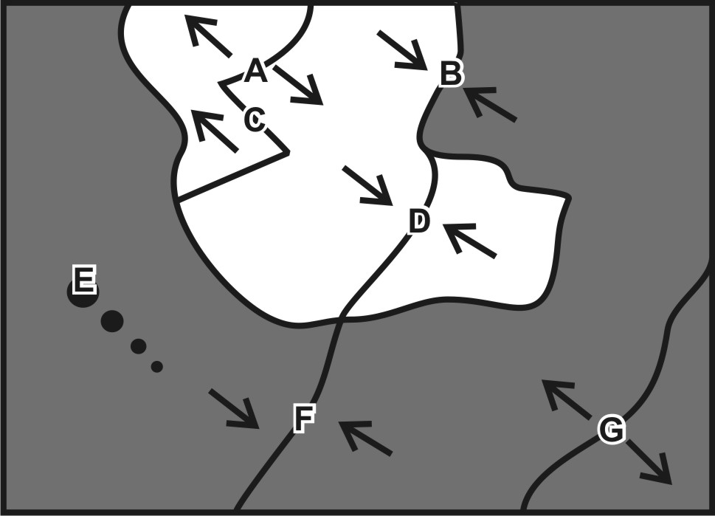Match each feature name to the corresponding feature on the plate map on the right. You can also refer to the incomplete plate drawings on page 3.

22. A B C D E F G Ocean/Ocean Divergent

23. A B C D E F G Ocean/Ocean Convergent

24. A B C D E F G Continent/Continent Convergent

25. A B C D E F G Continent/Continent Divergent

26. A B C D E F G Ocean/Continent Convergent

27. A B C D E F G Hotspot

28. A B C D E F G Transform Boundary

Each of the real-world locations below forms in an area that is similar to one of the lettered locations on the map. Match each real-world location to its corresponding map location.

29. A B C D E F G Hawaii

30. A B C D E F G East Africa

31. A B C D E F G Japan

32. A B C D E F G Mid-Atlantic Ridge

33. A B C D E F G Himalayas (Mt. Everest)

34. A B C D E F G Andes Mountains (South America)

35. A B C D E F G San Andreas Fault, California

The unfinished plate drawings at the bottom of this page match the features on the map from part 1 of this test. They are provided to help you think about these questions. Following each diagram, there is a set of true/false questions about the plate feature. *There is no provided diagram for letter C*. Before completing the questions below, quickly complete the diagrams by sketching the landforms that will be created. Properly shade the materials. Then use your knowledge and sketches to answer the questions. There will only be one correct answer for each question.

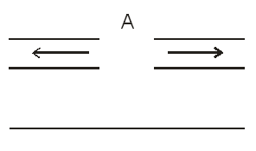36.

a. T F Relatively gentle eruptions may occur.

b. T F Relatively violent eruptions may occur.

c. T F Rounded, shield volcanoes exist here.

d. T F Steep, composite cone volcanoes exist here.

e. T F Situated over a **hotter** part of the mantle

f. T F Shallow-focus earthquakes may occur.

g. T F Deep-focus earthquakes may occur.

h. T F New ocean crust is being created here.

i. T F is an ocean trench.

j. T F There are tall mountains but no volcanoes.

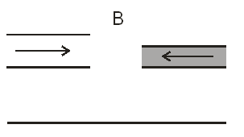37

a. T F Relatively gentle eruptions may occur.

b. T F Relatively violent eruptions may occur.

c. T F Rounded, shield volcanoes exist here.

d. T F Steep, composite cone volcanoes exist here.

e. T F Situated over a **hotter** part of the mantle

f. T F Shallow-focus earthquakes may occur.

g. T F Deep-focus earthquakes may occur.

h. T F New ocean crust is being created here.

i. T F is an ocean trench.

j. T F There are tall mountains but no volcanoes.

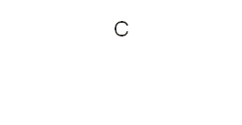38

a. T F Relatively gentle eruptions may occur.

b. T F Relatively violent eruptions may occur.

c. T F Rounded, shield volcanoes exist here.

d. T F Steep, composite cone volcanoes exist here.

e. T F Situated over a **hotter** part of the mantle

f. T F Shallow-focus earthquakes may occur.

g. T F Deep-focus earthquakes may occur.

h. T F New ocean crust is being created here.

i. T F is an ocean trench.

j. T F There are tall mountains but no volcanoes.

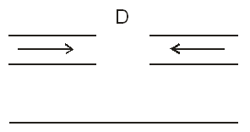39.

a. T F Relatively gentle eruptions may occur.

b. T F Relatively violent eruptions may occur.

c. T F Rounded, shield volcanoes exist here.

d. T F Steep, composite cone volcanoes exist here.

e. T F Situated over a **hotter** part of the mantle

f. T F Shallow-focus earthquakes may occur.

g. T F Deep-focus earthquakes may occur.

h. T F New ocean crust is being created here.

i. T F is an ocean trench.

j. T F There are tall mountains but no volcanoes.

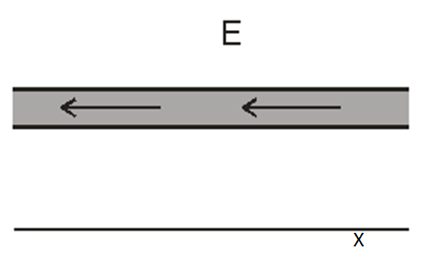40.

a. T F Relatively gentle eruptions may occur.

b. T F Relatively violent eruptions may occur.

c. T F Rounded, shield volcanoes exist here.

d. T F Steep, composite cone volcanoes exist here.

e. T F Situated over a **hotter** part of the mantle

f. T F Shallow-focus earthquakes may occur.

g. T F Deep-focus earthquakes may occur.

h. T F New ocean crust is being created here.

i. T F is an ocean trench.

j. T F There are tall mountains but no volcanoes.

41.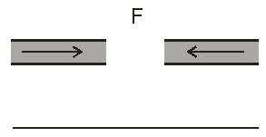

a. T F Relatively gentle eruptions may occur.

b. T F Relatively violent eruptions may occur.

c. T F Rounded, shield volcanoes exist here.

d. T F Steep, composite cone volcanoes exist here.

e. T F Situated over a **hotter** part of the mantle

f. T F Shallow-focus earthquakes may occur.

g. T F Deep-focus earthquakes may occur.

h. T F New ocean crust is being created here.

i. T F is an ocean trench.

j. T F There are tall mountains but no volcanoes.

42.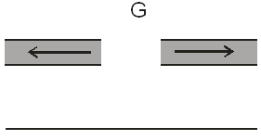

a. T F Relatively gentle eruptions may occur.

b. T F Relatively violent eruptions may occur.

c. T F Rounded, shield volcanoes exist here.

d. T F Steep, composite cone volcanoes exist here.

e. T F Situated over a **hotter** part of the mantle

f. T F Shallow-focus earthquakes may occur.

g. T F Deep-focus earthquakes may occur.

h. T F New ocean crust is being created here.

i. T F is an ocean trench.

j. T F There are tall mountains but no volcanoes.