ESS 100 (Stapleton) Name: ___________________________
Star Life Cycles Review
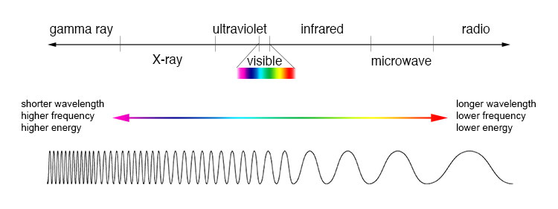
1. What is the general name that includes gamma rays, x-rays, ultraviolet, visible light, infrared, microwaves, and radio waves?

2. a. Draw and label two waves, one with a longer wavelength, and one with a shorter wavelength.

b. Which waves have more energy, those with short wavelengths or those with long wavelengths?

3. List the colors of the visible spectrum from longest wavelength to shortest wavelength.

4. Rank these star colors from hottest to coolest. Orange, Red, Yellow, Blue, White

5. Stars get their energy from a process called ____________________________________. Most of the time,

during this process, the element ______________________________ gets squeezed together to turn into

the element ______________________________

6. Draw a picture showing where these two elements (from the previous question) are located in the sun.

7. What is the heaviest element that can be created inside a star?

8. Right now, our sun is a main sequence star. What is a main sequence star?

9. In the next stage of our sun’s life (about 5 billion years from now),

its size will _________________________ (increase or decrease) and its

surface temperature will _______________________ (increase or decrease). In this new stage, it will be

called a _________________________. After that, the sun’s size its size

will _________________________ (increase or decrease) and its

surface temperature will _______________________ (increase or decrease). At that point it will be

called a ____________________________________.

10. The early universe was about 75% hydrogen and 25% helium. Where did the rest of the elements come from?

a. Where did the lighter elements come from (up to the mass of iron)?

b. Where did the heavier elements (heavier than iron) originate?

11. “One solar mass” is _________________________________________________________________

12. In order for a star to die as a supernova, the star’s mass needs to be at least _____________ solar masses.

13. After a supernova, the material left over from a very large star can have three different fates. One fate is that it can turn into a neutron star. What are two other possible fates of a star after a supernova explosion?

2)

Use the Hertzsprung-Russel diagram (H-R diagram) below to answer the following questions. Mark the correct letter as indicated on the chart. The boxes represent stars

EE
High

B

Brightness
A
(brightness units)

D

C

Low

High Low
Temperature (º C)

14. What is the name of this type of diagram?

15. Which of the lettered stars are main sequence stars?

16. Which star is the brightest?

17. Which star would be considered a red giant?

18. What star is most likely to be a white dwarf?

19. Which star has the hottest surface temperature?

20. Which letter could represent the present day Sun?

21. Which star is most likely to be blue?

22. What is the Big Bang?

23. How old is the Universe?

24. Which way is the star moving in the diagram below? How can you tell?

25. Which person in the diagram sees a red shift?

26. One piece of evidence for the Big Bang is that all other galaxies have red shifts. Explain how this provides evidence for the Big Bang.

27. Briefly describe one more piece of evidence suggesting that the Big Bang occurred.

