ESS 100 (Stapleton) Name: ___________________________
Notes: Greenhouse Effect and Solar Oven Notes

1. Use the diagram to explain how greenhouse gases warm up the Earth.
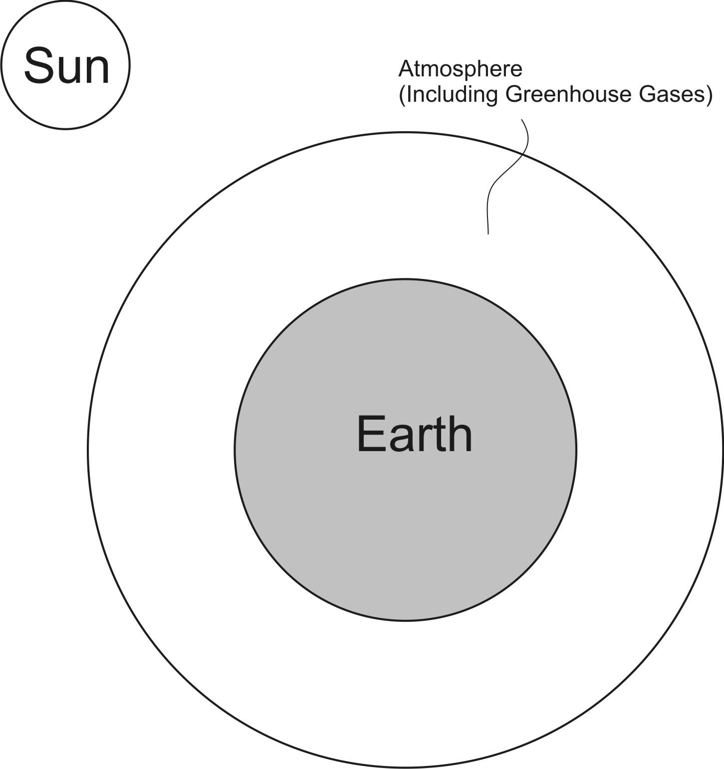

2. List the top 4 greenhouse gases that are causing global warming, and tell where each comes from.

1.

2.

3.

4.
3. Explain how a solar oven uses the greenhouse effect to cook food.

4. “A solar oven is powered by nuclear fusion.” Explain how this statement makes sense.

