ESS 100 Name: ________________________
Physical Properties: Temperature’s Relation to Volume and Pressure

Kinetic Molecular Theory: a way of understanding physical properties of matter by thinking about the motions of tiny, individual particles. This is the theory we will be using and exploring on this handout.

Temperature: the average kinetic energy of the molecules or atoms in a substance

Kinetic Energy: Energy of motion; think of it as the energy required to set something in motion at a given speed

Kinetic Energy Formula: KE = ½ mv² [m = mass, v = velocity]

States of Matter (a.k.a. phases of matter):
- Solid phase: Molecules (or individual atoms)are locked in place, touching one another, vibrating. Hotter solids vibrate more violently.
- Liquid phase: Molecules are touching one another, but sliding and bumping around and changing positions; flowing. Hotter liquid molecules slide and bump around faster.
- Gas phase: Molecules flying free, but occasionally bumping into one another. Hotter gas molecules fly faster.

Open the PhET States of Matter Simulation: Choose solid, and click on any substance other than water.

1. Heat up the substance and describe what happens to the motion of the particles.

2. Cool down the substance and describe what happens to the motion of the particles.

3. Reset. Select either Neon, Argon, or Oxygen. Heat up the substance. When you heat it up, what happens to its overall…

 | What happens? | How can you tell?
Mass

Volume

Density

Weight

4. Switch the simulation mode to “states of matter.” What happens to the pressure inside the container…

a. Heat up the substance and describe what happens to the pressure.

b. Cool down the substance and describe what happens to the pressure.
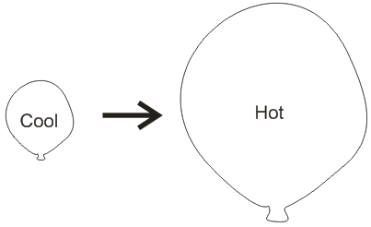

c. What do you think is causing the pressure inside the container?

5. Suppose you inflate a balloon with air and tie off the balloon. As you heat the balloon, what happens to the balloon’s…

 | What happens? | How can you tell?
Mass

Volume

Density

Weight

Pressure

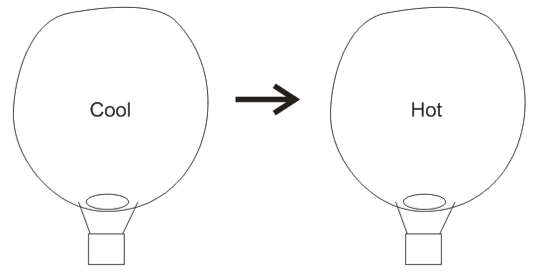

6. A balloon has a hole in the bottom. A flame heats the balloon, and then the flame shuts off, leaving the balloon hotter than before. Compared to when it was cooler, what has happened to the balloon’s…

 | What happens? | How can you tell?
Mass

Volume

Density

Weight

Pressure

