ESS 100 Name: ____________________________
Hot air Balloon Preparation:
Calculating Densities of Boxes

1. What is the meaning of the graphic above?

2. What is the formula for calculating the volume of a box?

3. Calculate the volumes and densities of the boxes below.

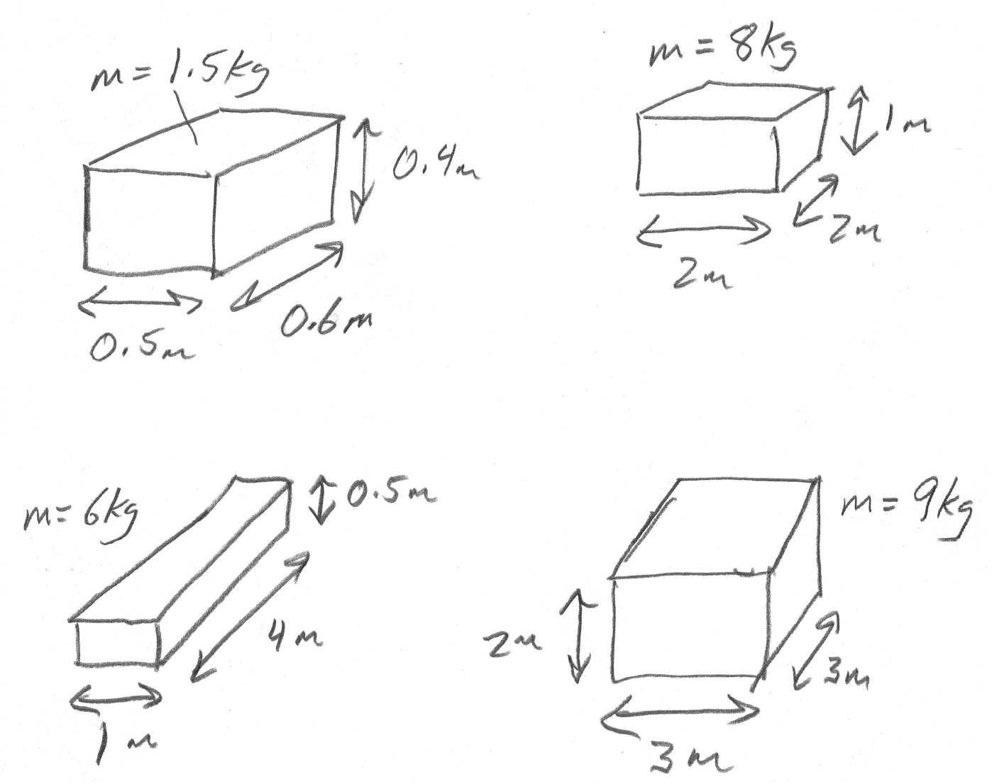

Measuring Lengths:

4. A _____________________________________________ is approximately 1centimeter.

5. A ______________________________________________ is approximately 1 inch.

6. Measure these line segments, in centimeters:

7. Practice Problem – to prepare you for hot air balloon practice, below: Suppose you have a box with sides of lengths 5cm, 8cm, and 10cm. The mass of the box is 2.5g. What are its volume, mass, and density?

Volume = _______ Mass = _________ Density = ____________

8. Hot Air Balloon Practice – Designing a Low Density Box
Using tape, scissors, and no more than 1 sheet of standard copier paper (8.5”x11”), construct an enclosed box with the lowest possible density. Think of this as practice for making a hot air balloon. A lower density balloon will fly better. This box can be any shape, as long as it has 6 sides that are all rectangles.

A) Build your box. You can use as much or as little tape as you want, but the box must support itself, and all of the its edges must more-or-less match up.

B) Determine your box’s mass, using the balance. Mass = __________ g

C) Measure your box’s 3 dimensions:

Length = ________ Width = __________ Height = ________

D) Calculate your box’s volume. Volume = _________ cm³

E) Calculate your box’s density.

Density = _________g/cm³

9. Based on your classmates’ box densities, what shape and size should a box have in order to have the lowest possible density?

