ESS 100 (Stapleton) Name: ___________________________
Star Lifetimes Part 1
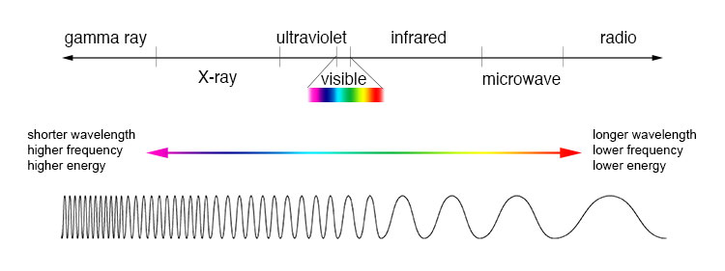
1. What is the general name that includes gamma rays, x-rays, ultraviolet, visible light, infrared, microwaves, and radio waves?

2. a. Draw and label two waves, one with a longer wavelength, and one with a shorter wavelength.

b. Which waves have the most energy? [Hint: think of the waves as ropes that are being shaken.]

3. List the colors of the visible spectrum from longest wavelength to shortest wavelength.

4. Rank these star colors from hottest to coolest. Orange, Red, Yellow, Blue, White

5. a. Which stars are the hottest, larger stars or smaller stars?

b. Why?

c. What color are they?

6. Stars get their energy from a process called ____________________________________. Most of the time,

during this process, ____________________________ are squeezed together to make

___________________________ . In this process, the new atoms that are created

have _______________ (more or less) mass than the atoms that fused.

Energy is created from this ___________________ (lost or gained) mass being turned to energy. The

amount of energy that is produced can be calculated using the formula _______________________.

In this formula, ____ = ____________, ______ = _______________, and ____ = _______________________

7. a. When elements fuse in a star, lighter elements fuse to become heavier elements. Where do these heavier elements go?

b. Why?

8. a. Bigger stars can fuse more “fuels” than our sun. Why?

b. What is the heaviest element that can be created by fusion in a very large star?

9. a. At some point, our sun will run out of hydrogen that it can fuse. When this happens, the

next fuel that will fuse is ________________________

b. At this point, the sun will expand, and its color will shift to ______________________ because the surface will be cooler than before. At this point, the sun will be called a

___________________ _____________________

10. a. After all nuclear fusion ceases in our sun, it will ___________ (expand or shrink).

b. This change in size will cause the sun’s temperature to _______________.

c. This change in temperature will cause its color to change from _____________ to

___________.

- At this point, the sun will be called a _____________ _______________.

11. The early universe was about 75% hydrogen and 25% helium. Where did the rest of the elements come from?

a. Where did the lighter elements come from (up to the mass of iron)?

b. Where did the heavier elements (heavier than iron) originate?

12. “One solar mass” is _________________________________________________________________

13. In order for a star to die as a supernova, the star’s mass needs to be at least _____________ solar masses.

14. Just before a star dies as a supernova, what element can be found at the star’s core? ___________________

15. After a supernova, the material left over from a very large star can have three different fates:

- If the leftover material is between 1 and 3 solar masses, it can become a:

- If the leftover material is over 3 solar masses, it can become a:

