ESS 100 (Stapleton) Name: _______________________________
Plate Tectonics, Part 2
Goals:
- Compare and contrast the materials in ocean crust, continental crust, seafloor sediment, and the mantle.
- Describe the motions and plates involved at a variety of types of plate boundaries and hotspots.
- Match real-world locations to the various types of plate boundaries and hotspots.
- Know the characteristics and features associated with each type of plate boundary and hotspot.
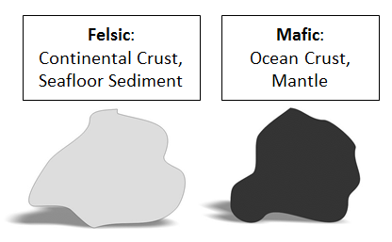
Continental Crust:
- Classified as Felsic
- Light in color
- Not dense
- High Viscosity (gooey) when turned to magma
  - Builds up pressure and makes volcanoes more explosive
  - Piles up, so it makes volcanoes steeper
- Example Rock -- Granite
Ocean Crust (similar to mantle):
- Classified as Mafic
- Dark in color
- Dense
- Low Viscosity (runny) when turned to magma
  - Does not build up high pressure, so it roduces gentler eruptions
  - Does not pile up, so volcanoes are lower and rounder
- Example Rock -- Basalt
Mantle (similar to ocean crust):
- Classified as Mafic
- Dark in color
- Very Dense
- Low Viscosity (runny) when turned to magma
- When mantle material melts and solidifies, it turns into ocean crust.
Seafloor Sediment:
- Classified as Felsic
- Similar to Continental Crust
- Thicker over older ocean crust. Thinner over younger ocean crust.
- Contains water; when it turns to magma, water in seafloor sediment turns into steam. The steam produces pressure and can cause explosive eruptions.
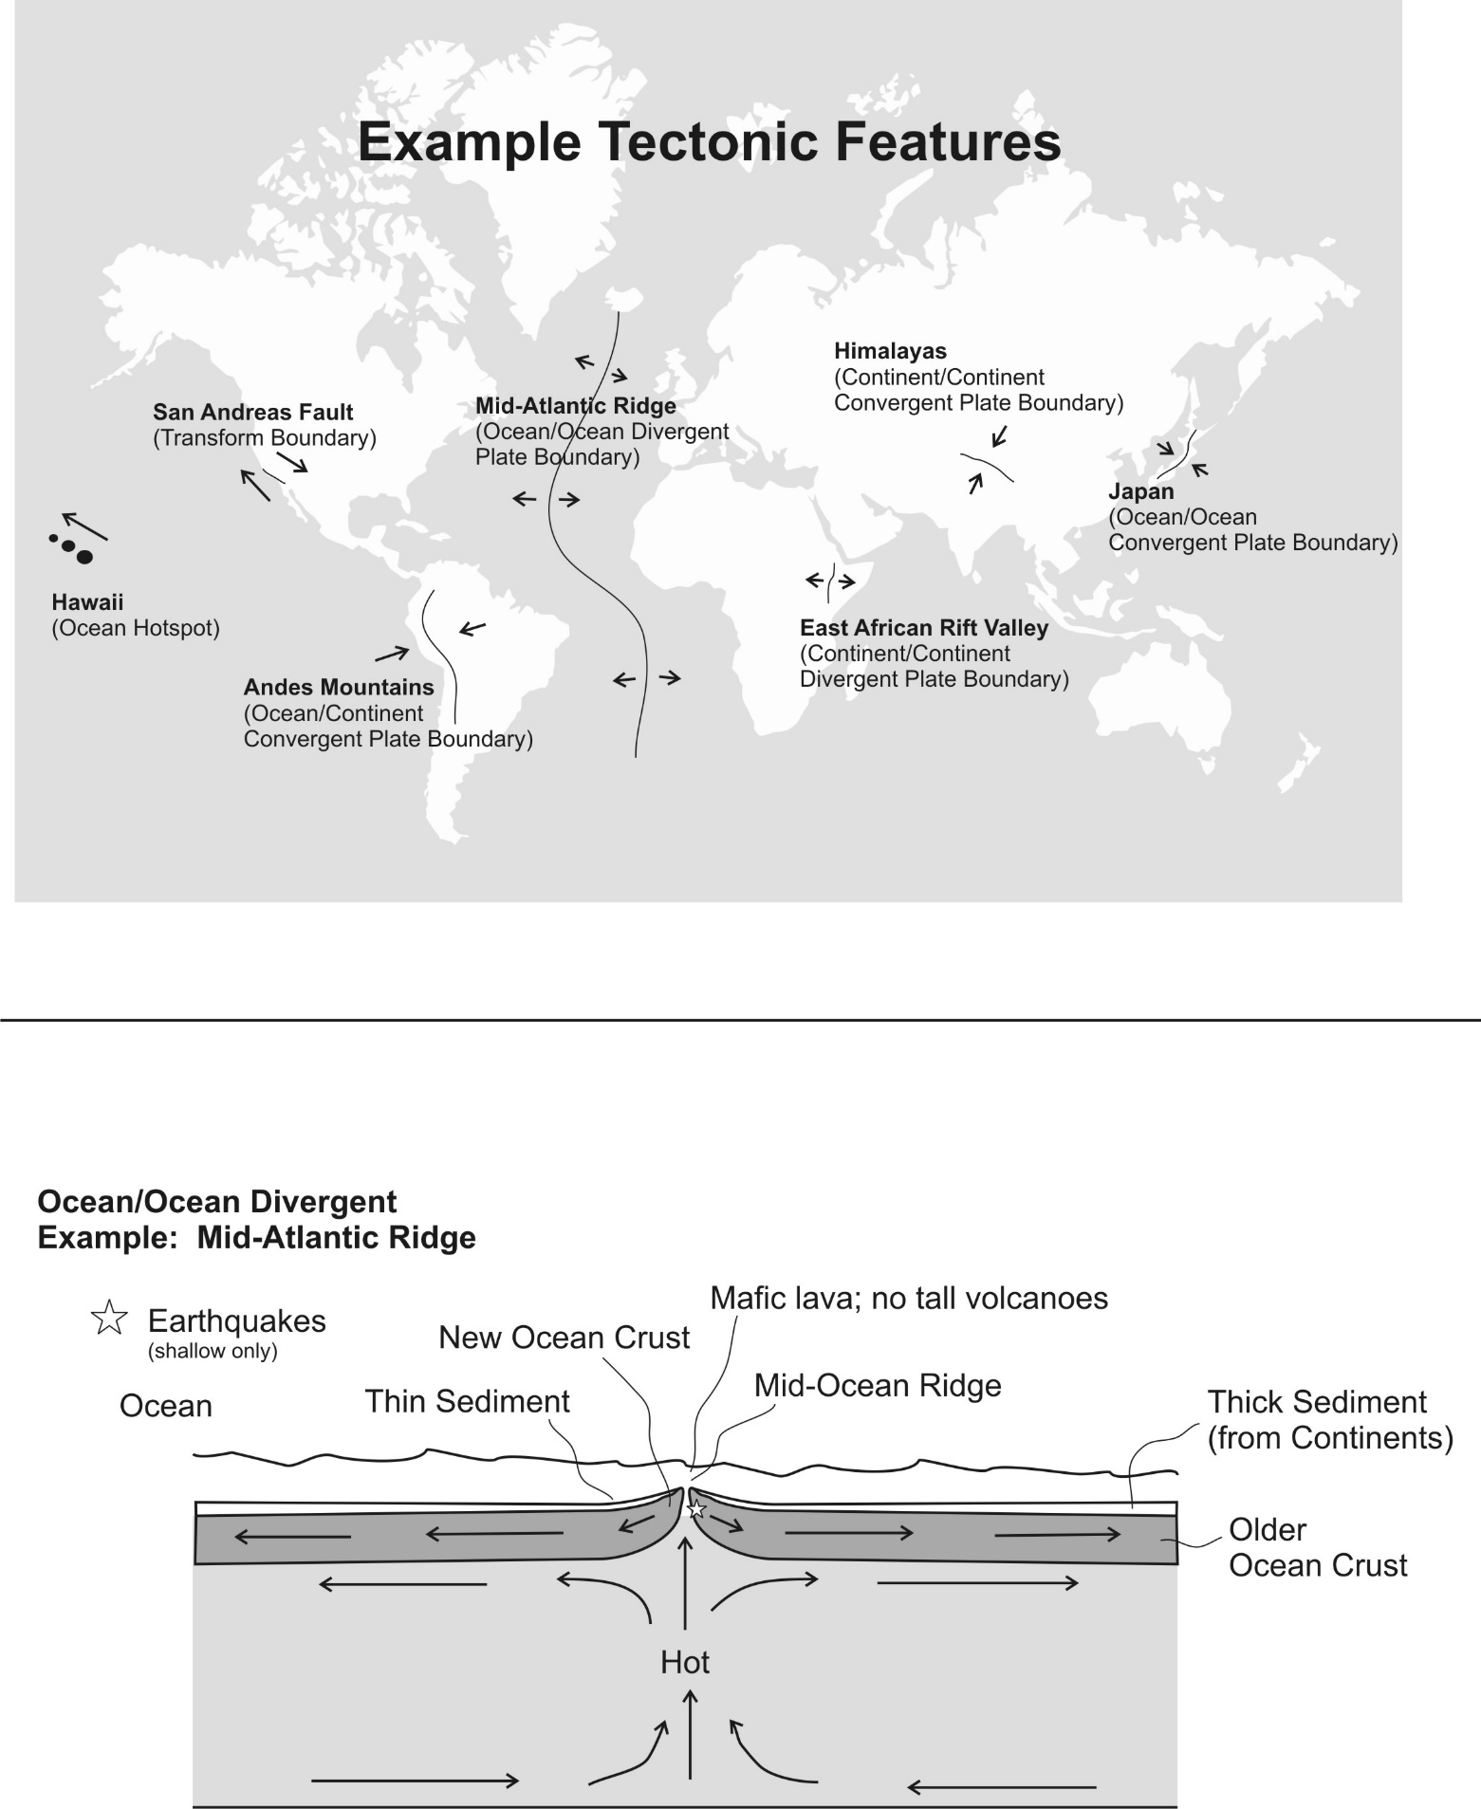
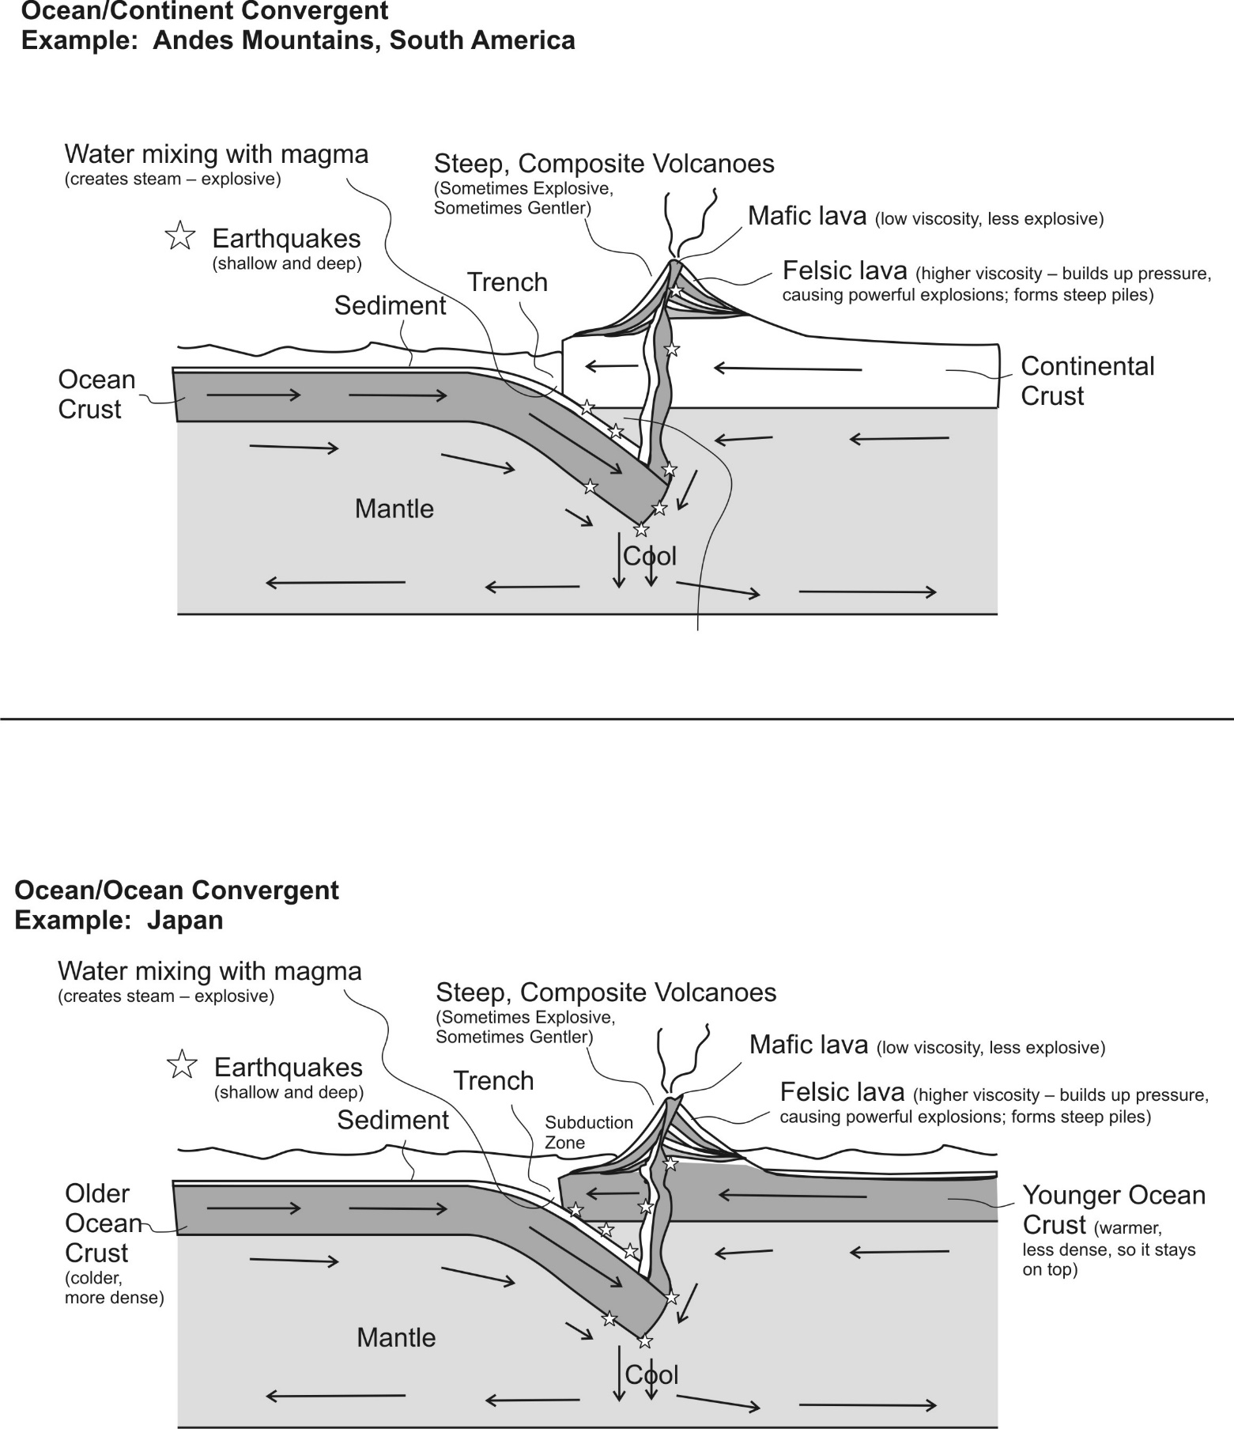
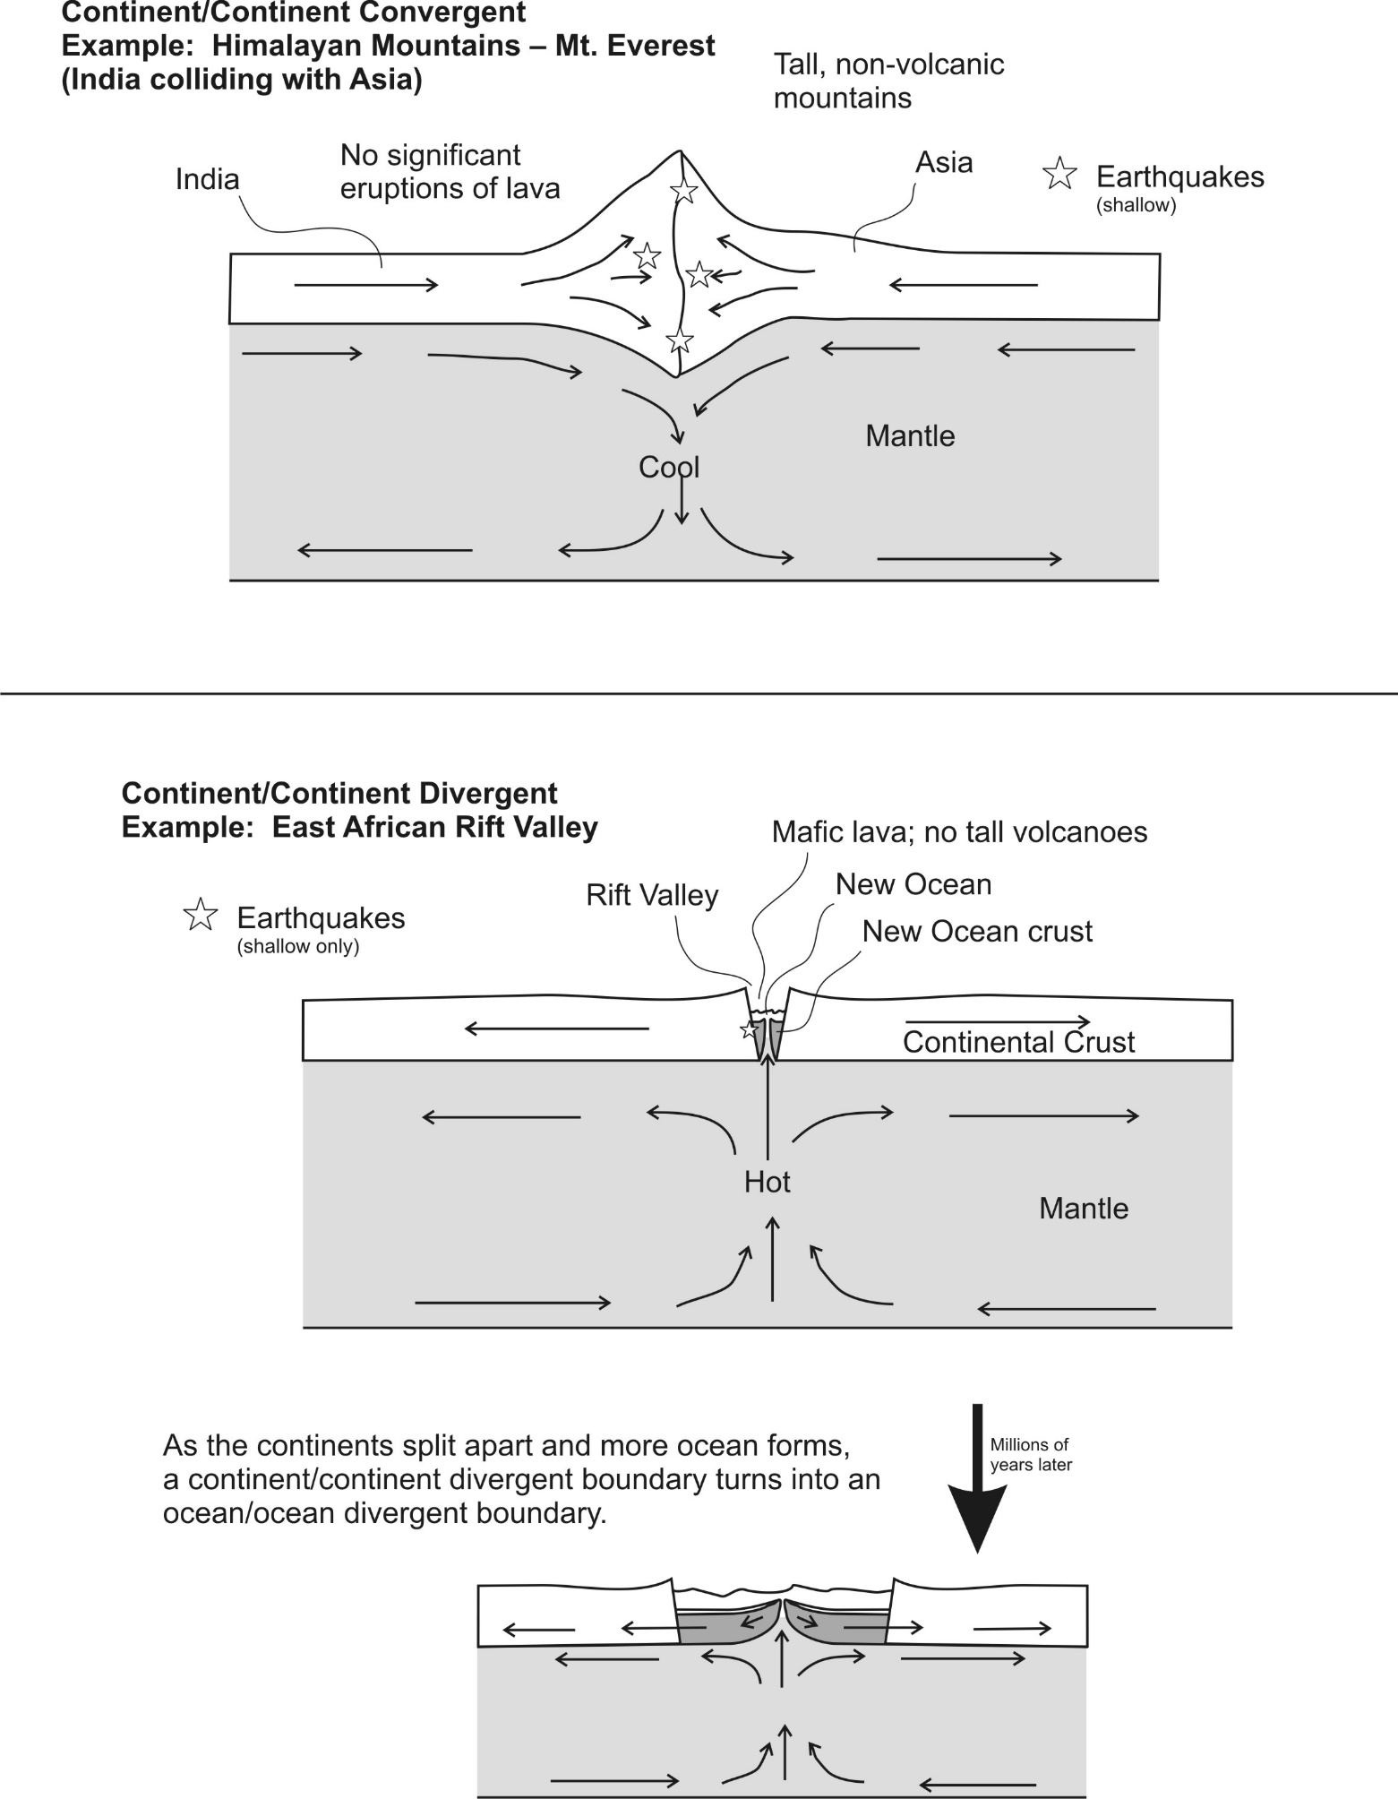

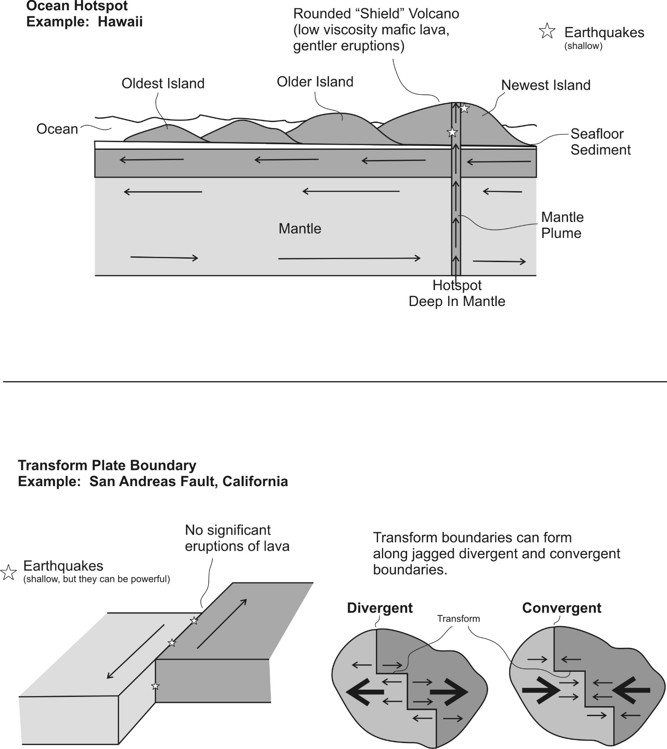

Practice
PLEASE DARKEN THE CORRECT ANSWER CHOICES.

Match each description to the appropriate crust type. Choices: A= Continental Crust B = Ocean Crust

1. A B Relatively light in color/shade
2. A B Relatively high viscosity (runny) when molten
3. A B Similar to the material in the mantle
4. A B The most explosive volcanoes have this type of rock.
5. A B When this type of lava creates volcanoes, those volcanoes are steep.
6. A B An example of this rock type is called basalt.
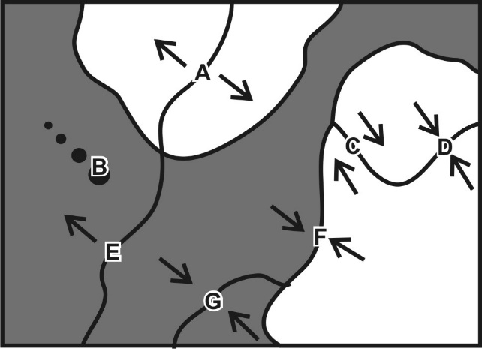
Match each feature name to the corresponding feature on the plate map on the right.

7. A B C D E F G Ocean/Continent Convergent
8. A B C D E F G Transform Boundary
9. A B C D E F G Continent/Continent Convergent
10. A B C D E F G Hotspot
11. A B C D E F G Ocean/Ocean Divergent
12. A B C D E F G Ocean/Ocean Convergent
13. A B C D E F G Continent/Continent Divergent

Each of the real-world locations below forms in an area that is similar to one of the lettered locations on the map. Match each real-world location to its corresponding map location.

14. A B C D E F G Mid-Atlantic Ridge
15. A B C D E F G San Andreas Fault, California
16. A B C D E F G East Africa
17. A B C D E F G Andes Mountains (South America)
18. A B C D E F G Himalayas (Mt. Everest)
19. A B C D E F G Japan
20. A B C D E F G Hawaii

For each lettered feature on the map above, darken all of the descriptions below that apply. [Suggestion: start with letter A. Darken that letter for all of the descriptions that apply to location A on the map. Continue the process one map feature at a time.]

15. A B C D E F G Steep, composite cone volcanoes
16. A B C D E F G Relatively violent eruptions of lava can occur.
17. A B C D E F G Relatively gentle eruptions of lava can occur.
18. A B C D E F G Shallow earthquakes (in lithosphere – crust)
19. A B C D E F G Deep earthquakes (in mantle)
20. A B C D E F G Situated over a relatively cool part of the mantle
21. A B C D E F G New ocean crust is being created here.
22. A B C D E F G Situated over a relatively hot part of the mantle
27. A B C D E F G Tall mountains that are not volcanoes
23. A B C D E F G Rounded, shield volcanoes

