ESS 100 Name: ________________________________
System of the Earth, Moon, and Sun
Practice Test #1

Matching Moon Phase Terms. Some terms are used more than once:
A. Waxing B. Waning C. Crescent D. Gibbous E. Quarter F. New G. Full

1. _____ A moon phase that appears to be half light and half dark.
2. _____ A moon phase that is a completely-lit, bright circle.
3. _____ This describes any moon phase that is in the process of growing (the lighted part is getting bigger).
4. _____ A moon that is completely dark (the shaded side is facing Earth).
5. _____ This describes any moon phase that is in the process of shrinking (the lighted part is getting smaller).
6. _____ A moon that is mostly lighted, with a curved slice of darkness on one side.
7. _____ A moon that is mostly dark, but with a curved, lighted slice on one side.
8. _____ In the Northern Hemisphere, this describes any moon that is lit only on the left side.
9. _____ In the Northern Hemisphere, this describes any moon that is lit only on the right side.

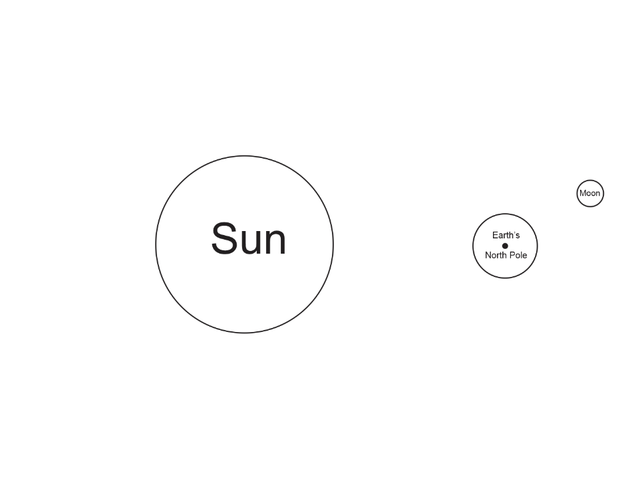
10. On the diagram to the right, use labeled arrows to demonstrate each of the following:
- Earth’s rotation
- Earth’s revolution
- The Moon’s rotation
- The Moon’s revolution

Causes of phenomena:
11. What causes the time of day to change (from morning to afternoon to night…?
a. Moon’s rotation b. Moon’s revolution
c. Earth’s rotation d. Earth’s revolution

12. What causes the Moon’s phase to change?
a. Moon’s rotation b. Moon’s revolution c. Earth’s rotation d. Earth’s revolution

13. What causes our seasons to change?
a. Moon’s rotation b. Moon’s revolution c. Earth’s rotation d. Earth’s revolution

14. What causes tides to rise and fall each day?
a. Moon’s rotation b. Moon’s revolution c. Earth’s rotation d. Earth’s revolution

15. What causes the Moon to rise and set?
a. Moon’s rotation b. Moon’s revolution c. Earth’s rotation d. Earth’s revolution

16. What causes the strength of tides to change – from neap tides to spring tides, and back?
a. Moon’s rotation b. Moon’s revolution c. Earth’s rotation d. Earth’s revolution

17. What causes eclipses to begin and end?
a. Moon’s rotation b. Moon’s revolution c. Earth’s rotation d. Earth’s revolution
On the diagram below…
18. Use arrows to show the direction of the Earth’s rotation and the Moon’s revolution.
19. Shade the dark side of the Earth and the dark side of each of the moons.
20. On the outside edge of the Earth, label the following times:
12am 3am 6am 9am 12pm 3pm 6pm 9pm
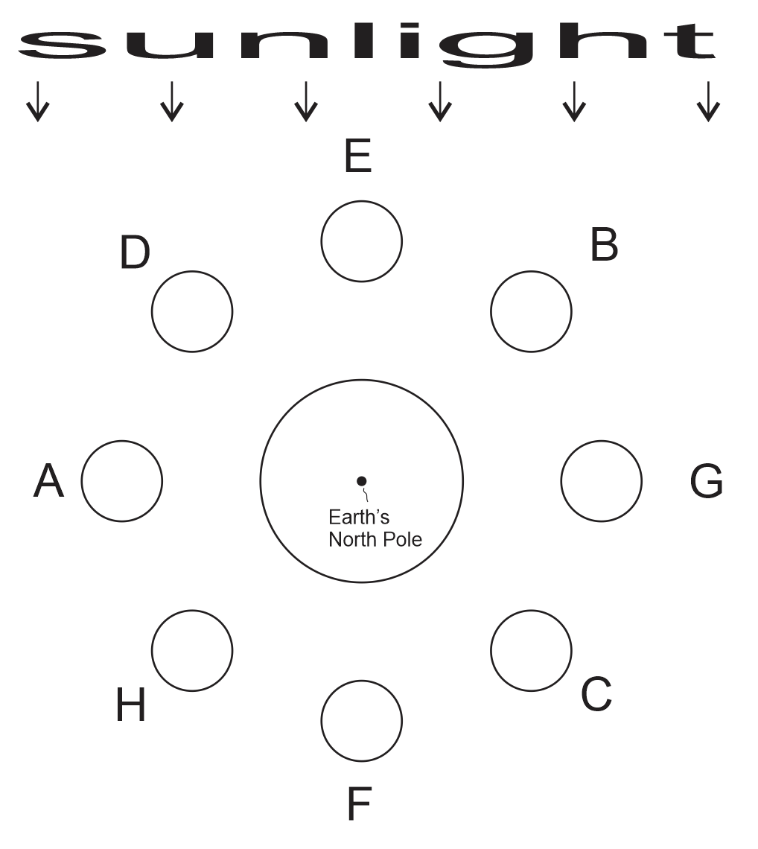
Use the diagram from the opposite page to answer these questions

21. During which moon phase can we have a lunar eclipse?
A B C D E F G H
22. During which moon phase can we have a solar eclipse?
A B C D E F G H

23. Consider Moon A…
a. Circle the picture that shows what this moon would look like from the Northern Hemisphere.
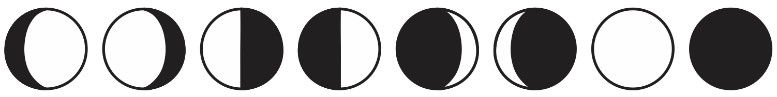
b. What is the shape of this moon phase?
Full New Gibbous Crescent Quarter
c. This moon is _______.
Waxing Waning Neither
d. How many weeks until the moon moves to position B?
0 .5 1 1.5 2 2.5 3 3.5 4
e. How many weeks until the moon phase is a waxing crescent?
0 .5 1 1.5 2 2.5 3 3.5 4
f. At what approximate time does this moon rise?
12am 3am 6am 9am 12pm 3pm 6pm 9pm
g. What type of tides can we expect during this moon phase?
Spring Tides Neap Tides Neither Spring nor Neap

24. Consider this moon: 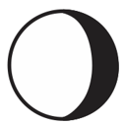
a. What is the shape of this moon phase?
Full New Gibbous Crescent Quarter
b. This moon is _______.
Waxing Waning Neither
c. Which moon in the diagram looks like this when viewed from Earth?
A B C D E F G H
d. How many weeks after this moon will the next full moon occur?
0 .5 1 1.5 2 2.5 3 3.5 4
e. How many weeks until the moon phase is a waning crescent?
0 .5 1 1.5 2 2.5 3 3.5 4
f. At what approximate time is this moon highest in the sky?
12am 3am 6am 9am 12pm 3pm 6pm 9pm
g. What type of tides can we expect during this moon phase?
Spring Tides Neap Tides Neither Spring nor Neap

25. a. What are the names of the two moon phases when Spring Tides occur?

b. Use a diagram to show why spring tides occur during those moon phases.

26. On the first diagram below, use pencil and a ruler to show the edges of the umbra and penumbra formed as the Sun shines on the other sphere.
27. Turn the diagram below into a total lunar eclipse.
a. Label the circle that was provided with either “Earth” or “Moon” – whichever is correct for a lunar eclipse.
b. Draw the missing sphere (either the Moon or the Earth), so that there’s a total lunar eclipse.
c. Shade the umbra and penumbra appropriately (so that it is clear which is darker), and label them.
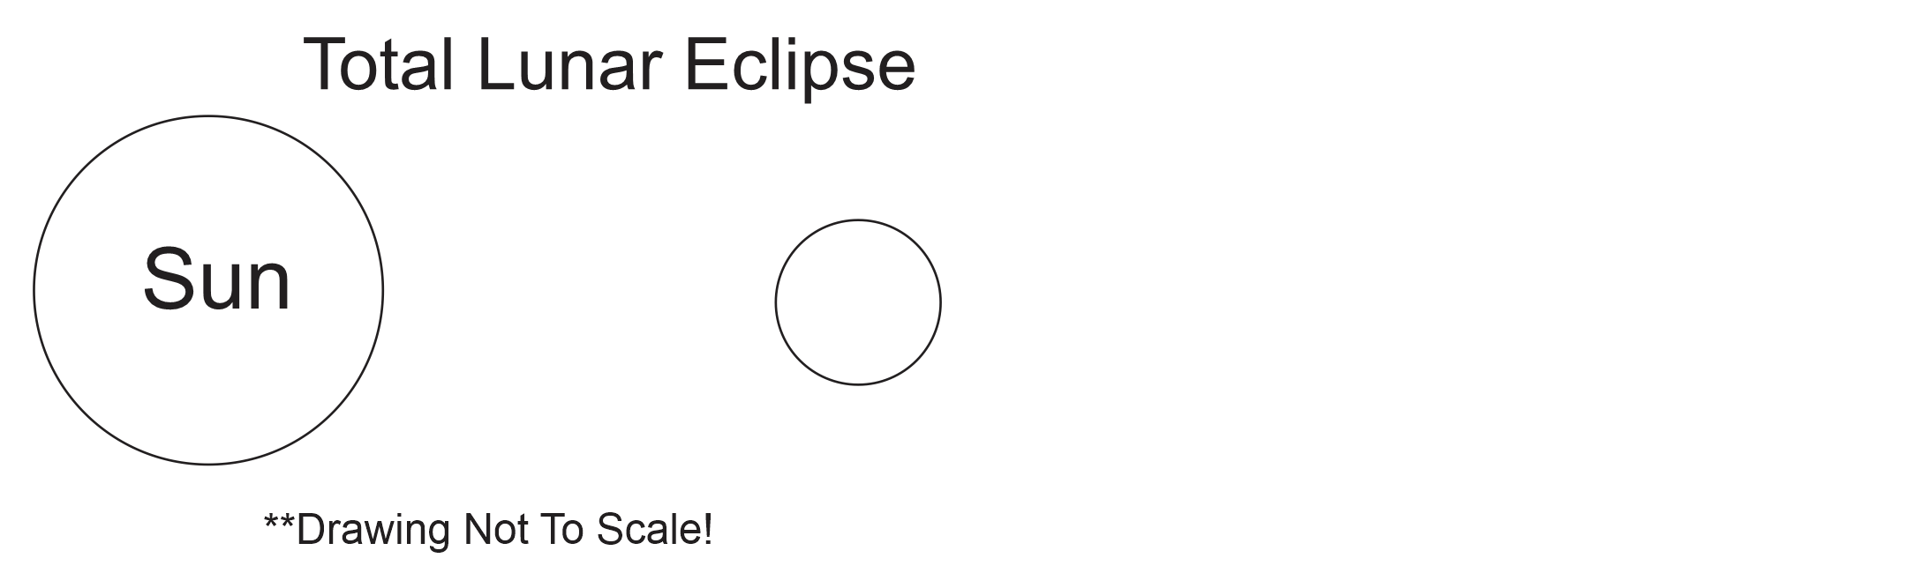

28. Again, use pencil and a ruler to show the edges of the umbra and penumbra formed as the Sun shines on the second sphere. Shade the umbra and penumbra so that it is clear which is darker.
29. Turn the diagram into a solar eclipse, but position the othere sphere so that some places experience a partial eclipse and some experience a total eclipse – and some experience no eclipse at all.
30. Label the Earth and Moon.
31. Label these areas:
- “total eclipse”
- “Partial eclipse”
- “no eclipse” – must be on the sunny side of the sphere.

