EPS 200 Name: ________________________________
System of the Earth, Moon, and Sun
Part 3: Eclipses

Still More Helpful Information:
- Umbra: the part of an eclipse shadow from which no part of the Sun can be seen; the part of an eclipse shadow where a total eclipse is experienced; a totally dark part of an eclipse shadow.
- Penumbra: the part of an eclipse shadow where some, but not all, of the Sun can be seen; the part of an eclipse shadow where a partial total eclipse is experienced; a slightly dark part of an eclipse shadow.

On the diagram below, draw rays of sunlight…
- Starting at the top edge of the Sun and continuing past the top edge of the Moon.
- Starting at the bottom edge of the Sun and continuing past the bottom edge of the Moon.
- Starting at the top edge of the Sun and continuing past the bottom edge of the Moon.
- Starting at the bottom edge of the Sun and continuing past the top edge of the Moon.

5. On the diagram, lightly shade the penumbra and more darkly shade the umbra.
6. Pick a place on the Earth where a viewer would not be able to see the Sun at all and label that location. Something like “can’t see the sun at all from here” is okay.
7. Find a place on the Earth where a view can see part of the sun but not all of it, and label that location, explaining what part of the Sun the viewer can see.
8. Find a place on the Earth where a view can see all of the Sun and label that location.
9. Add three more labels in the appropriate location: “no eclipse,” “partial eclipse,” and “total eclipse.”
9.5. What type of eclipse is this? Explain how you know – what rule helps you remember which type of eclipse is which?

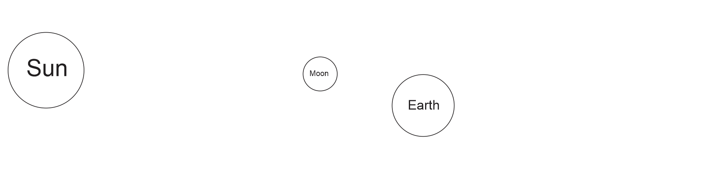
10. On the diagram below, draw lines separating the umbra and the penumbra. Then label and shade the umbra and penumbra.
11. Draw the Moon so that part of it is in the umbra, and the rest of it is in the penumbra.
12. Label the part in the umbra and the part in the penumbra.
13. What would be the complete name for this type of eclipse (including “partial” or “total”)?
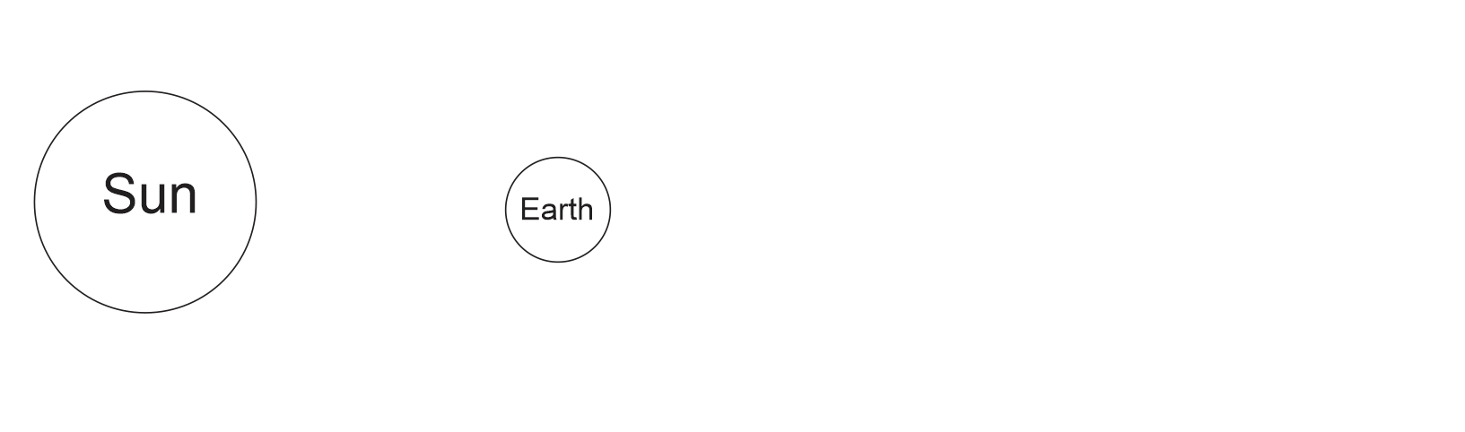
More Eclipse Investigation:

14. Notice that we are looking down on the Earth’s North Pole. Use arrows to show the rotation of the Earth and the revolution of the Moon.
15. Shade the dark side of the Moon and Earth.
16. Use a ruler to draw the umbra and the penumbra of the Moon’s shadow.
17. Based the movement of the Moon in your drawing, find the place on Earth that will first experience a total eclipse. Label that location “eclipse starts here” and describe the time of day at that location.
18. Label the place on Earth that will be the last to experience a total solar eclipse “eclipse ends here,” and describe the time at that location.
19. Use an arrow to show the path/direction of the umbra (total eclipse shadow) as it moves across the Earth. Label it “shadow moves this way.”
20. Somewhere in the middle of the shadow’s path, label “Essex Vermont.”
21. What moon phase will we experience as the moon passes between us and the Sun?

The End! (except for review and testing)

Here’s an example of an impressive set of questions that you should be able to answer after we’re done reviewing…

If the Moon looks like this: 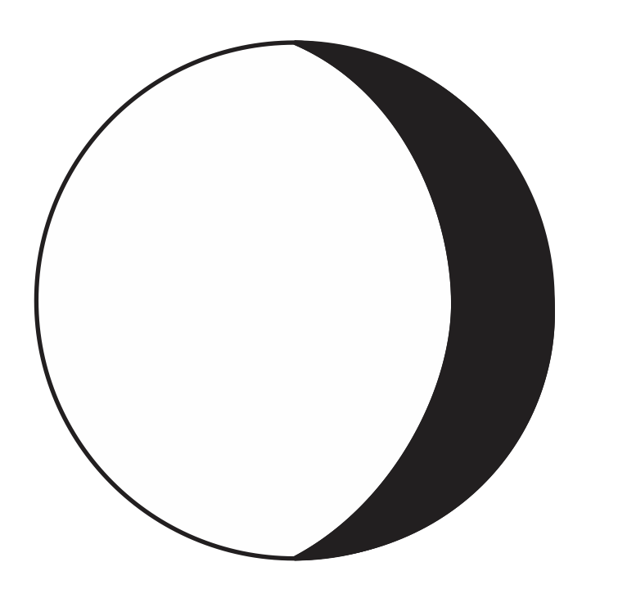
- What is the name of its phase?
- At what approximate times does it rise and set?
- How long will it be until the next New Moon?
- Are the tides today especially strong, especially weak, or in between?
- How long will it be until the next moon phase when there might possibly be an eclipse?
- What type of eclipse would that be?
- Where would you need

