ESS 100 (Stapleton) Name: ___________________________
Notes: Formation of Our Solar System Part 1 – Gravitational Contraction

Drawing #1 -- The Solar Nebula (Over 4.6 Billion years ago) – the solar system is ready to form

More than 4.6 billion years ago, a nebula (cloud of dust and ice) was floating freely in space. The “dust” was rock and metal, and the “ice” was mostly frozen Hydrogen, plus some Helium. This nebula contained matter from other stars that had lived, died, and destroyed themselves in events called supernovae. The supernovae scattered those bits into space, where they became part of our nebula.

In the space below, create a labeled drawing representing the nebula, including its movement, and component materials.

The Nebula Begins to Contract

1. Gravity is a force of attraction between bits of matter. Anything that has mass will be pulled by gravity toward anything else that has mass.

Is dust affected by gravity? What about ice?

2. According to your answer to question number 1, what must have begun to happen to the overall size of the nebula?

Why?

The Nebula’s Motion Changes

3. Imagine a bunch of gas molecules in a container. What happens to their speed and temperature if the container is compressed?

4. What happens to the speed and temperature of some compressed molecules if the container is allowed to expand?

5. A spinning figure skater is like a container of gas molecules. What happens to the motion of the figure skater’s particles when the skater compresses inward by pulling in their arms and legs? [Try it! And Watch a video.]

6. What happens to their motion when they relax and expand, by spreading out their arms and legs? [Try it!]

7. The nebula that formed our solar system was huge, and it was rotating very slowly. What happened to the speed of its rotation? Why?

The Nebula’s Shape Changes

8. Fill in the missing part of Newton’s 1st Law: Objects at rest stay at rest, and objects in motion stay in

motion in a _____________________ _______________________ and at a constant speed, unless they are acted on by an unbalanced force.

9. __________________________ is sometimes referred to as “mass in motion,” and it is a measure of something’s tendency to keep moving in a straight line.

10. What is the formula for momentum?

11. What kinds of things have the most momentum?

12. Imagine you have a ball on a string, and you begin swinging the ball in circles over your head. As you swing the ball, you feel a pull. If you let go, this pull will cause the ball to fly away. On the diagram to the right, show the direction in which the ball will fly after you let it go. [Try it!]

13. What causes the ball to continue flying in this direction?

14. When a pizza maker spins a ball of soft dough in the air, what shape does it make? [Watch a video]

15. A spinning lump of pizza dough forms this shape because it’s middle is pulled outward. What is stretching the dough outward?

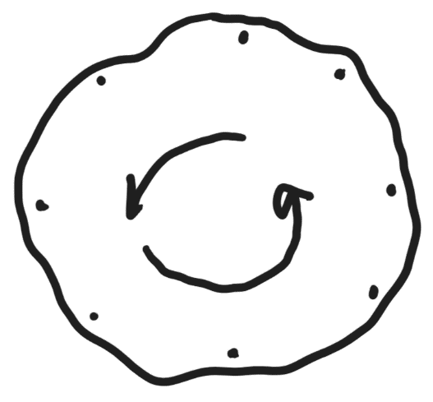
16. The dough isn’t really being pulled directly outward (away from the center). A force directly away from the center is called “centrifugal force,” and it does not really exist. On the diagram to the right, use arrows to show the directions that some dough particles (the dots) are actually being carried by their momentum.

17. What part of a spinning blob has the most momentum? Why?

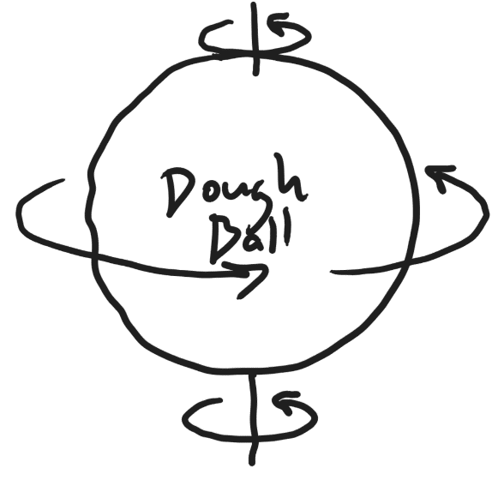

18. What would happen to a water balloon if we used a drill to spin it rapidly? Why?

19. Where is the “biggest part of the Earth?” Why?

20. As the solar nebula contracted (compressed together), what happened to its shape? Why?

Drawing #2: The Solar Nebula Begins Gravitational Contraction

- The size became ____________________ because

______________________________________________________________________________________

- The speed of rotation became ________________ because

______________________________________________________________________________________

______________________________________________________________________________________

- The shape turned from ______________________ into a _______________________________________

- The shape changed because the ______________________ was moving fastest, so it had the most

____________________, which prevented it from being ________________________________________

by ___________________________.

- The nebula’s temperature became _________________ because _________________________________

______________________________________________________________________________________

