ESS 100 Name: ___________________________
Ages of Rocks, Part 1: Relative Dating

Unit Goals:
- Know and apply the four principles of relative dating (box below) to put rocks, fossils, and events in order according to their age.
- Know and apply the principles of absolute dating to estimate the ages of rocks based on their radioactive isotope content.
- Define atom, element, electron, proton, neutron, isotope, and radioactive isotope, and understand how these terms relate to absolute dating.

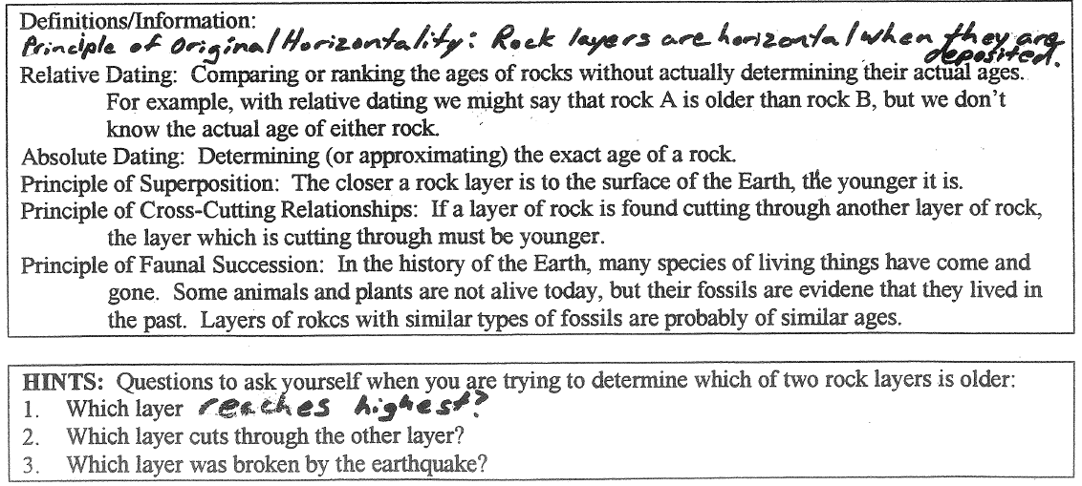

Practice #1. Rank the rocks in the diagram from oldest to youngest.
Oldest Youngest
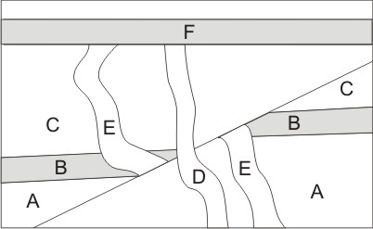

Practice #2. Rank the rocks in the diagram from oldest to youngest.

Oldest Newest

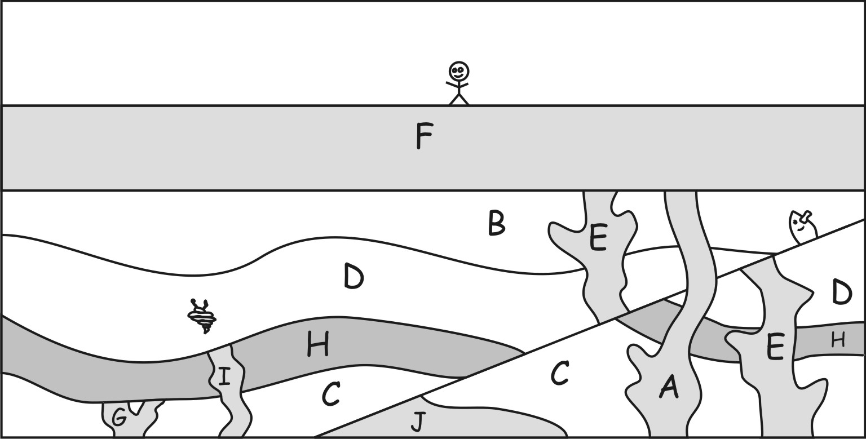

Oldest Newest

Practice #3. Rank the rocks in the diagram from oldest to youngest.
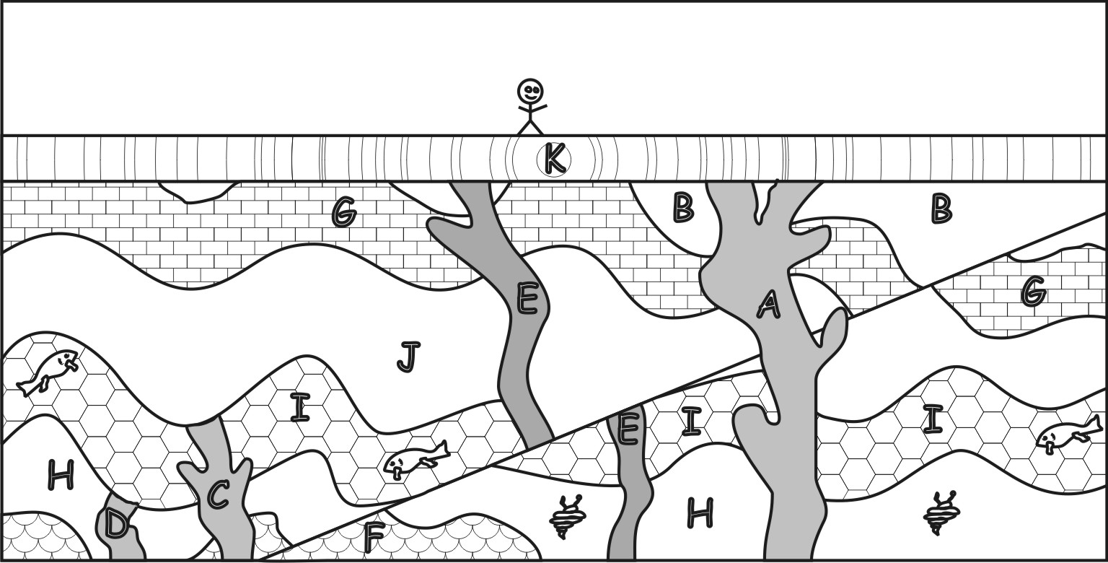
Ages of Rocks, Part 2: Absolute Dating
(a.k.a. radiometric dating)

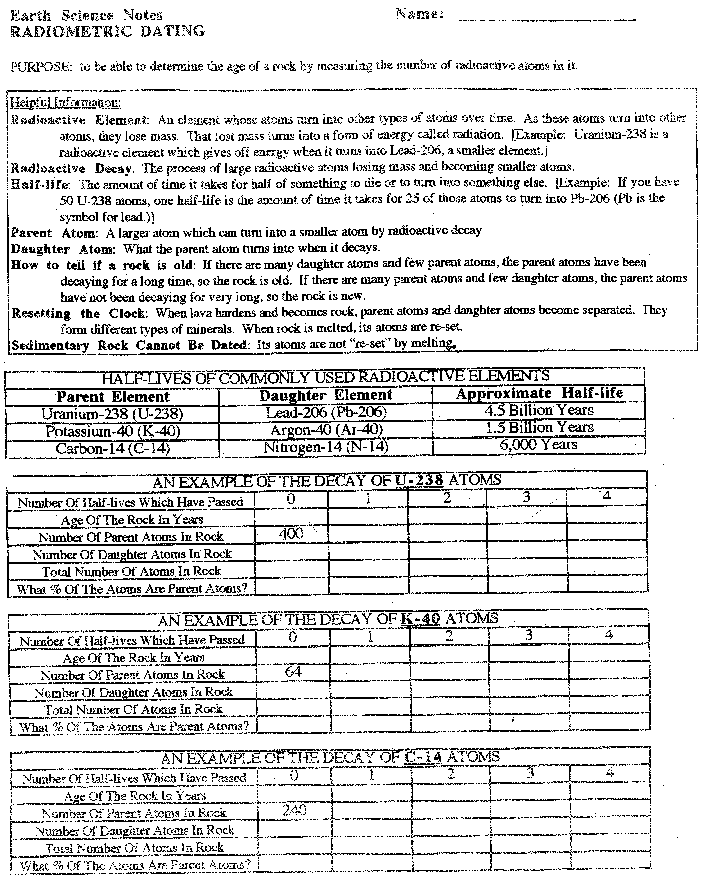

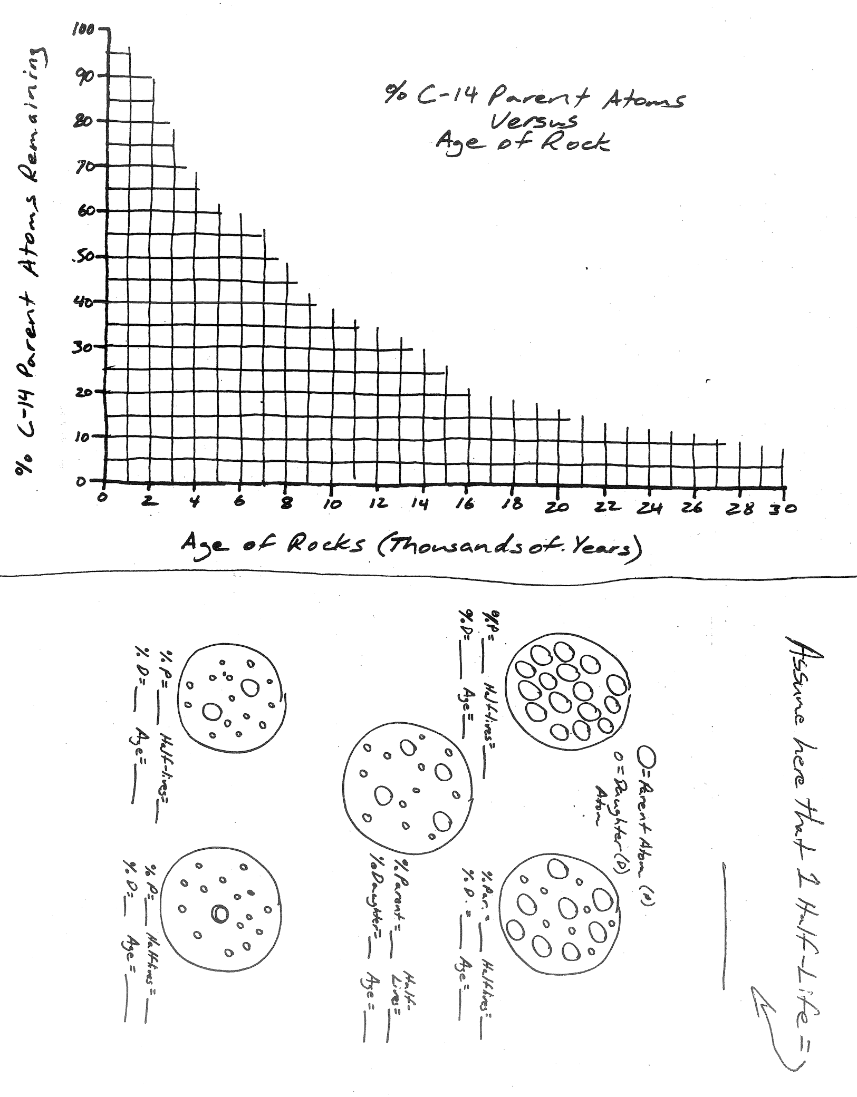
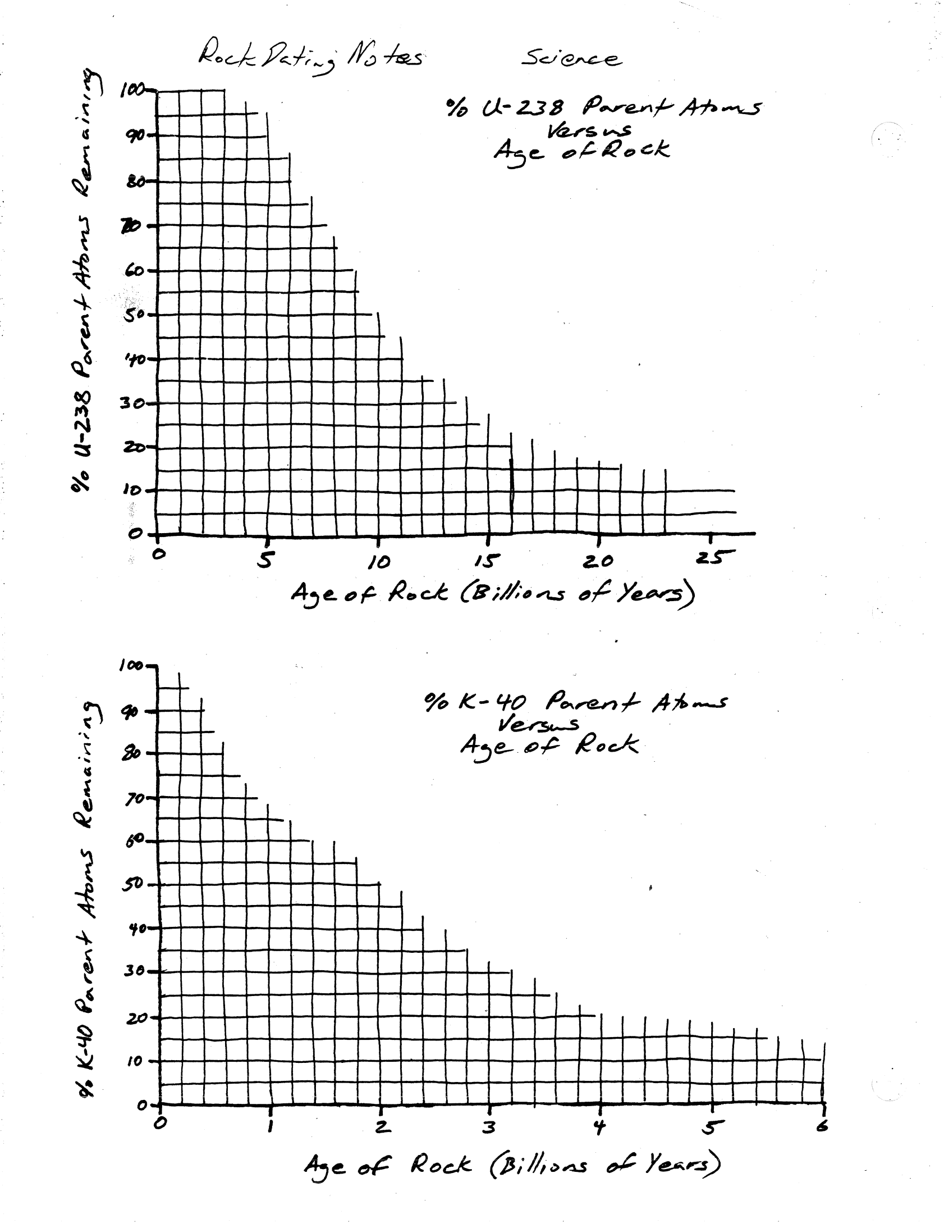

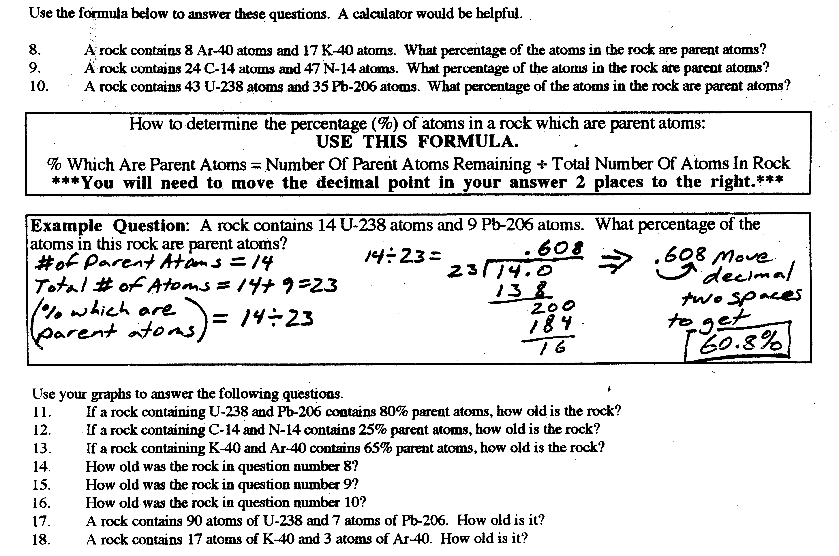

Practice Test – Ages of Rock

Part 1: Organize the lettered rock samples in Figure 1 from oldest to youngest. Then make a mark where the earthquake occurred in the sequence.

Oldest Newest

1. Which letter is barely older than layer B? ____ 2. Which letter is barely younger than layer B? _____

3. Which letter is barely older than layer J? ____ 4. Which letter is barely younger than layer J? _____

5. Which letter is barely older than letter H? ____ 6. Which letter is barely younger than letter H? _____

7. Which letter is barely older than letter C? ____ 8. Which letter is barely younger than letter C? _____

9. Which letter is barely older than layer A? ____ 10. Which letter is barely younger than layer A? _____

11. The earthquake occurred between the appearance of letters _____ and _____.

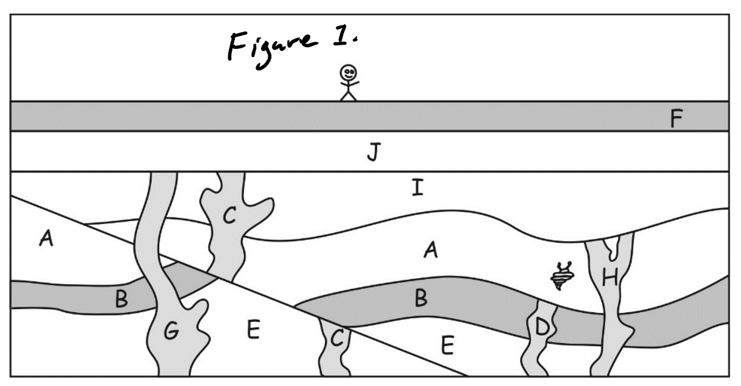

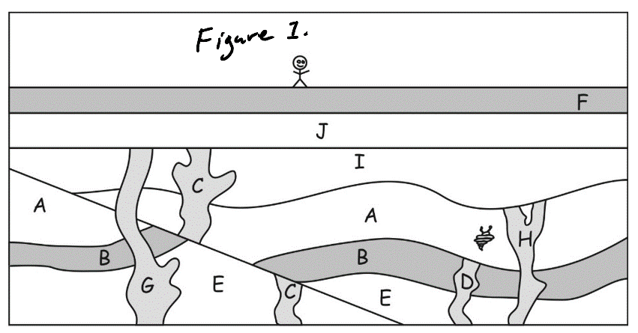
Part 2:

12. Sample C contains 50 K-40 parent atoms and 150 Ar-40 daughter atoms.
a. What is the total number of parent + daughter atoms?

b. What percentage of those atoms are parent atoms?

c. Which of the following is closest to the age of Sample C?
0by 1by 2by 3by 4by 5by 6by 7by 8by

13. Sample G contains 150 K-40 parent atoms and 228 Ar-40 daughter atoms.
a. What percentage of those atoms are parent atoms?

b. Which of the following is closest to the age of Sample G?
0by 1by 2by 3by 4by 5by 6by 7by 8by

14. Which of the following is closest to the age of the fault created by the earthquake?
0-1by 1-2by 2-3by 3-4by 4-5by 5-6by 6-7by 7-8by

15. Sample D contains 90 K-40 parent atoms and 820 Ar-40 daughter atoms.
a. What percentage of those atoms are parent atoms?

b. Which of the following is closest to the age of Sample D?
0by 1by 2by 3by 4by 5by 6by 7by 8by

16. Sample H contains 50 K-40 parent atoms and 215 Ar-40 daughter atoms.
a. What percentage of those atoms are parent atoms?

b. Which of the following is closest to the age of Sample H?
0by 1by 2by 3by 4by
5by 6by 7by 8by

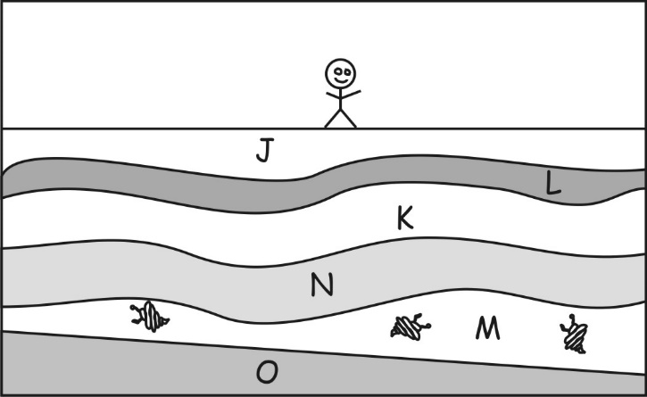
17. The diagram on the right shows rock samples from another location on Earth. Choose the most likely age range for layer M, in that diagram.
0-1by 1-2by 2-3by 3-4by 4-5by 5-6by 6-7by 7-8by

