ESS 100 (Stapleton) Name: ________________________
Plate Tectonics

1. Layers of the Earth:
- Label the layers
- Describe the type(s) of material in each layer
- Describe the rigidity (or fluidity) of each layer
- Describe the density of each layer

2. Reasons why the inside of the Earth is hot:

3. Why is the surface of the Earth cooler?

4. Use arrows to demonstrate the plate motions at the three types of plate boundaries.

5. Create a diagram showing how and where convergent and divergent plate boundaries form.
- Draw three plates
- Label one plate boundary “convergent” and one “divergent.”
- Draw the currents in the mantle
- Use “hotter” and “colder” labels to help explain why there are currents in the mantle.

6. The currents in the Earth’s mantle are called __________________________ currents.

7. Briefly explain what causes these currents.

8. What are the three ways that energy can be transferred? Give an example of each.

Two General Categories of Rocks: Mafic and Felsic
Characteristics of Mafic Rock:
- Dark in color
- More Dense
- Low Viscosity (runny) when turned to magma
  - Does not build up high pressure, so it roduces gentler eruptions
  - Does not pile up, so volcanoes are lower and rounder
- An example of this type of rock is basalt
- Found mostly in the mantle and in ocean crust (because it is dense, and it sinks)
- It is called “mafic” because it contains the elements Magnesium (symbol Ma) and Iron (symbol Fe).
Characteristics of Felsic Rock:
- Light in color
- Less dense
- High Viscosity (gooey) when turned to magma
  - Builds up pressure and makes volcanoes more explosive
  - Piles up, so it makes volcanoes steeper
- An example of this type of rock is granite
- Found mostly in continental crust and in seafloor sediment.
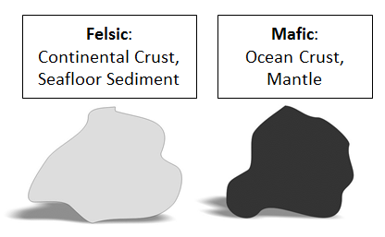
- It is called “felsic” because it contains the minerals Feldspar and Silica.
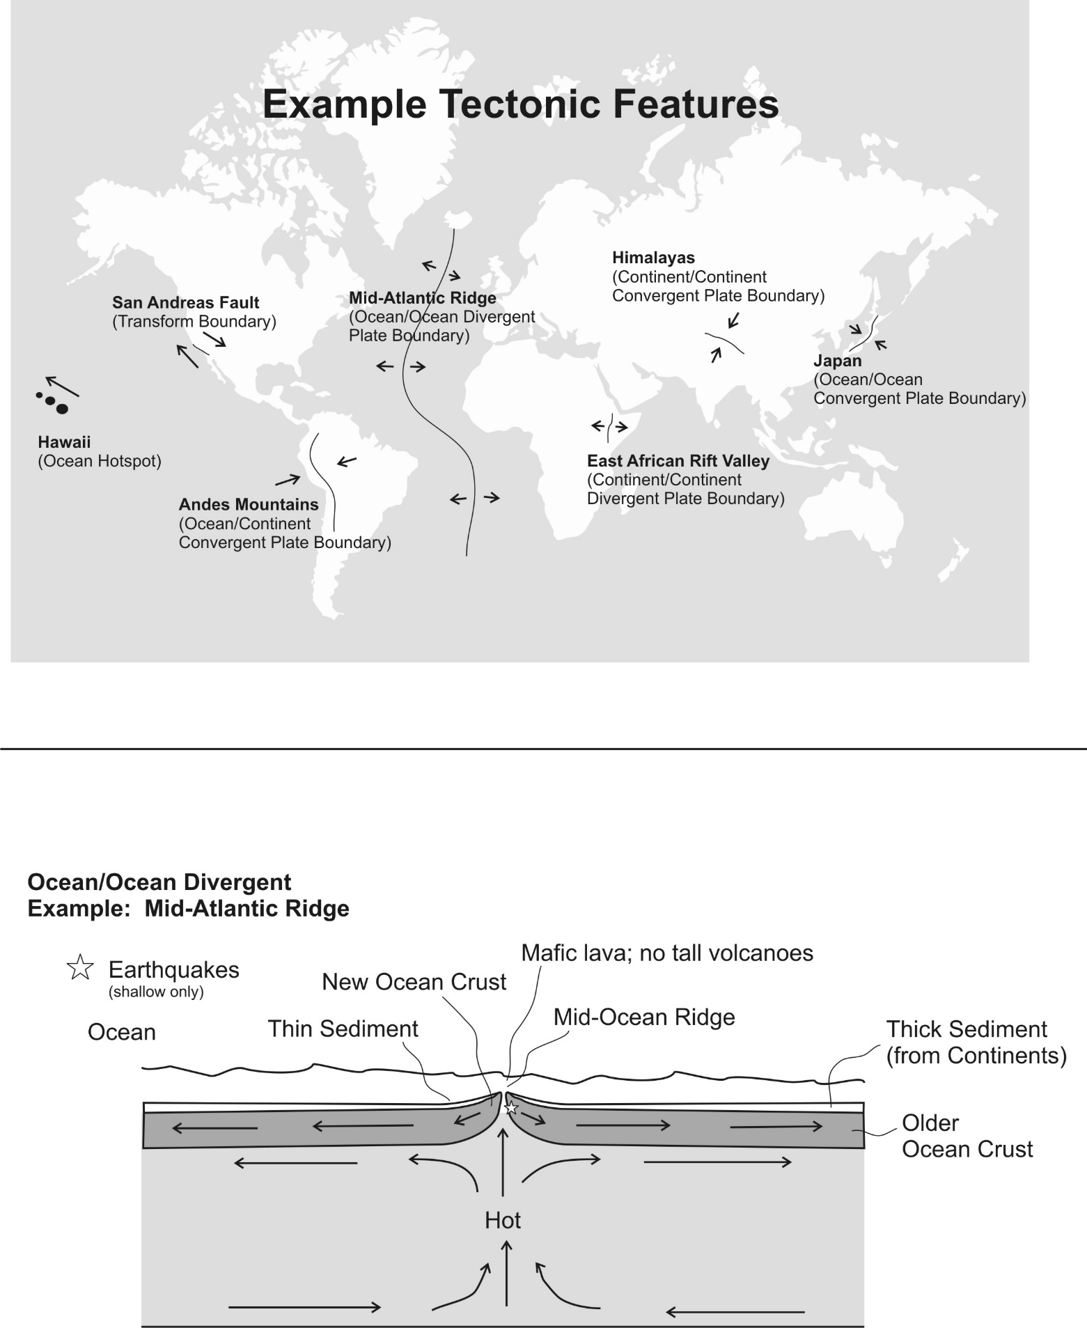
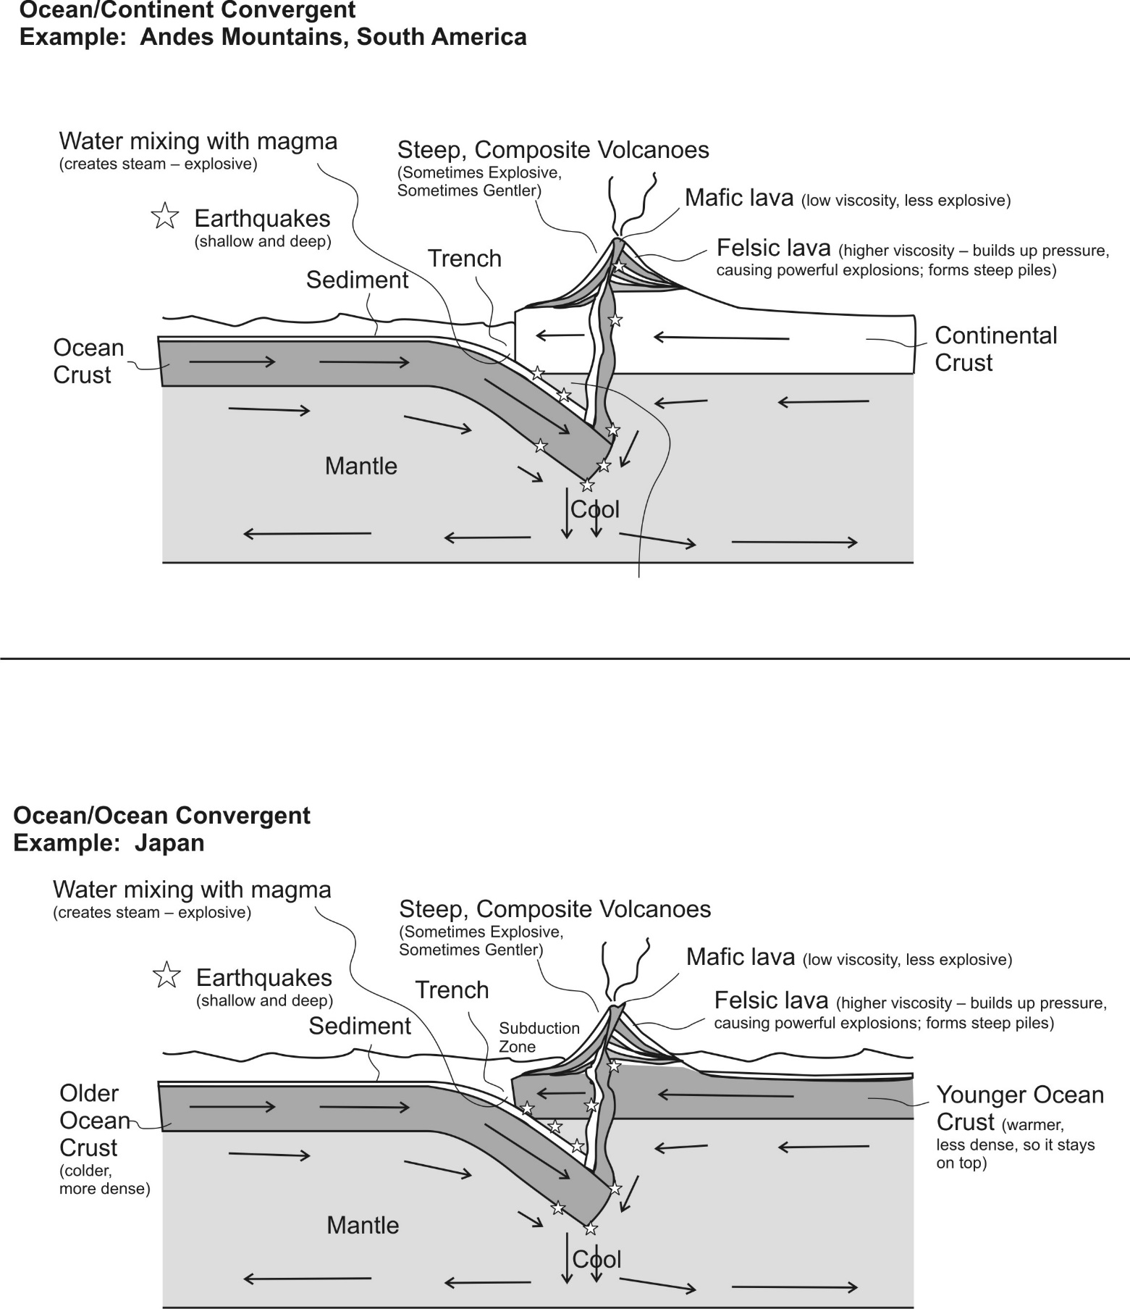
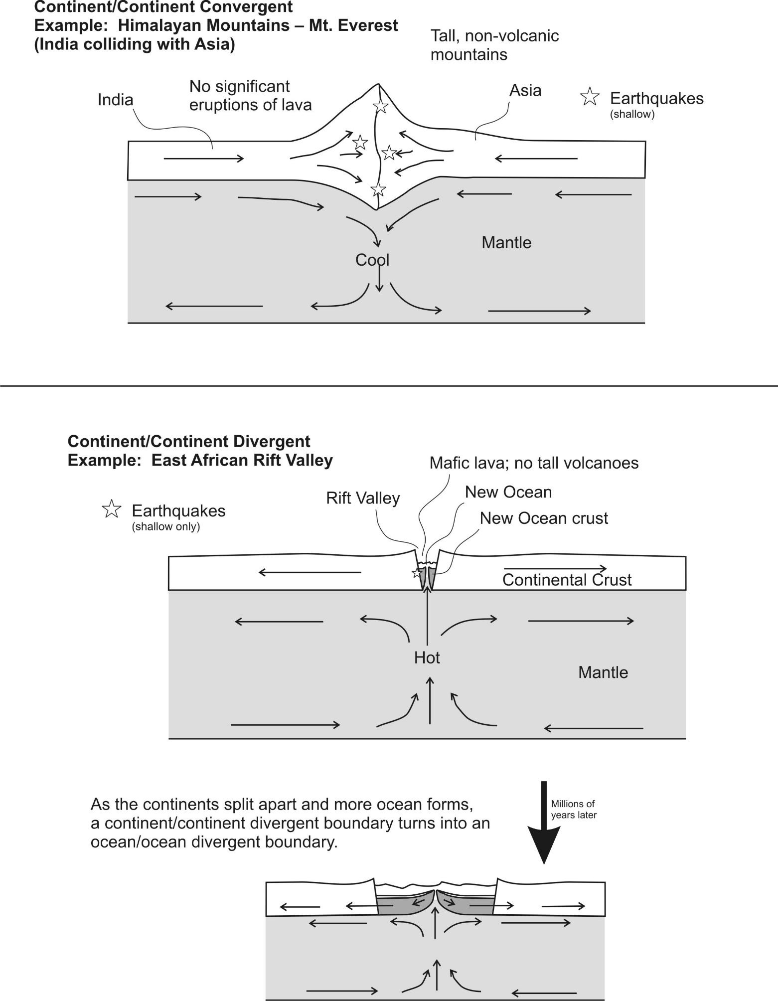

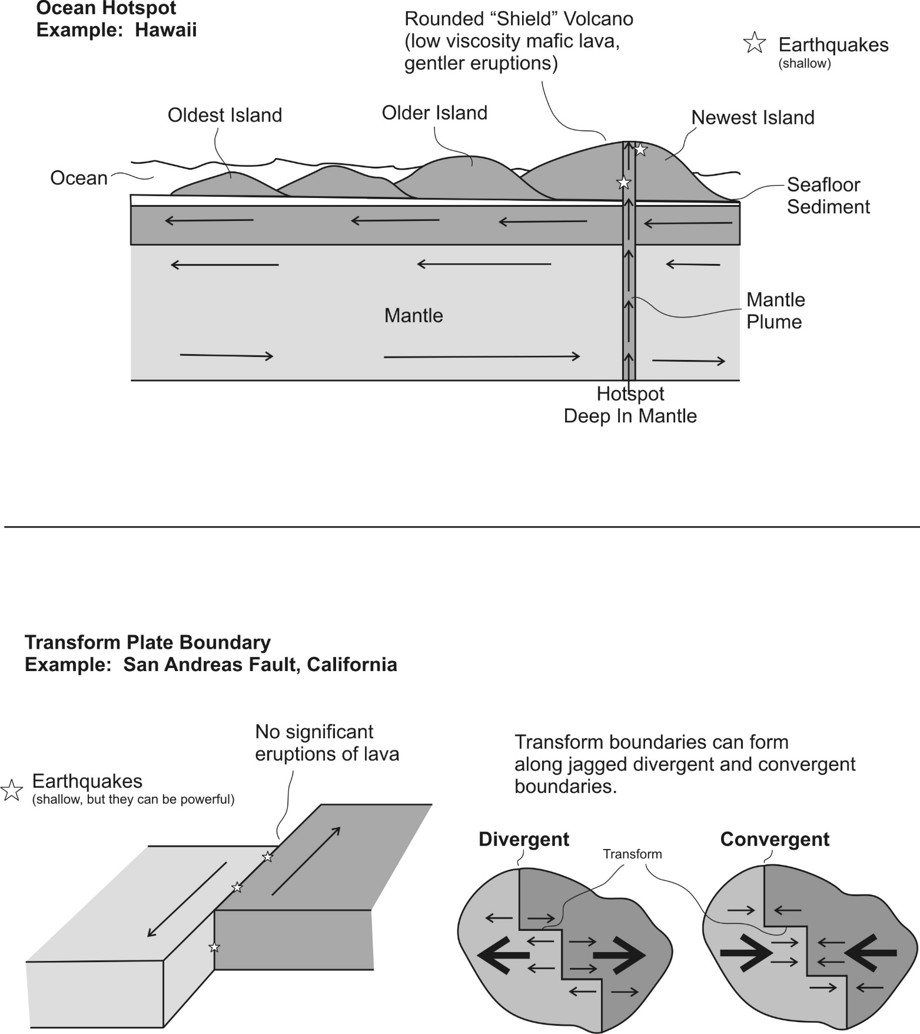

Drawing Tectonic Features (Plate Boundaries and Hotspots)
Feature Name:

Example:

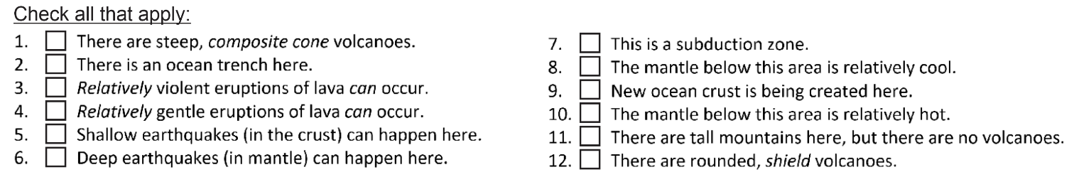
_____________________________________________________________________________________________

Feature Name:

Example:

Drawing Tectonic Features (Plate Boundaries and Hotspots)
Feature Name:

Example:

_____________________________________________________________________________________________

Feature Name:

Example:

Drawing Tectonic Features (Plate Boundaries and Hotspots)
Feature Name:

Example:

_____________________________________________________________________________________________

Feature Name:

Example:

