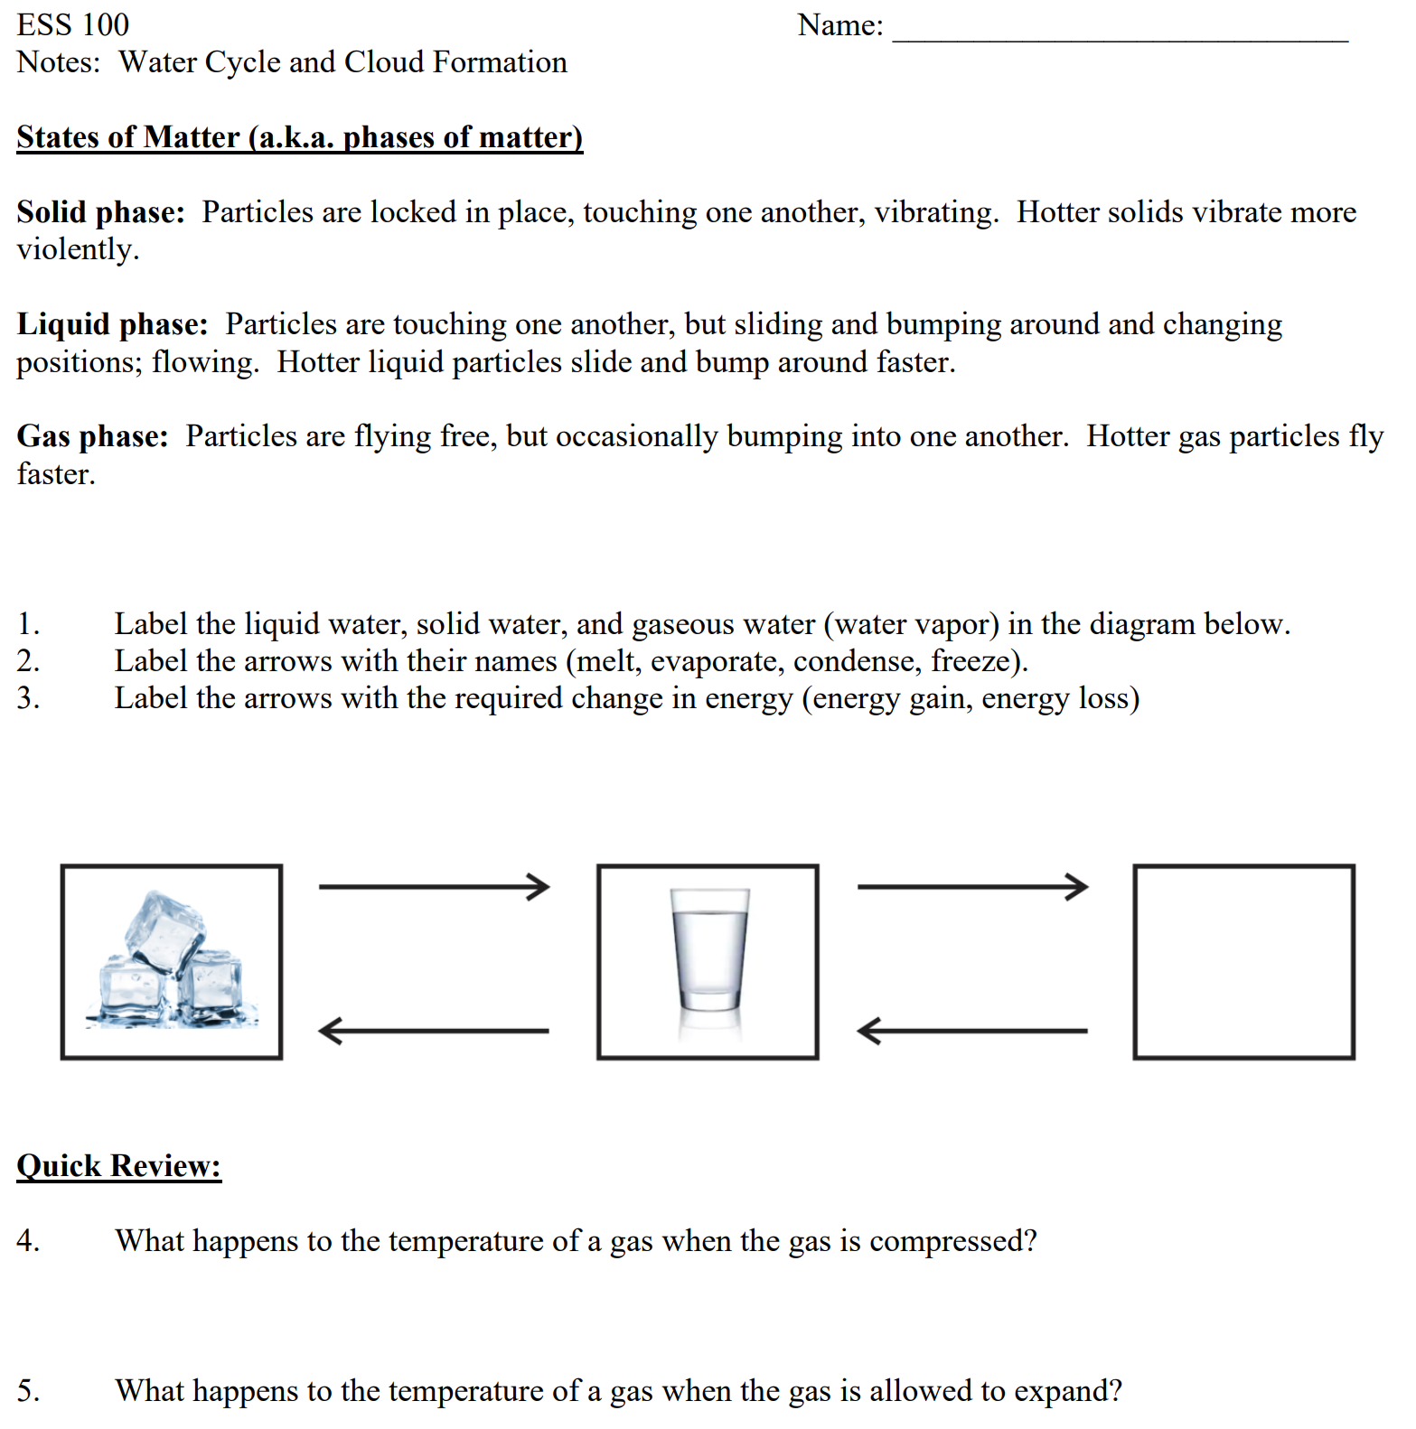

Practice: Rising Air, Sinking Air, and Weather

Part 1: Evaporation at the Equator (and other places)

The Sun shines on Earth’s surface, causing the Earth’s surface to heat up. If there is water on the Earth’s surface, this heat gets transferred to that water and to the air near the ground. This heating causes the speed of water and air molecules to _____________________ (increase or decrease). Eventually, the water molecules have gained enough energy to _________________________(evaporate or condense). Their state of matter turns from __________________ (solid, liquid, or gas) to _______________ (solid, liquid, or gas), and they leave their puddles (or their ocean, river, lake, etc.) to become an invisible part of the warm air near the ocean’s surface.
Another effect of this increasing warmth near the ocean’s surface is that the volume of the air that is heating at the Earth’s surface begins to __________________(increase or decrease). This change in volume causes the air’s density to _________________(increase or decrease). This density change causes the air (and the water that is in the air) to ____________________ (rise or sink).
Part 2: Rising Air

As the rising air gets higher, it encounters _________________ (higher or lower) air pressure, because there is _____________ (more or less) air above it. This change in air pressure causes the volume of the rising air to _________________ (expand or shrink). This ____________________ (expansion or compression) of the air causes the temperature of the air to _________________ (increase or decrease). This new change in the temperature of the air causes the speed of the air molecules to _______________(increase or decrease). The change in molecular motion causes the water molecules to change phase (state) again from _________________ (solid, liquid, or gas) to _______________ (solid, liquid, or gas). When this happens, tiny droplets of water form around specs of dust, creating clouds. At first the droplets are too small and light to fall to the ground. They fall so slowly that even gentle updrafts keep pushing them back up. Eventually, when enough individual droplets come together, they become big enough to fast enough to make it to the ground as rain.
Part 3: Sinking Air

In other places, air sinks. As the sinking air gets lower, it encounters _________________ (higher or lower) air pressure, because there is _____________ (more or less) air above it. This change in air pressure causes the volume of the sinking air to _________________ (expand or shrink). This ____________________ (expansion or compression) of the air causes the temperature of the air to _________________ (increase or decrease). This new change in the temperature of the air causes the speed of the air molecules to _______________(increase or decrease). If there are water molecules in the air, this change in molecular speed causes the water molecules to change phase (state) from _________________ (solid, liquid, or gas) to _______________ (solid, liquid, or gas). This is how clouds ___________________ (appear or disappear).

