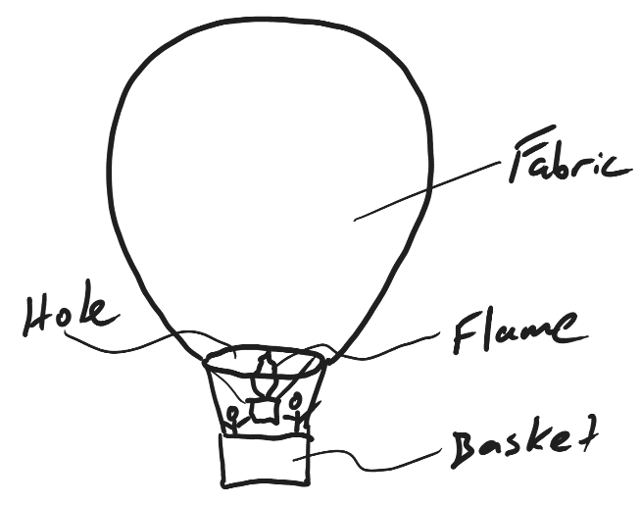
ESS 100 (Stapleton)
Hot Air Balloon Practice

A hot air balloon is basically a big bag with a hole in the bottom. Below the hole is a basket for passengers and a burner to create a flame. When a hot air balloon is sinking, it can be made to rise by turning on the flame and heating the air inside the balloon. There are two processes that can cause a hot air balloon to rise when the air gets heated. They can work alone, or they can work together.

1. Explain how heating the air in the balloon can make the balloon rise by changing the volume of the balloon but keeping the mass the same. In this case…

- If the balloon is rising, what is happening to its density?

- What happens to the motion of the air particles in the balloon when the flame is turned on.

- How does the volume of the balloon change? What makes it change?

- If the overall mass of the balloon is staying the same, what does that tell you about the air in the balloon? What is that air doing or not doing?

- Explain why the density of the balloon is changing. Give an answer that shows that you understand what density means.

- How does heating the air in the balloon change its pressure?

- What role does this pressure change play in this process of the balloon rising?

2. Explain how heating the air in the balloon can make the balloon rise by changing the mass of the balloon but keeping the volume the same.

- If the balloon is rising, what is happening to its density?

- If the volume is remaining the same, is the balloon’s overall mass increasing or decreasing? Explain your reasoning.

- Why is the mass of the balloon changing in this way? What is causing the change?

- How does heating the air in the balloon change its pressure?

- What role does this pressure change play in this process of the balloon rising?

