ESS 100 (Stapleton) Name: _________________________
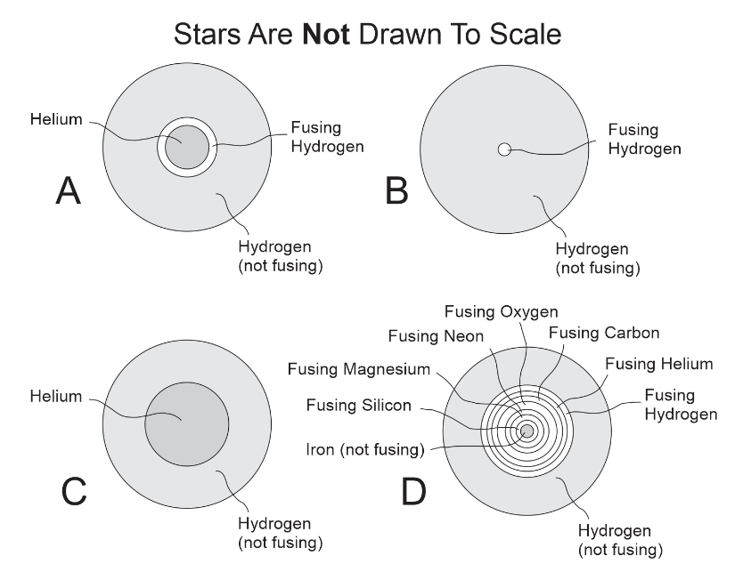
Practice Quiz: Massive Stars, H-R Diagrams, and The Big Bang

Part 1: Life Cycles of Stars

1. Identify each of the stars on the right. Be as specific as you can be.

A.

B.

C.

D.

- Neutron star or Black hole
- White Dwarf
- Protostar
- Main Sequence Star
- Supernova
- Nebula
- Red Giant
- Red Supergiant
- Black Dwarf

2. Number the life stages of a massive star (20 times more mass than our Sun). Beware, the word bank on the right includes some extra stages that should not be used.

3. A supernova is similar to the formation of a white dwarf, but it is also different.

a. Explain how a supernova is similar to the formation of a white dwarf.

b. Explain how a supernova is different from the formation of a white dwarf.

4. What determines whether a dead star will turn into a Black hole or a neutron star?

5. List one of the “interesting facts” about Neutron stars.

Part 2: The origins of matter:

6. The heaviest elements: Atoms of Gold, lead, mercury, and Uranium are all heavier than iron. None of these substances were created by the Big Bang. What created them?

7*. The lightest element: [I forgot to put this in the notes, but I bet you can guess the answer.] Stars are made mostly of hydrogen. Where did the hydrogen come from?

8. Medium Elements: What created the elements that are heavier than hydrogen and helium, but lighter than iron?

Part 3: 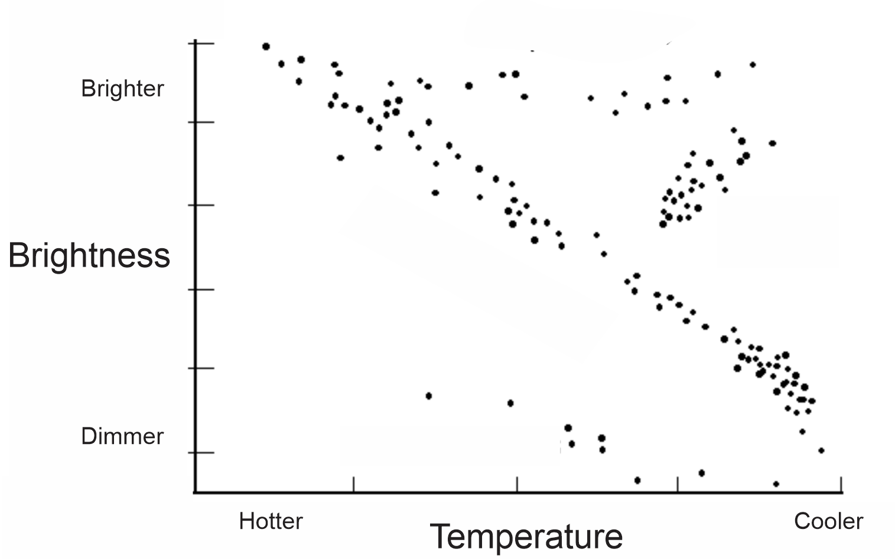

9. What is the name for this kind of diagram. Label the diagram with its name.

Show/label all of the following on the diagram above.

10. Red giants 11. White dwarfs 12. The Main Sequence
13. Our Sun 14. A small, red star 15. A blue star
16. Our Sun’s future path as it changes its position in the diagram (use a labeled arrow)

Part 4: Evidence for The Big Bang theory

Two major claims of the Big Bang theory are that…
1) The Universe began as a hot, dense point of matter, and
2) The Universe has continued to expand since it first formed.

17. What does CMBR stand for?

18. Explain how the CMBR is evidence for the Big Bang theory?

19. Draw a diagram that shows how two observers of the same moving star can see different Doppler shifts – one observer seeing a red-shift, and the other seeing a blue-shift.

20. Describe Edwin Hubble’s discovery (Hubble’s Law).

21. How did Edwin Hubble’s discovery provide evidence for the Big Bang theory?

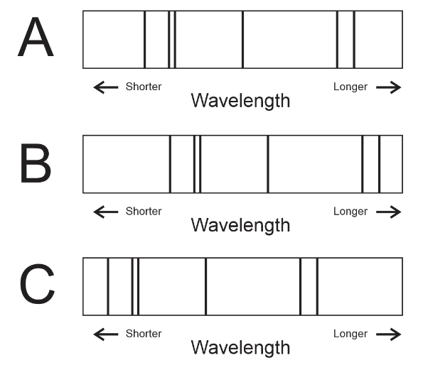

22. The diagram on the right shows the same group of spectral lines from three different stars that were observed from the Earth. Which star is moving away from the Earth?

23. How old is the Universe?

