ESS 100 (Stapleton) Name: _________________________
Life Cycles of Very Massive Stars

1. For these notes, “very massive” means…

2. List the life stages of a very massive star.

3. Show how nuclear fusion in a very massive star is different than fusion in a medium star like our Sun?
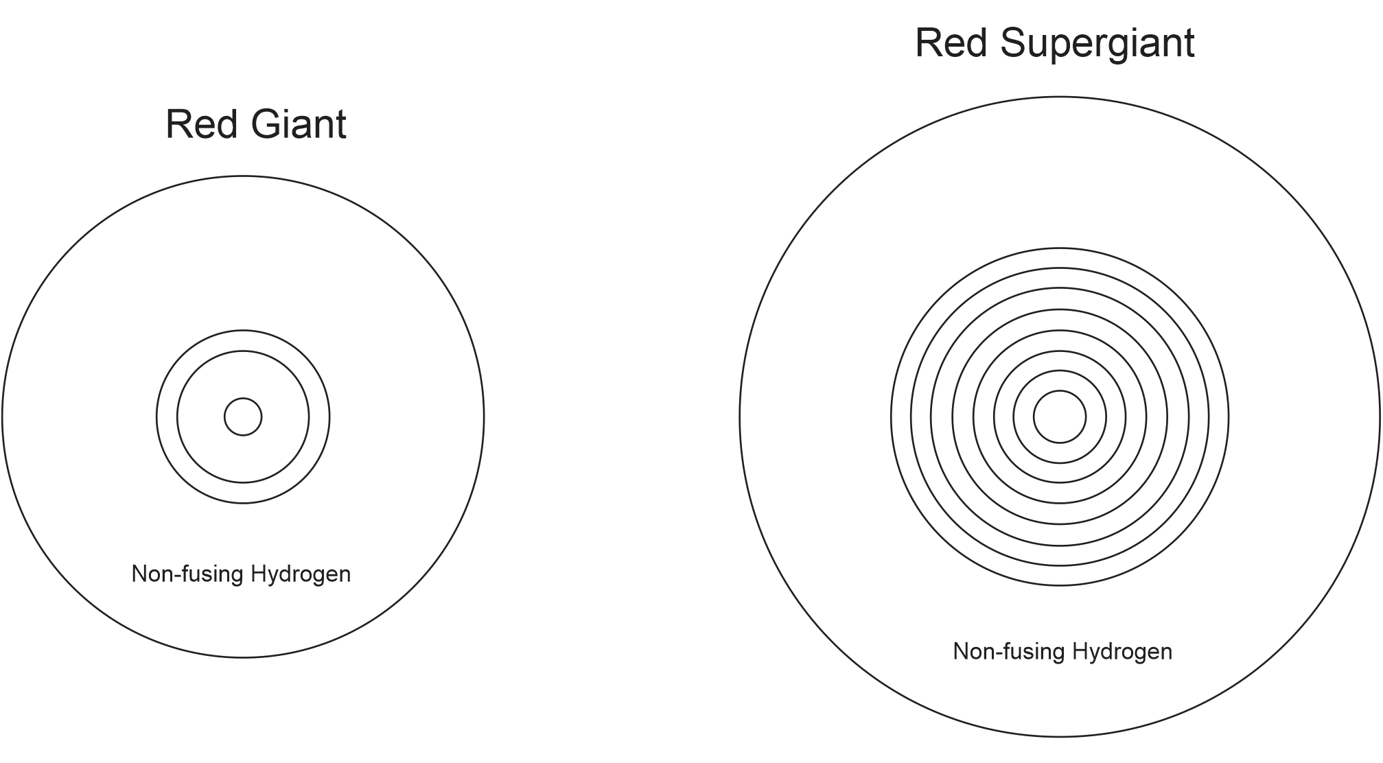

4. What is the heaviest element that can be made by nuclear fusion in a star?

5. What happens when a massive star runs out of nuclear fuel that it can fuse?

6. Why do the outer layers of an exploding supernova fly away so fast?

7. Give one reason that we should be thankful for supernovas.

8. What happens to the star material after a supernova?

a) Some material gets blasted out into space. This material…

b) A black hole can form if…

c) A neutron star can form if…

9. Some neutron star facts:

