ESS 100 (Stapleton) Name: _____________________
Notes: H-R Diagrams

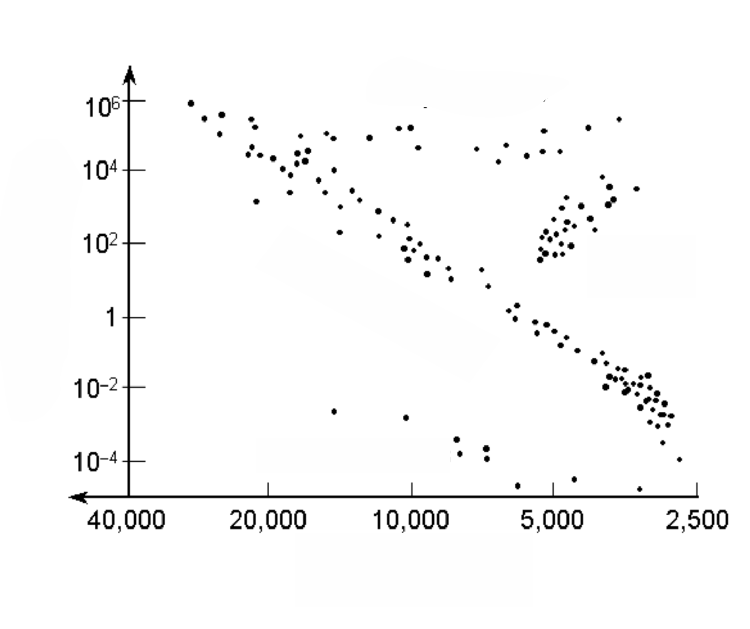
1. What does H-R stand for?

2. As you move from bottom to top in an H-R diagram, how do stars change?

3. As you move from left to right in an H-R diagram, how do stars change?

4. If you put all of the stars in the Universe on an H-R diagram, where would 90% of them be located?

5. What is the name for the group of stars that form a diagonal line from top left to bottom right?
6. What is the energy source of all main sequence stars?

7. a. Describe the stars in the top right of an H-R diagram.

b. What is their main energy source?

8. a. Describe the stars in the bottom middle of an H-R diagram.

b. What is their energy source?

9. Where are the blue stars in an H-R diagram?

10. Where would our Sun be in this H-R diagram? Why?

11. In the future, our Sun is going to move to different parts of the diagram. What path will it follow on the diagram, and why?

