ESS Plate Tectonics Test Review Name: _______________________________
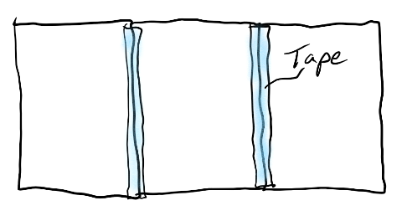
Part 1: On three sheets of paper connected with tape, draw all of the plate features that we have discussed in class. Hint: plan your diagram on scrap paper before you begin to draw it.
- Across the bottom half of the sheets, create one continuous cross-section diagram of the Earth’s plates and mantle. This diagram must include all of the plate features (except for a transform boundary) from class (There are 6: Ocean/Ocean Convergent, Ocean/Ocean Divergent, Ocean/ Continent Convergent, Continent/Continent Convergent, Continent/Continent Divergent, and Ocean Hotspot)
- Above each plate feature (across the middle of the sheets), label the plate boundary (or hotspot) with its name.
- Across the top of the sheets, draw a satellite view (from above the Earth) of the plate features.
Part 2: Once you have drawn your diagram, make sure that you have met the requirements on this checklist.
- Oceans have water in them.
- Seafloor sediment is included where appropriate.
- All material is shaded appropriately (dark for mafic, light for felsic).
- Volcanoes exist in the correct locations, with the correct shapes and shading.
- Arrows are included to show all plate movement and currents in the mantle.

Part 3: On the cross-section diagram, label all of the following everywhere that they occur.

- Subduction zone
- Mid-ocean ridge
- “New ocean crust forming”
- Composite cone volcano
- Shield cone volcano
- Ocean trench
- Subduction Zone
- Tall non-volcanic mountains
- Hotspot
- Rift valley

Part 4: On the cross-section diagram, label each of the following in one location and describe it as either “more dense” or “less dense.”

- Seafloor sediment
- Mantle
- Continental Crust
- Ocean Crust

Part 5: On the satellite-view diagram, label all of the following everywhere that each occurs.

- Transform boundary
- Tall, non-volcanic mountains
- Mid-ocean ridge
- Ocean trench
- Composite cone
- Shield cone
- Hotspot

Part 6: Explain why the plates and mantle move. On the cross-section diagram…
- Choose one moving plate. Add a label explain why it is moving.
- Choose one rising current in the mantle. Add a label explaining what causes that rising current.
- Choose one sinking current in the mantle. Add a label explaining what causes that sinking current.

