ESS Practice Quiz Name: ________________

1. What causes wind?
2. What determines the direction in which wind will blow?
3. How will the winds blow in the diagram below?

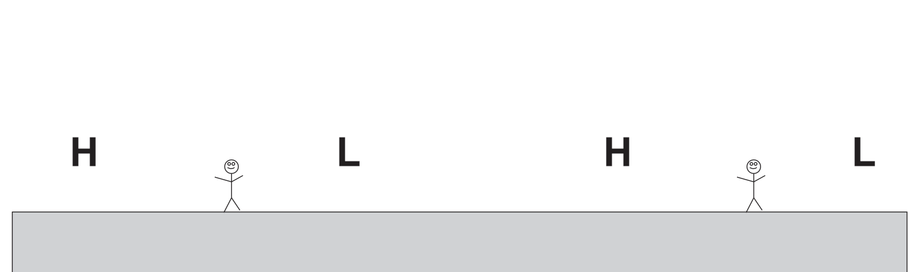

4. What causes atmospheric pressure (the pressure in the air around us)?
5. Where is air pressure stronger – at high altitudes or at low altitudes? Why?
6. What happens to your eardrum when you travel rapidly upward? Why?
7. What happens to your eardrum when you travel rapidly downward? Why?

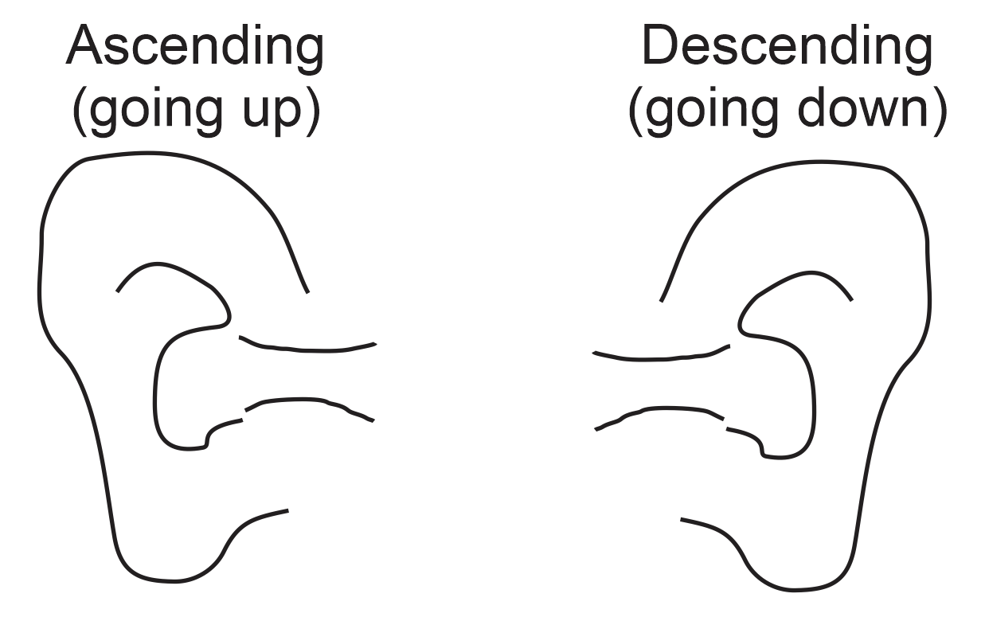

8. What does “psi” stand for?
9. What is the average air pressure at sea level (approximately)?
a. 1.5psi b. 15psi c. 150psi d. 1,500psi
10. Explain why a suction cup sticks to glass, but other things don’t.
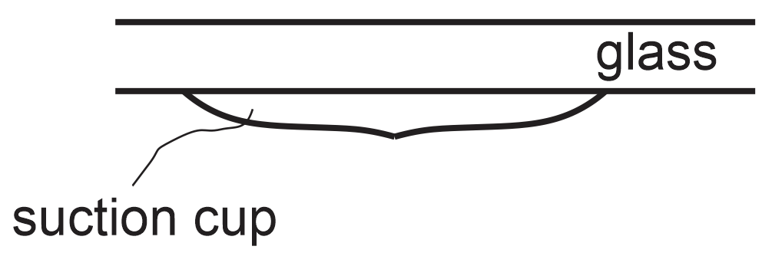
11. In the diagram below…
a. Label the “heavy” and “light” air masses
b. Below the air masses, label the areas of high (H) and low (L) pressure.
c. Use arrows to draw the winds that will be produced by these pressure differences.
d. Fill in the rest of the currents in the diagram.

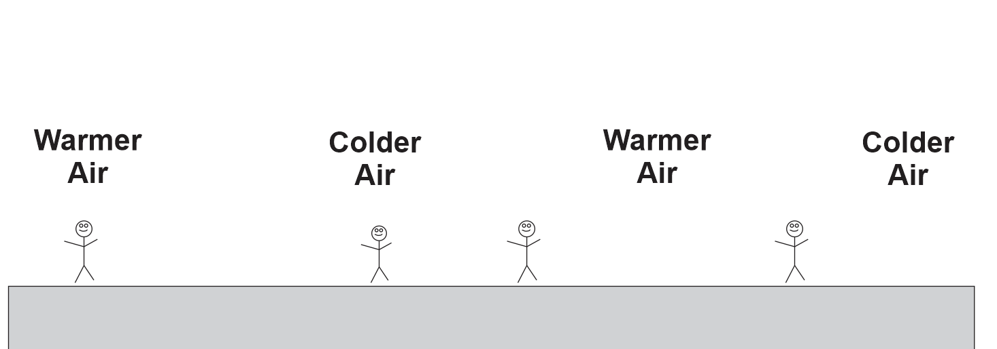

12. On some parts of the Earth, winds near the ocean blow in one direction during the day and in the opposite direction during the night. Label the areas of high and low air pressure and draw the winds in the diagram below.

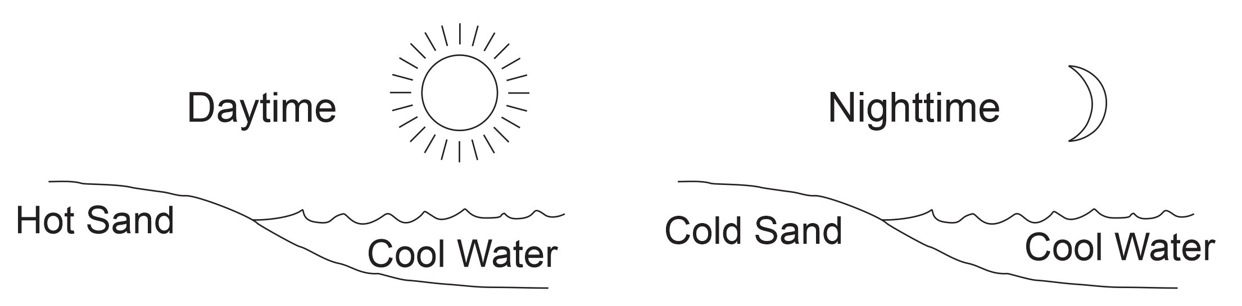

13. Mountain peaks heat up and cool off much more quickly than valleys. In the mornings, mountain peaks heat up faster than valleys, and in the evenings, mountain peaks cool off faster than valleys. This results in winds. Draw those winds.

