ESS 100 Name: ____________________________
Climate Mapping Practice Maps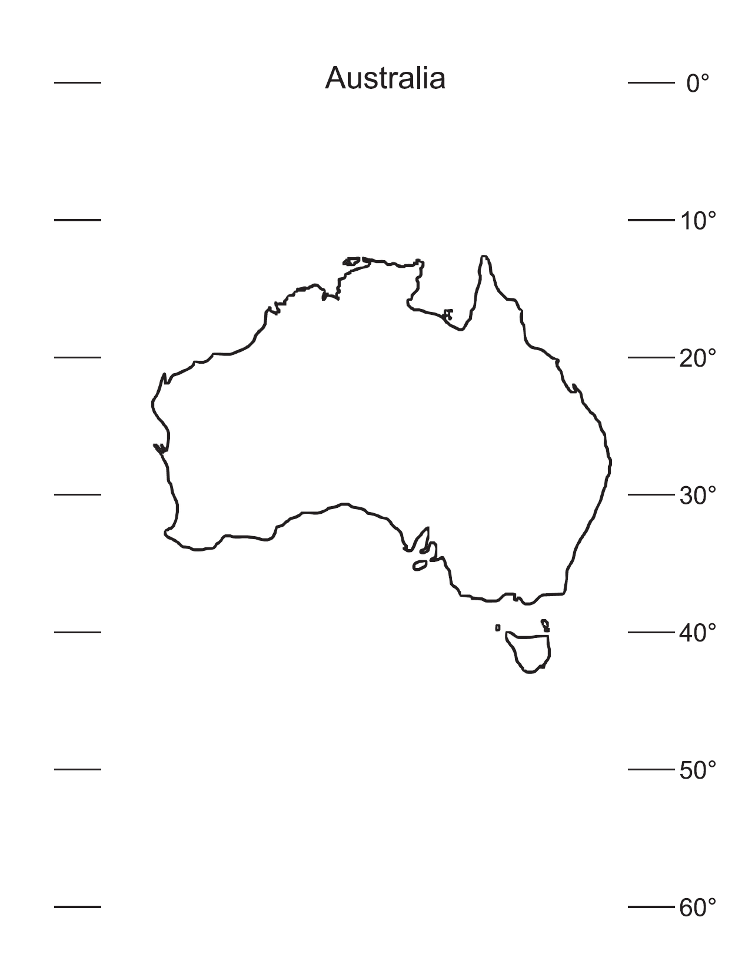
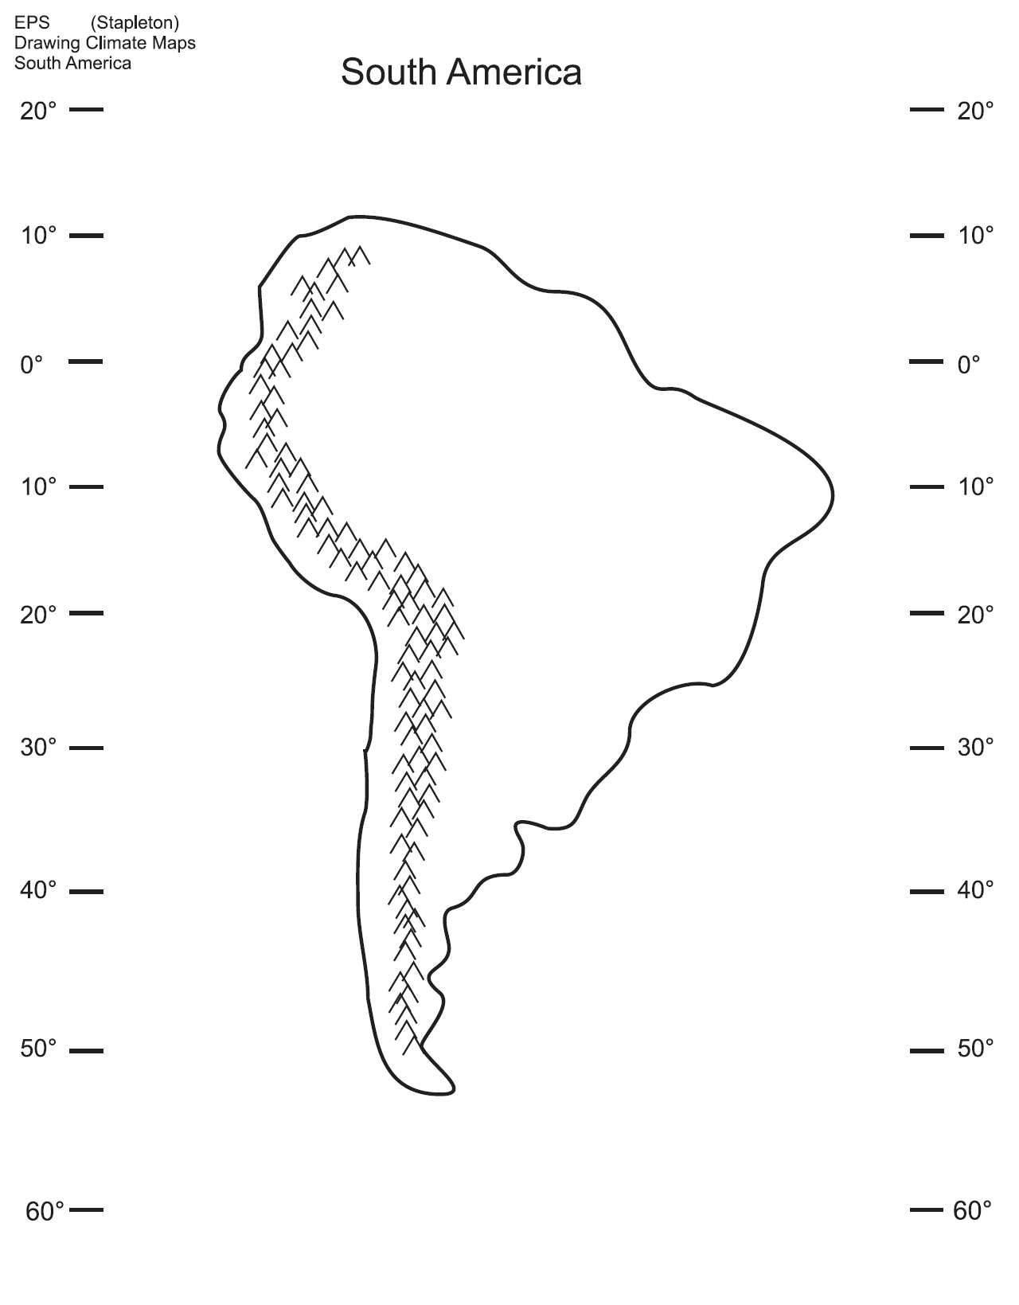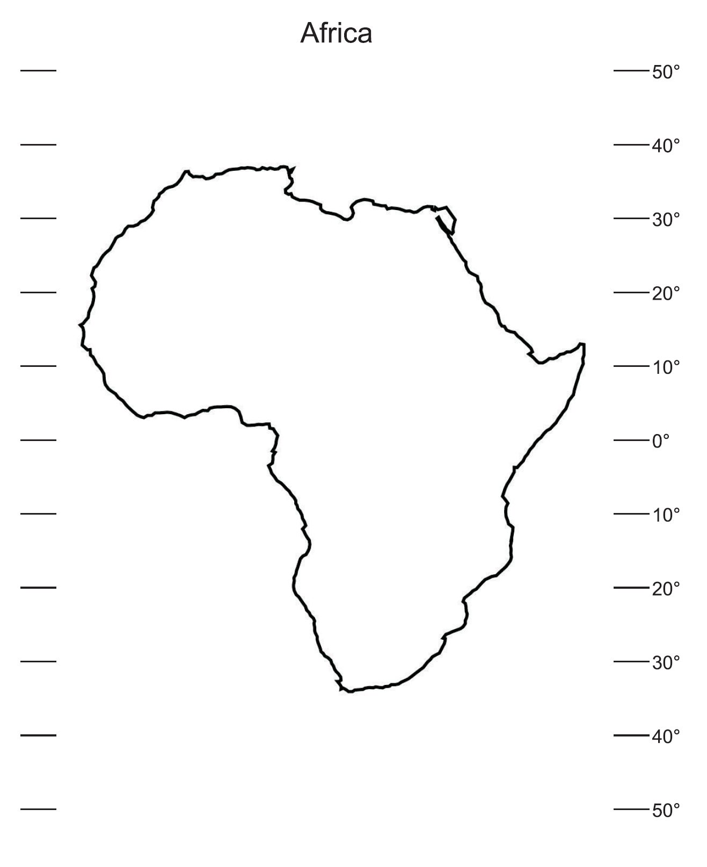

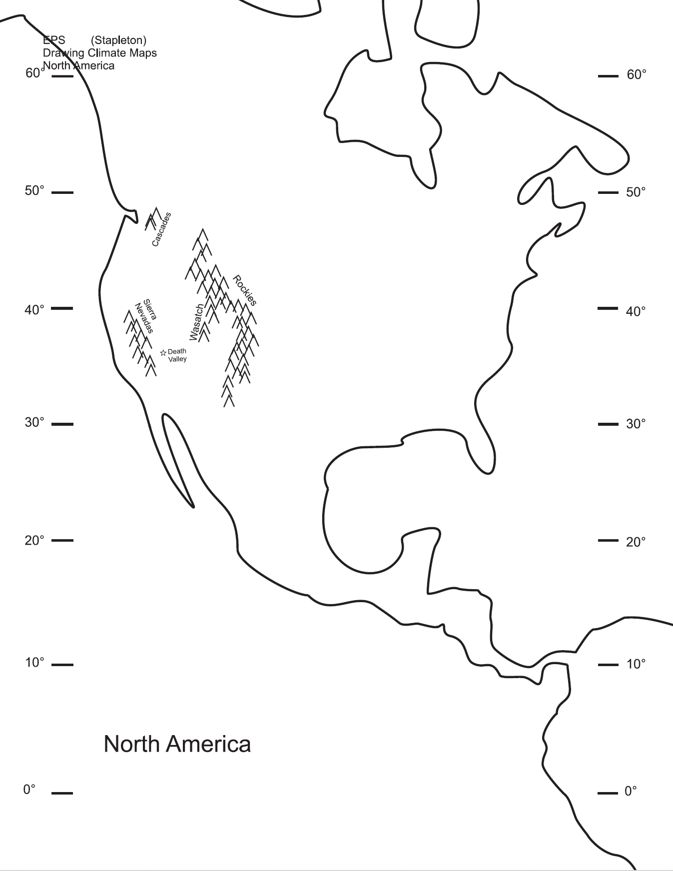

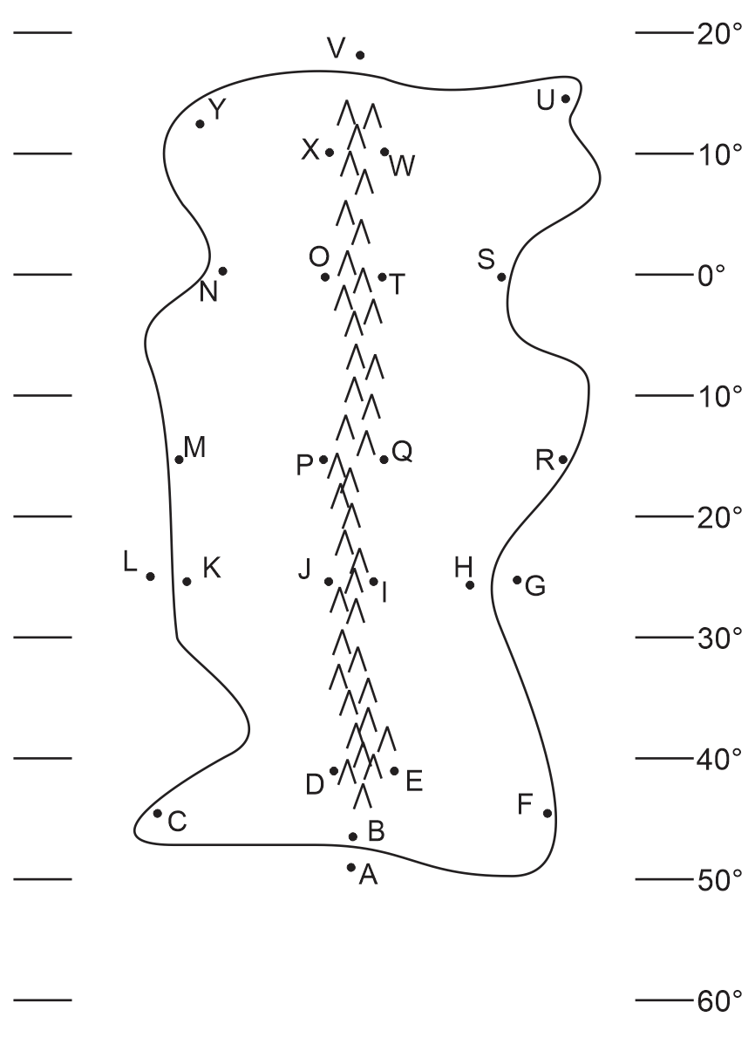
ESS 100 (Stapleton) Name: _______________________________
Climate Mapping Practice Quiz #1

Part 1: Multiple Choice. Complete the map on the right. Then answer the questions below. Choose all of the answer choices that apply.

1. Which letter is in a high pressure belt?
W T Q I E A
2. Which letter is in a low pressure belt?
W T Q I E A
3. At which letter does the wind blow toward the southwest ?
W T Q I E A
4. At which letter is there a cold current?
G L
5. At which letter is there a warm current?
V A
6. At which letter does the ocean current flow most directly toward the South Pole?
V L G A
7. At which letter does the ocean current flow toward the east?
V L G A
8. Which letter is in a major rainforest?
W T Q I E A
9. Which letter is in a major desert?
W T Q I E A
10. Which letter is in a coastal wet climate?
H F B C K M N
11. Which letter is in a wet climate caused by the rain shadow effect?
O P J D
12. Which letter is in a dry climate caused by the rain shadow effect?
O P J D
13. Which letter is in an area that can only be classified as a humid climate?
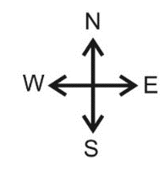
K J H R M C F B

ESS 100 (Stapleton) Name: _______________________________
Climate Mapping Practice Quiz #2
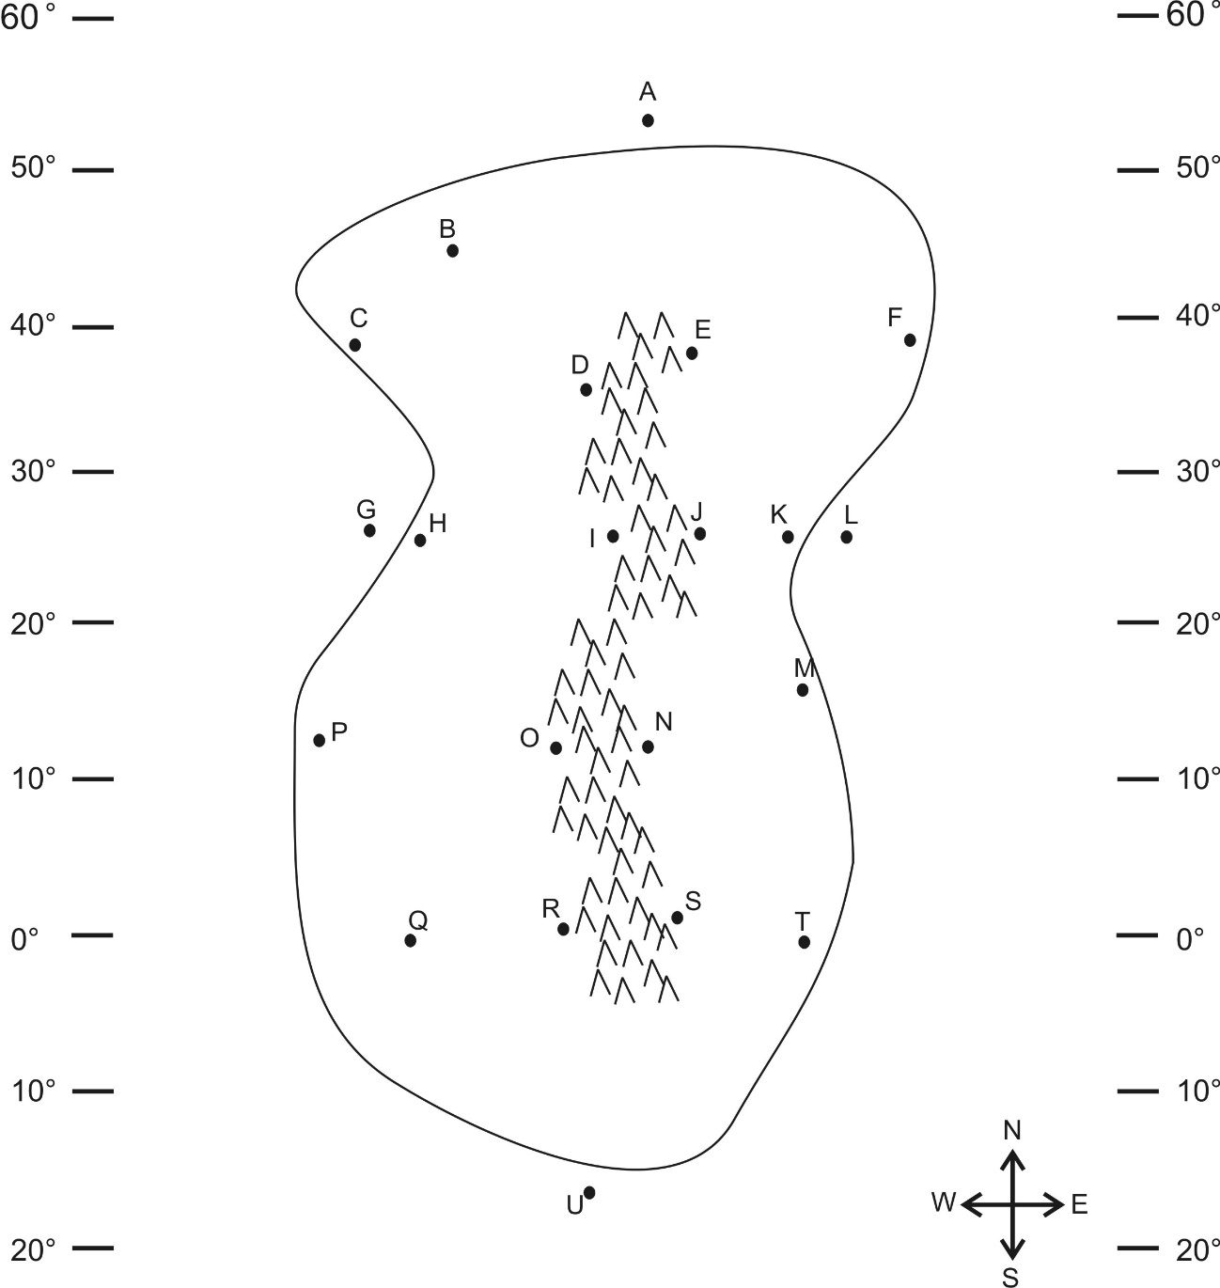
Part 1: Multiple Choice. Complete the map on the right. Then answer the questions below. Choose all of the answer choices that apply.

1. Which letter is in a high pressure belt?
A B D I O R U
2. Which letter is in a low pressure belt?
A B D I O R U
3. At which letter does the wind blow toward the northwest?
A B D I O R U
4. At which two letters is there a cold current?
A U
5. At which two letters is there a cold current?
G L
6. Which letter is in a major rainforest?
A B D I O R U
7. Which letter is in a major desert?
A B D I O R U
8. Which letter is in a coastal wet climate? Pick two.
C H P T K F
9. Which letter is in a wet climate caused by the rain shadow effect?
D I O R
10. Which letter is in a dry climate caused by the rain shadow effect?
D I O R
11. Which letter is in an area that can only be classified as a humid climate?
Q T M K F B C H P
12. At which letter does the ocean current flow most directly toward the North Pole?
A G L U
13. At which letter does the ocean current flow toward the east?
A G L U

