ESS 100 Name: ___________________________________
Notes: The Coriolis Effect

1. In the space on the right, draw an arrow that traces out a clockwise curve.

2. Draw a curved arrow making a counter-clockwise curve.

3. In the leftmost box, below, add new segments to the arrows so that the arrows turn clockwise. In the rightmost box, add segments to the arrows causing them to turn counter-clockwise.
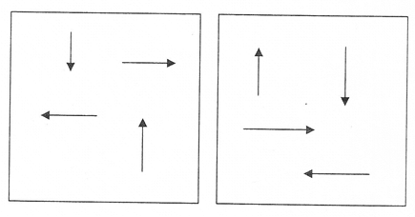
4. If these arrows were cars, which cars would be turning left? Which ones would be turning right?

5. Simulate the Coriolis Effect. First get a wadded up piece of paper. Now imagine that your head is the North Pole. Stretch out your non-throwing arm and let it represent a target on the equator. The Earth turns Eastward, so you will need to turn in circles to your left. Begin turning. While you are turning, hold the paper wad near your eye and then gently toss it in the direction of your hand. Don’t stop turning when you toss!
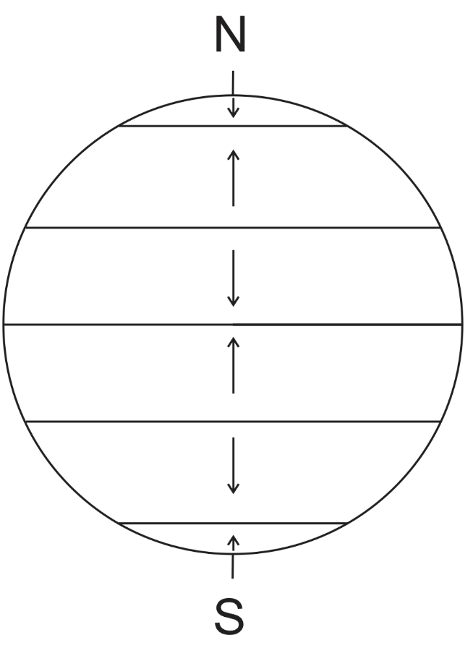
Did it curve to your left or to your right?

6. Repeat the simulation, but now turn to the right, so that your head represents the South pole.

Did the projectile curve to your left or to your right?

7. In the Northern Hemisphere, the Coriolis Effect causes flying objects to curve __________ (clockwise or counter-clockwise).

8. In the Southern Hemisphere, the Coriolis Effect causes flying objects to curve __________ (clockwise or counter-clockwise).

9. The diagram on the right shows the directions of winds that are blowing across the Earths surface. Use your knowledge of the Coriolis Effect to show how the missiles will curve.

ESS 100 Name: ___________________________________
Notes: Atmospheric Circulation and Winds
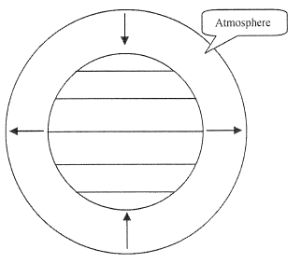
1. The diagram on the right shows the Earth and the atmosphere surrounding the Earth. The diagram shows air rising at the equator and sinking at the poles. We will pretend that this Earth is not rotating.

a. Why does air rise at the equator?

b. Why does air sink at the poles?

c. The rising and sinking air currents are convection currents. Use arrows to show how these air currents might cause the atmosphere to circulate.
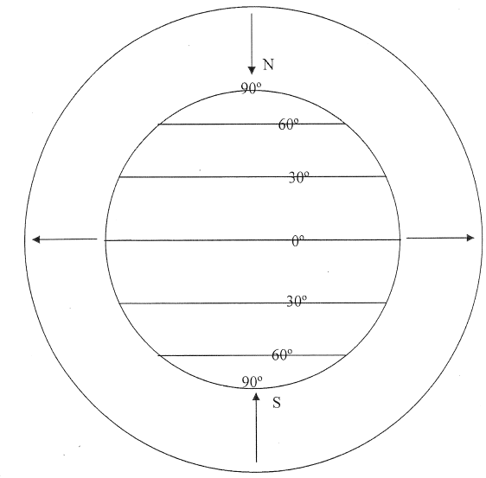

2. In reality, winds cannot travel all of the way from the poles to the equator in a straight line. This is because the Earth’s rotation causes the Coriolis Effect, and the Coriolis Effect causes winds to curve. By the time the air at the poles reaches 60° latitude, it is no longer moving toward the equator. In order to replace the rising and sinking air at the equator and the poles, air also sinks at about 25° Latitude and rises at about 60° Latitude. Draw The complete circulation pattern that results when you add-in these rising and sinking air currents.

3. Sinking air = _______ (high pressure or low pressure)

4. Rising air = _______ (high pressure or low pressure)

Drawing Prevailing Winds

Prevailing winds are big winds. They are the dominant wind patterns that move air around the globe, and their directions generally do not change. Prevailing winds are different from local winds, which can change direction on a daily basis and which do not affect large scale weather patterns.

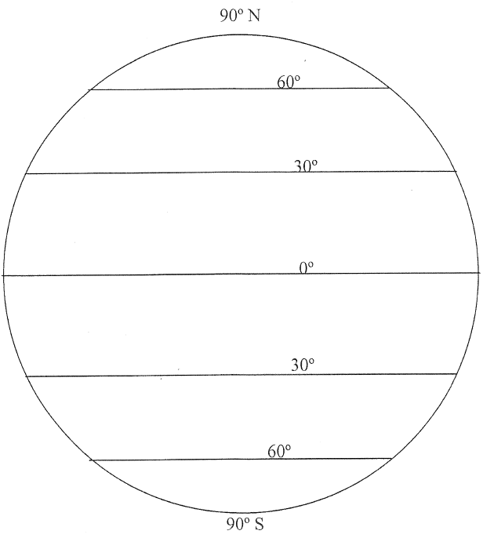
5. On the diagram below, label the Earth’s major pressure belts. Then use your knowledge of air pressure and the Coriolis Effect to draw the Earth’s prevailing winds.

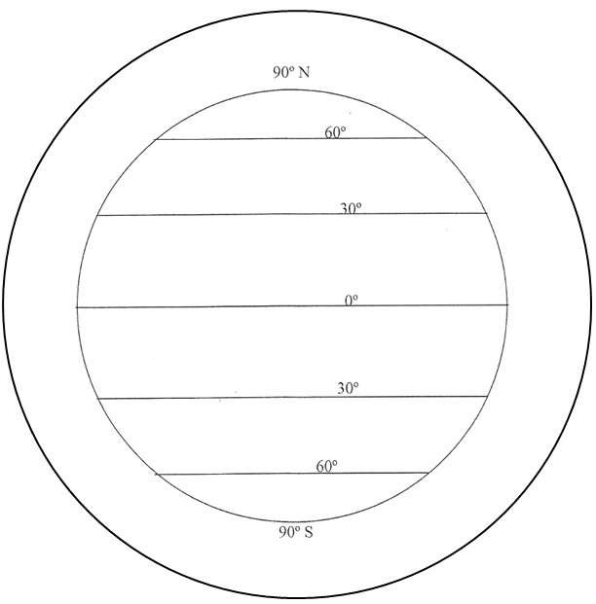
Final practice: On the diagram below, draw…
- Arrows showing the circulation of the atmosphere
- All of the Earth’s high and low pressure belts
- The Earth’s prevailing winds

