ESS Term 1 Review Name: _____________________________
Part 2

1. Label the regions (bottom) of the Solar System and all of the indicated individual objects (top).
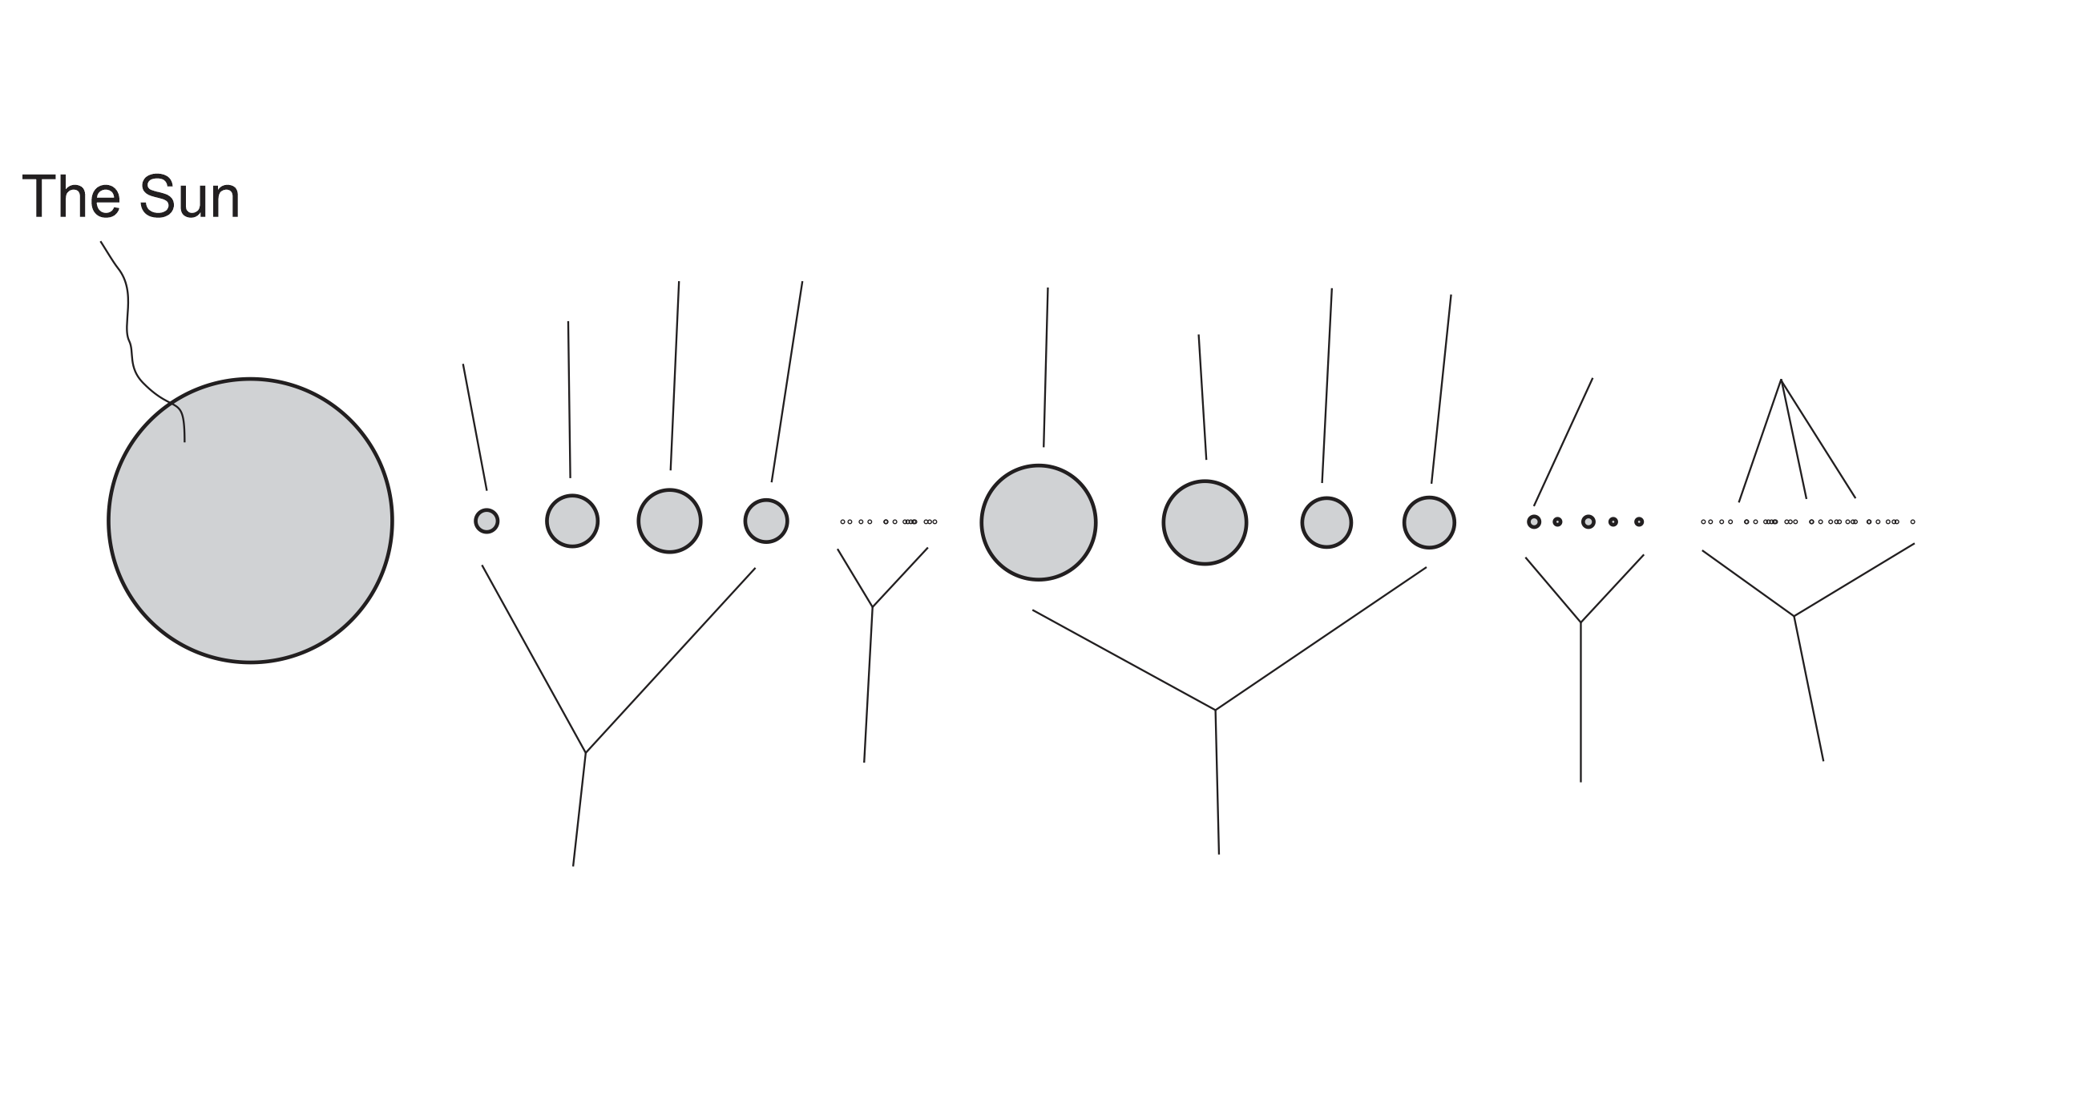
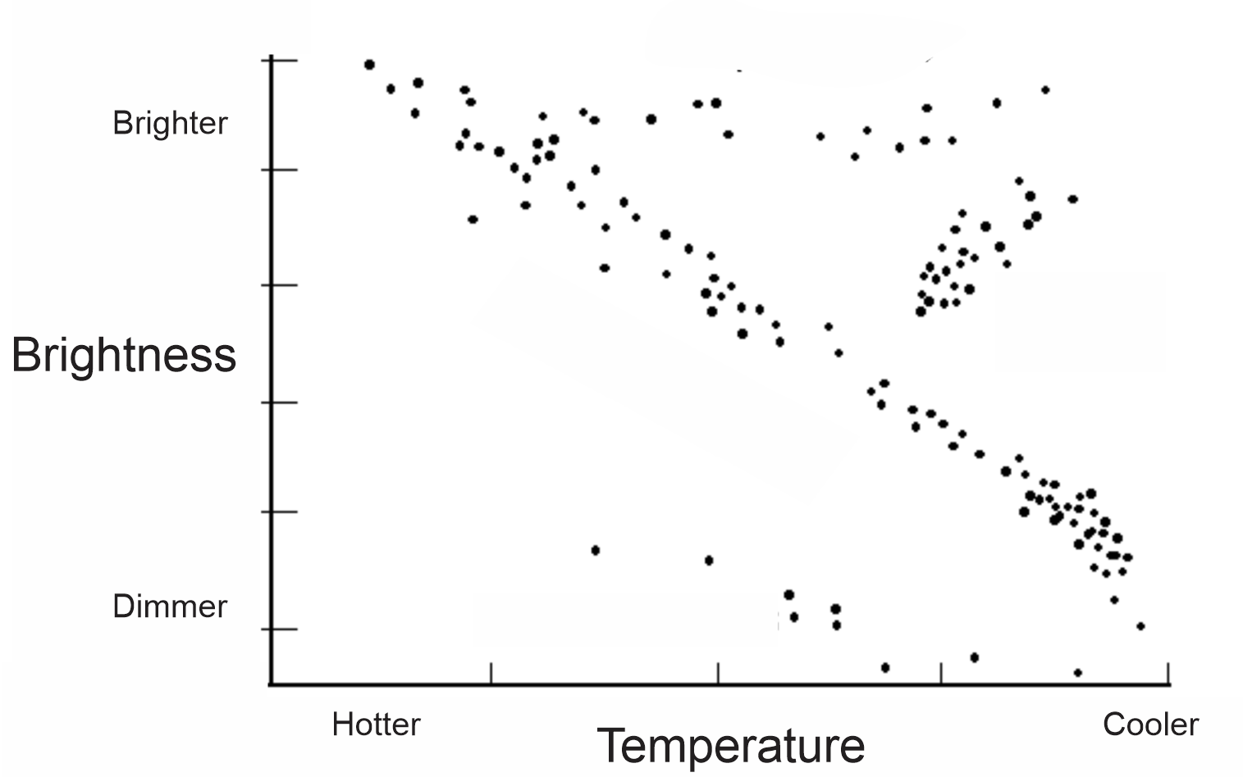

2. Show/label all of the following on the diagram above.

a. Red giants b. White dwarfs c. The Main Sequence
d. Our Sun e. A small, red star f. A blue star
g. Our Sun’s future path as it changes its position in the diagram (use a labeled arrow)

Write the correct letter here. | Terms | Answer Choices
 | Supernova | A | Any object that orbits something else. Most of these orbit planets or stars.
 | Nuclear Fusion | B | This is the main fuel that Stars use to produce energy.
 | Hydrogen | C | An area of such intense gravity that not even light can escape.
 | The Universe | D | Our Galaxy's Name
 | Comet | E | This is created inside main sequence stars.
 | The Milky Way | F | This very dense object forms after a Supernova, if the mass left is less than 3 times the Sun's mass.
 | Nebula | G | The explosive death of a very large star
 | Satellite | H | A "dirty snowball" that orbits the Sun; made of rock and ice
 | Light Year | I | All of space and everything in it
 | Black hole | J | Millions or billions of stars, dust, and gas, held together by gravity
 | Neutron Star | K | The process that produces the Sun's Energy
 | Helium | L | 5,880,000,000,000 miles
 | Galaxy | M | A cloud of dust and ice, floating in space
 | Mass | N | Size
 | Volume | O | The force of gravity pulling an object toward a planet
 | Density | P | The amount of stuff in an object
 | Weight | Q | Crowdedness
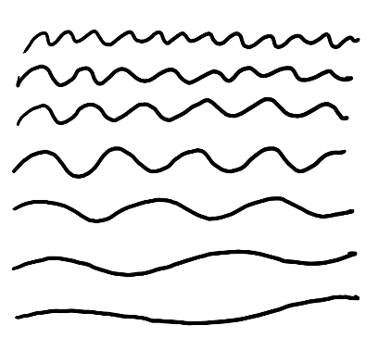
16. Label the waves of light on the right with their color (or at least write the first letter of each color).

17. Complete the diagram below to show which person sees a red shift. Label the person who sees the red shift.

18. The Big Bang theory states that the Universe started out as a tiny, extremely hot, extremely dense point of matter. This point of matter “exploded” outward and has continued to expand outward for the last 13.8 billion years. The Doppler Effect and the CMBR provide evidence for the Big Bang Theory.

a. Explain how the Doppler Effect has shown that the Universe is expanding.

b. How does the CMBR (Cosmic Microwave Background Radiation) serve as evidence for the Big Bang Theory?

20. Where did all of the matter in the Universe come from?

a. Where did the lightest elements (Hydrogen and some helium) come from?

b. Where did the medium weight elements (between the weights of helium and iron)?

c. Where did the heaviest elements (heavier than iron) come from?
Examine the objects below.

21. Which object has the most volume? ____ Least? ____

22. Which has the most mass? _____ Least? _____

23. Which has the most weight? _____ Least? _____

24. Which is most dense? _____ Least? _____

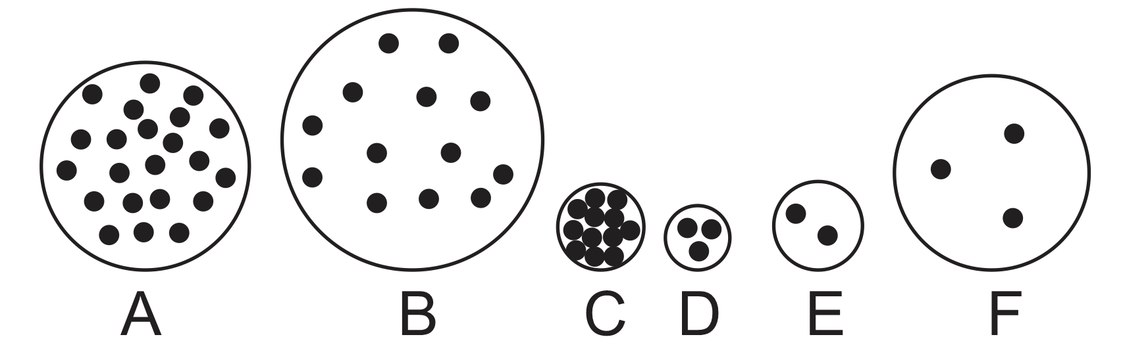

25. On the actual test, the last question will be either #13, 14, 15, or 16, from Part 1 of the Term 1 Review.
#13 asks about the changes that occur when a nebula begins to shrink
#14 asks about the changes that occur as a planet grows from tiny bits of dust to a full size planet
#14 asks about the changes that will occur when our Sun turns into a red giant
#15 asks about the changes that will occur when our Sun turns from a Red Giant to its next stage

