ESS Term 1 Review Name: _____________________________
Part 1

Define each of the following:

1. Mass

2. Volume

3. Density

4. Weight

Examine the objects below.

5. Which object has the most volume? ____ Least? ____

6. Which has the most mass? _____ Least? _____

7. Which has the most weight? _____ Least? _____

8. Which is most dense? _____ Least? _____
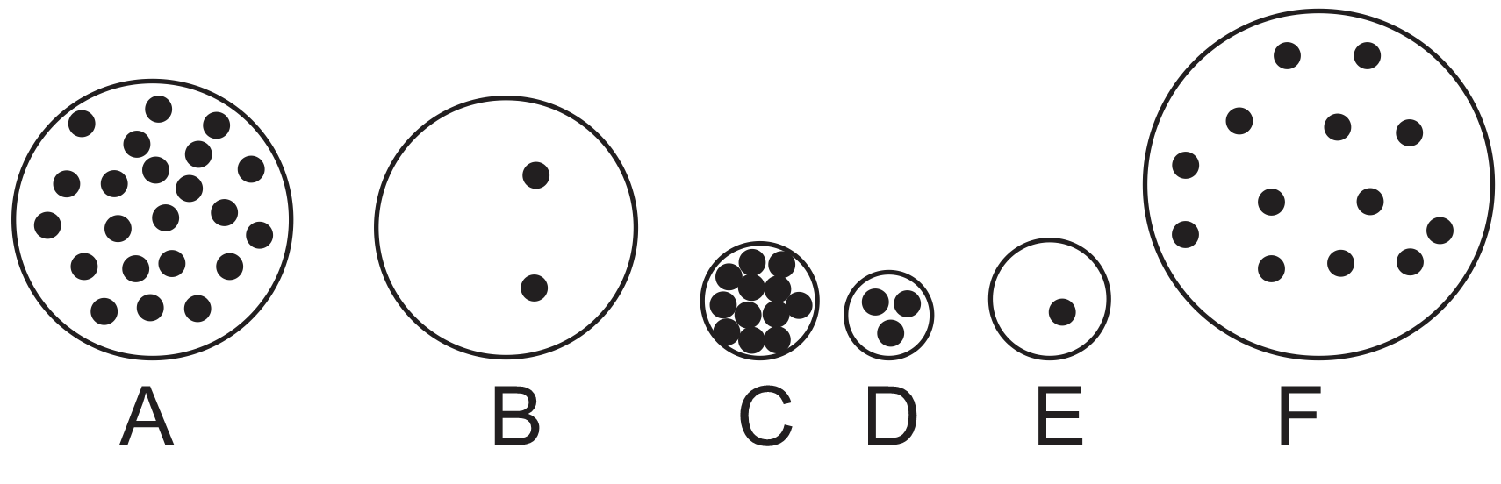

9. Show two fundamentally different ways to make this box more dense. In each case, explain what changes you made to mass, volume, or weight.

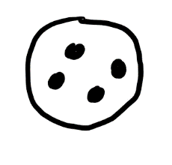

10. Draw two objects (similar to my drawing above) that have different masses but similar densities.

11. Suppose you heat a sealed container full of gas (this could be air, hydrogen, or something else)…

a. What happens to the motion of the gas molecules?

b. What happens to the pressure of the gas?

c. What is pressure, and why does it change?

d. If the container is stretchy, what will happen to its volume? Why?

e. If the container is stretchy, what will happen to its density? Why?

12. Suppose you compress a sealed container full of gas (this could be air, hydrogen, or something else)…

a. What happens to the temperature of the gas?

b. Explain why compression changes the temperature in this way.

d. What has happened to the volume of the gas? Why?

e. What has happened to the gas’ density? Why?

. List the colors of stars, from hottest to coolest.
13. Approximately 4.6 billion years ago, our solar system did not exist. There was only a nebula. Soon the nebula began to change, and a protostar began to form. During this period of change, what happened to the nebula’s…

Property | Change in Property (+, -, or =) | Explanation (explain why, or how you know)
Mass
Volume
Density
Temperature
Rotational Speed

14. Planets formed as tiny bits of matter were pulled together, first by static electricity, and then by gravity. As one of these planets formed, what happened to its…

Property | Change in Property (+, -, or =) | Explanation (explain why, or how you know)
Mass
Volume
Density
Temperature

15. About 5 billion years from now, our Sun will begin to change. It will turn into a giant. During this period of change, what will happen to the Sun’s…

Property | Change in Property (+, -, or =) | Explanation (explain why, or how you know)
Mass
Volume
Density
Temperature
Color

16. As soon as our Sun’s red giant stage is over, the Sun will change again. During this next period of change, what will happen to the Sun’s…

Property | Change in Property (+, -, or =) | Explanation (explain why, or how you know)
Mass
Volume
Density
Temperature
Color

