EPS 100 Stapleton Name: _______________________________
Unit 1 Test: Physical Properties and Air Pressure

Part I (Mass, Volume, Density, Weight) :

The objects below are mostly empty space. The circle is the edge of each object. The dots inside represent all of each object’s mass. The empty space inside the objects has no air or mass of any kind. All of the objects are in similar locations on the same planet.

1. Which object has the most mass?

2. Which object has the least mass?

3. Which object has the most volume?

4. Which object has the least volume?

5. Which object is most dense?

6. Which object is least dense?

7. Which object has the most weight?

8. Which object has the least weight?

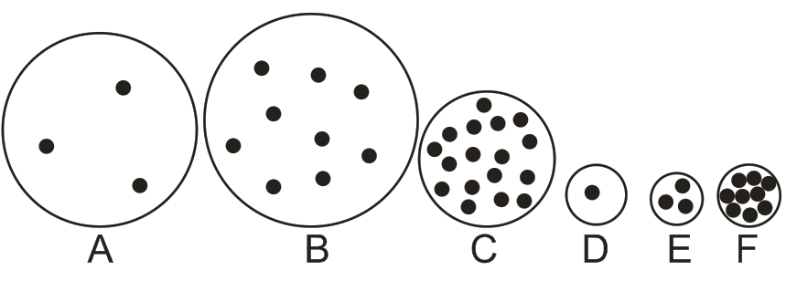

Part II (changes in mass, volume, density, and weight): For the following questions, tell whether each property increases, decreases, or stays the same. Choose the correct symbol, either +,-, or =.

9-12. An object’s size doesn’t change, but more stuff is added to it.

9. mass + - = 10. volume + - =

11. density + - = 12. weight + - =

13-16. The particles inside an object become less crowded, but the amount of stuff in the object doesn’t change.

13. mass + - = 14. volume + - =

15. density + - = 16. weight + - =
Part III: How heating and cooling can affect pressure, volume, and density
A sealed jar has air inside. The jar cannot change its size, and no air can enter or leave. What will happen when the jar and the air inside are heated up?
17. What will heating do to the motion of the molecules in the jar?

18. When the jar is heated, what will happen to the pressure inside the jar?

19. What is creating the pressure that is inside the jar?

A plastic Ziplock bag is filled with air and sealed. No air can enter or leave the bag. What will happen to the bag of air when it is cooled down?
20. How does cooling affect the overall mass of the bag and its air? (increase, decrease, or no change)
21. How does cooling affect the overall volume of the bag and its air? (increase, decrease, or no change)
22. How does cooling affect the overall density of the bag and its air? (increase, decrease, or no change)
23. How does cooling affect the overall weight of the bag and its air? (increase, decrease, or no change)
24. How does cooling affect the pressure inside the bag? (increase, decrease, or no change)

Part IV: How compression and expansion can affect temperature
Consider the same Ziplock bag filled with air and sealed. No air can enter or leave the bag.
25. What will happen to the temperature of the bag if you squeeze the bag (but not hard enough to pop the bag)?

26. Explain why squeezing changes the temperature in this way.

27. What will happen to the temperature of the air in the bag if you release it after you have been squeezing it for a while?

28. [This won’t be on the quiz unless it’s part of a bonus.] If you see a cloud suddenly appear in air, that mean’s the air’s temperature ______________ (increased or decreased). If you see a cloud suddenly disappear, that means the temperature of the air around the cloud suddenly _____________ (increased or decreased.)

